Topical Review Article
Evidence-Based Diagnosis, Health Care, and Rehabilitation for Children With Cerebral Palsy

Iona Novak, PhD, MSc (Hons), BAppSc OT
Abstract
Journal of Child Neurology
2014, Vol. 29(8) 1141-1156
Safer and more effective interventions have been invented for children with cerebral palsy, but the rapid expansion of the evidence base has made keeping up-to-date difficult. Unfortunately, outdated care is being provided. The aims were to survey the questions parents asked neurologists and provide evidence-based answers, using knowledge translation techniques. Parents asked the following questions: (1) what’s wrong with my baby? An algorithm for early diagnosis was proposed. (2) What is cerebral palsy and what online resources are current? Reputable information websites were sourced and hyperlinks provided. (3) The prognosis? Prognostic data from meta-analyses were summarized in an infographic. (4) What interventions offer the most evidence-supported results? Systematic review data about the most effective interventions was mapped into a bubble chart infographic. Finally, (5) What can we expect? Predictors and facilitators of good outcomes were summarized. This article provides an overview of the most up-to-date diagnostic practices and evidence-based intervention options.
Keywords
cerebral palsy, evidence-based, intervention, knowledge translation
Received April 02, 2014. Received revised April 02, 2014. Accepted for publication April 03, 2014.
ª The Author(s) 2014 Reprints and permission: sagepub.com/journalsPermissions.nav DOI: 10.1177/0883073814535503 jcn.sagepub.com

Safer and more effective interventions have been invented for children with cerebral palsy in the last decade, as a consequence of an exponential growth in high-quality cerebral palsy research.¹ There are now at least 64 different interventions for cerebral palsy,¹ with even more interventions being studied at clinical trial. Up until the new millennium, the words unpreventable, incurable, and untreatable were synonymous with cerebral palsy. The field has however started to think very differently about cerebral palsy, as a result of prevention research breakthroughs (eg, magnesium sulfate for the pregnant mother prior to the imminent delivery of a premature infant and hypothermia for newborns in intensive care with encephalopathy) and the discovery of activity-based rehabilitation interventions that induce neuroplasticity (eg, constraint-induced movement therapy). A leading cerebral palsy researcher recently declared,
For years, there has been much appropriate sensitivity about not trying to make children with CP [cerebral palsy] ‘‘normal,’’ because that has not yet been thought possible. But what if it were? The evidence...provides considerable cause for optimism for children with CP [cerebral palsy].’’^{2(p196)}
Now more than ever, families are seeking guidance from neurologistsabouthowtochoosebetweentime-honoredconventional interventions and newer neuroplasticity-inducing interventions. There is also an ever-expanding need for neurologists to take a leading role in advancing cerebral palsy treatment options in the fields of neuroplasticity, neuroregeneration, and neuroprotection research.
Rapid expansion of the evidence base, however, has made it difficult for health professionals to keep up-todate and it is challenging for families to know how to best help their child. Outdated clinical care is regrettably being provided to children with cerebral palsy.^{3,4} Consistent with other fields, 10% to 40% are not offered proven effective interventions, and another 20% receive harmful or ineffective interventions.⁵ Furthermore, the persistent preference for conservative late diagnosis of cerebral palsy following failed milestones conflicts with current neuroscience evidence. Very early intervention, close to the time of injury, is now advised to optimize neuroplasticity.⁶ The President of the American Academy of Cerebral Palsy and Developmental Disability (AACPDM) recently observed that
The care that children [with cerebral palsy] receive is disproportionately dictated by where they live, who they see, and how their care is financed, rather than what is warranted by their condition...The translation of the best science and the best ‘art’ into best practice for all children is still more hope than reality.^{7(p876)}
Knowledge translation is the science designed to disseminate evidence-based interventions faster, in order to improve health outcomes.⁸ Knowledge translation also acknowledges the growing role of social media and the Internet as common information sources and support networks for families and devises knowledge products in delivery formats compatible with these preferences.⁹ No one knowledge translation approach single-handedly moves evidence into practice; instead a range of knowledge translation strategies is
needed.^{10,11} Effective knowledge translation should follow a Knowledge-To-Action cycle.¹² First, knowledge summaries, products, and tools must be developed in response to identified knowledge gaps,¹² with due consideration given to the what, who, when, where, and how of messaging.¹³ Second, local barriers to research utilization must be identified. Third, tailored strategies to redress these barriers must be chosen, enacted upon, and evaluated.¹²
The aims of this paper were to (1) learn what questions parents of children with cerebral palsy are currently asking neurologists and (2) provide neurologists with up-to-date evidence-based answers to these parent questions, using a range of proven effective knowledge translation techniques.¹¹

Method
The author created a simple informal social media survey in September 2013 to solicit the views of parents of children with cerebral palsy about working with neurologists. Anyone who came across the survey was able to participate if they met the inclusion criteria (ie, were a parent or caregiver of a person with cerebral palsy). In order to quickly obtain the largest and most representative number of views, the internet and social media was used to solicit participants. Ads for the surveys were placed within an American parent support network ‘‘Reaching for the Stars’’ (n ¼ 12 000 þ members) using social media, and on Australian parent support network hosted on Cerebral Palsy Alliance’s Facebook page (n ¼ 10 000 þ friends). Participants were asked the following open-ended question: ‘‘What are the most important questions you think a neurologist should be able to answer about cerebral palsy?’’ In the survey preamble, the purpose of survey was explained and assurances were given about responses being reported anonymously. Voluntary social media responses to the survey were considered consent to participate.
Knowledge translation products were then designed based on best-available evidence, to answer the questions posed by parents responding to survey. Best-available evidence was considered systematic reviews, since systematic reviews are recognized as gold standard evidence summaries. Knowledge translation products included sourcing reputable websites to direct parents to for more information; the creation of evidence-based decision-making algorithms; the discussion of illustrative case studies, and use of infographics to summarize data.

Results
Knowledge and Workforce Gaps Appear to Exist
Almost all of the survey respondents volunteered that they experienced major difficulties in locating neurologists with a recognized speciality in cerebral palsy. Neurology was a service they wanted and perceived as important for their child. Moreover, parents reported feeling perplexed as to why it was so hard to find neurologists who were the ‘‘wheelhouse’’ of cerebral palsy care. One parent summarized this dilemma as follows:
If cerebral palsy is a brain disorder/brain injury, why aren’t more neurologists really interested in treating it, talking about it, serving as the ‘‘quarterback of the team’’?
In this information technology era where families often undertake considerable self-directed learning on the internet, parent respondents also perceived that some neurologists had gaps in their knowledge about contemporary treatments options for cerebral palsy. One parent stated,
Many neurologists don’t seem particularly well-versed in cerebral palsy in terms of the current research, treatments or how to talk to parents about it in a hopeful way.
Therefore, the focus of this paper was on the first step of the Knowledge-To-Action cycle, that is, to develop knowledge translation summaries, products, and tools for neurologists to respond to the parent-perceived knowledge gaps about current diagnostic and treatment options for cerebral palsy. It was not feasible to identify worldwide research implementation barriers regarding neurology services for cerebral palsy, nor devise local solutions to redress each of these barriers; therefore, attending to the later steps of the Knowledge-To-Action cycle were outside the scope of this paper. In this article, known effective knowledge translation strategies¹¹ were used to summarize the best available evidence about the early diagnosis of cerebral palsy and what interventions work for children with cerebral palsy.¹

Important Questions Parents Perceive a Neurologist Should Be Able to Answer About Cerebral Palsy
What Is Wrong With My Baby?
Evidence-based early diagnosis. Cerebral palsy is historically diagnosed around 12 to 24 months of age given the lack of biomarkers, causing diagnosticians to favor a conservative ‘‘wait and see’’ approach.¹⁴ Early diagnosis of cerebral palsy at 12 weeks of age is now possible for approximately half the population via comprehensive diagnostic workups
Diagnostic best practice for cerebral palsy involves a combination of:

- Risk factor history taking
- Neurologic examination (preferably using the standardizedHammersmith Infant Neurological Evaluation because cut scores exist helping to identify cerebral palsy and the severity level)
- Standardized motor assessment, of quality of movement (usingPrechtl’s General Movement for infants <4 months corrected) and of volitional movement (using the parent questionnaire Developmental Assessment of Young Children for infants 6-12 months of age).
- Neuroimaging; all children with a presumed or suspected braininjury should have magnetic resonance imaging (MRI)^{14,17} 5. Ruling out of alternative diagnoses, including progressive disorders

among neonatal intensive care unit graduates with identifiable risk factors (eg, prematurity, encephalopathy, neonatal seizures, neonatal or postnatal stroke, multiple births, postnatal infection, and postnatal surgery¹⁴). Early diagnosis among ‘‘healthy term borns’’ without identifiable risk factors requires more research. The Developmental Assessment of Young Children¹⁹ and Hammersmith Infant Neurological Evaluation,²⁰ which are known to accurately predict cerebral palsy in high-risk populations, also look promising for this lower-risk population. Early diagnosis is considered best practice because it enables timely access to diagnosticspecific early intervention when the greatest neuroplastic gains are possible.¹⁴ Figure 1 provides an algorithm of evidencebased diagnosis.
A diagnostic label is often the gateway to rehabilitation services (more accurately referred to as habilitation services). Delayed diagnosis might be harmful to a child’s development because it may deprive the child of early intervention for months or even years.¹⁴ In addition, delaying the delivery of bad news is known to worsen parental depression and stress rather than making it better.¹⁵ A diagnosis is a very important first step in helping a family to access diagnosis-specific parent support and gain evidence-based information on how to best help their child. Early intervention for cerebral palsy is no longer generic enrichment, but rather diagnosis-specific intervention, for example, active hip surveillance; motor training; early standing; constraint induced movement therapy; robotics etc.¹⁶ Without the label of cerebral palsy, children are not likely to be offered these interventions early enough and neuroscience suggests this delay is detrimental.¹⁶ In cases where the neurologist is not yet sure of the diagnosis, recommending that the family seek early intervention from services that accept parent-initiated referrals is ethically prudent.
What Is Cerebral Palsy?
The International Consensus definition is as follows:
Cerebral palsy describes a group of permanent disorders of the development of movement and posture, causing activity limitation, that are attributed to non-progressive disturbances that occurred in the developing fetal or infant brain. The motor disorders of cerebral palsy are often accompanied by disturbances of sensation, perception, cognition, communication, and behaviour, by epilepsy, and by secondary musculoskeletal problems.^{26(p9)}
Cerebral palsy can be classified using different systems, with the most reliable of these being the Gross Motor Function Classification System.²⁷ Cerebral palsy has 5 levels of severity, described using the Gross Motor Function Classification System (I ¼ independently ambulates; II ¼ independently ambulates with limitations; III ¼ ambulates with walking aids; IV ¼ independently mobilizes with powered mobility; and V ¼ dependent for all mobility).²⁷ When thinking about intervention options for cerebral palsy, it is also useful to classify cerebral palsy by topography as some interventions are only indicated for certain topographies, for example, constraintinduced movement therapy for hemiplegic cerebral palsy or selective dorsal rhizotomy for diplegic cerebral palsy. Population register data indicates a strong relationship between topography and Gross Motor Function Classification System,²⁸ although not all experts agree that topography is a reliable classification system for predicting function.²⁹ Figure 2 outlines the proportion of cerebral palsy by topography and severity from 2 country’s population data sets.
What Resources Can I Look up Online That Will Have Correct and Current Information?
What Is the Prognosis of Cerebral Palsy?
Key prognostic facts
Life-long. Cerebral palsy is a life-long physical disability; disability increases with age, and ageing occurs earlier.³¹ Rehabilitation planning must also consider adulthood.
Normal life expectancy. Almost all children with cerebral palsy have normal life expectancy, with 5% to 10% dying during childhood.^{32,33} Those with co-occurring epilepsy and intellectual disability in combination with severe physical disability have the greatest risk for poor prognosis and premature
death.32,34
Most children with cerebral palsy will walk. Sixty percent are independent ambulators (35.5% Gross Motor Function Classification System I; 24.5% Gross Motor Function Classification System II); 10% are aided ambulators (10.7% Gross Motor Function Classification System III); and 30% are wheelchair users (12.2% Gross Motor Function Classification System IV; 14.1% Gross Motor Function Classification System V).³⁰ It is important to communicate this message to families, as they may hold the common misconception that all children with cerebral palsy are ‘‘wheelchair bound.’’
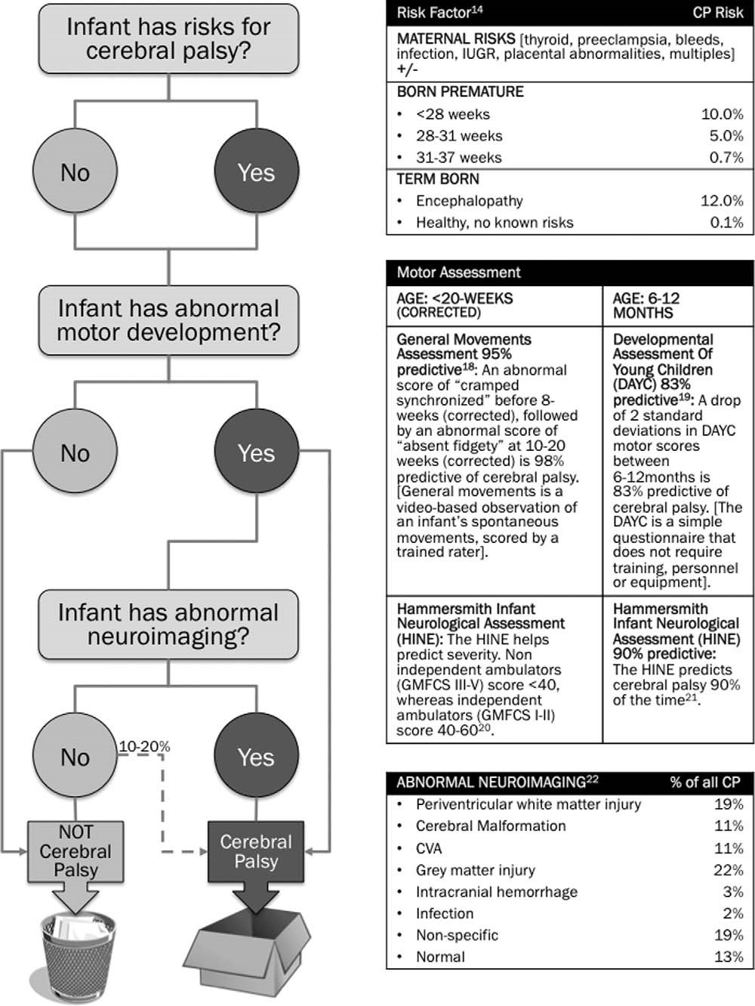
Figure 1. Evidence-based decision-making algorithm for diagnosing cerebral palsy early.
Severity predictions are most accurate at 2 years. Under 2 years of age, severity predictions are incorrect 42% of the time,³⁵ since voluntary movement is still developing and hypertonia may still be evolving with myelination.^{6,23,36} MRI provides some guidance but is not bullet proof for predicting function: unilateral injuries usually result in milder presentations; periventricular white-matter lesions generally result in milder motor impairments (ie, usually ambulatory) but not always,³⁷ whereas brain malformations, cortical, subcortical, and basal ganglia lesions generally result in more severe motor impairments (ie, nonambulatory).³⁸ Parents’ chief criticisms of diagnosticians relate to unclear information and communication of a pessimistic outlook.³⁹ A positive, accurate, and evidence-based way to answer questions about severity is to explain,
It is not possible to be certain of severity under 2, as the baby’s brain is still developing. There are 5 levels of gross motor severity and we will watch the baby carefully together rule them out one at a time. So, if your baby learns to hold their head up they automatically do not have the most severe cerebral palsy. If they learn to sit independently before they turn 2, they will walk.
Comorbidities affect outcome. Cerebral palsy is almost always accompanied by comorbidities, which can be as

Infant Diagnostic Case Study:

Medical History: Twins born at 26 weeks. At 5 weeks corrected; the twins are discharged home, with twin 2, the male twin, on nasogastric feeding. Prior to discharge from the Neonatal Intensive Care, the Occupational Therapists assesses twin 2 to have abnormal General Movements (ie, poor quality of spontaneous movement), with a profile predictive of cerebral palsy. This is despite having a normal head ultrasound, mildly abnormal neurologic exam and no hypertonia present. At 12 weeks corrected, the General Movements assessment is repeated (since that is the most accurately predictive time window) and twin 2 is found to have persistent abnormal General Movements, with a profile 98% predictive of cerebral palsy. The parents are informed that twin 2 is at high risk of cerebral palsy and early intervention was recommended. The neurologist however, reassures the mother that twin 2, had a normal head ultrasound, is growing normally, feeding well and is smiling and therefore might not have cerebral palsy and to ‘‘wait and see.’’ The mother embraces the ‘‘good news’’ and declines early intervention. At age 2, twin 2 is diagnosed with diplegic cerebral palsy following failed motor milestones and a magnetic resonance imaging (MRI) confirming white matter injury. A subsequent hip radiograph reveals twin 2’s hips are both subluxing, secondary to the untreated bilateral spastic cerebral palsy.
The facts
Substantial risks for cerebral palsy existed in the medical history: multiple birth, extreme prematurity, male gender, feeding issues, and prolonged hospitalization¹⁴
The General Movements assessment has the best sensitivity of all tools for detecting cerebral palsy early (98% sensitivity and 91% specificity at 10-20 weeks post term age; versus gold standard MRI with 80%-87% sensitivity; versus neurologic examination with 57%-86% sensitivity in preterms and 68%-96% sensitivity post-term age).^{17,18}
12%-20% of children with cerebral palsy will have normal neuroimaging and neuroimaging should not be used in isolation.¹⁷ Moreover, MRI is diagnostically superior to ultrasound.
Spasticity and dyskinesia may not be observable until 1-2 years of age.²³
The combined sensitivity of abnormal General Movements plus abnormal MRI showing white matter injury, in preterms, is 100%.²⁴
Waiting and watching until children fail motor milestones conflicts with neuroscience evidence about the benefits of early enrichment to promote neuroplasticity.⁶
Diagnosis-specific evidence-based early intervention was not provided to this child (eg, hip surveillance to prevent hip dislocation) directly as a result of late diagnosis. Late diagnosis in this case was harmful, as hip dislocation is preventable in this population.²⁵ Unmanaged hip dislocation causes pain and hinders ambulation, markedly affecting outcomes and quality of life.
Early diagnosis is evidence-based and contributes to better child outcomes. Involvement of therapists in conducting motor assessments can help accelerate data gathering to make a diagnosis early.

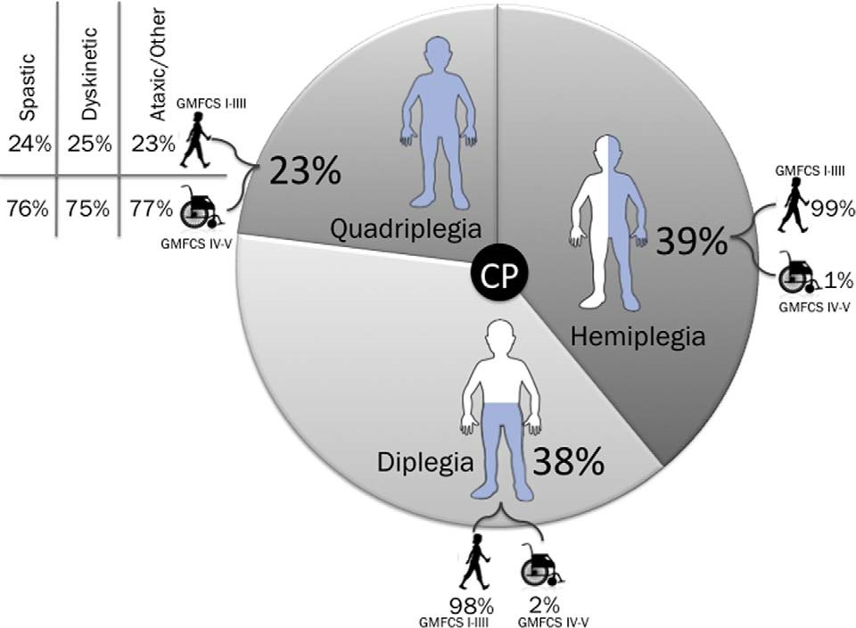
Figure 2. Proportion of cerebral palsy by topography and severity.^{28,30}
disabling as the physical disability. A meta-analysis of cer- prognostic messages for communicating to parents³⁶ (Figure ebral palsy register data has summarized the comorbidities 3). Figure 3 also outlines evidence-based management strarates and translated these rates into parent-friendly tegies for each comorbidity.

Useful and reputable websites for parents about cerebral palsy:

reachingforthestars.org cpdailyliving.com cerebralpalsy.org.au childhooddisability.ca canchild.ca cdc.gov neurodevnet.ca ucp.org scope.org.uk
FAQs exist written by parents of children with cerebral palsy: cp.org/wp-content/uploads/2013/01/each-of-us-remembers-parentsof-children-with-cerebral-palsy-answer-your-questions-2013.pdf

Pain, behavior, and sleep disorders are underrecognized. Some of the most underrecognized but treatable co-occurring limitations include chronic pain (affecting 3 in 4), behavior disorders (affecting 1 in 4), and sleep disorders (affecting 1 in 5).³⁶ History taking should include routinely screening for all comorbidities as specific treatments for these problems can substantially improve the child’s outcome, coping, and quality of life (refer to Figure 3).
Deterioration can occur secondary to musculoskeletal impairments. For the most part, medical or rehabilitation treatment do not lessen the severity of the condition, or assist a person to improve up into a milder Gross Motor Function Classification System level. Without rehabilitation and orthopedic management, a person can deteriorate physically and drop down a full Gross Motor Function Classification System level; therefore, it is very important to refer children to rehabilitation, developmental services, and orthopedic surgery.
What Are the Therapies/Treatment That Offer the Most Researched Results?
Contemporaneous management of cerebral palsy can be broadly categorized into 3 areas of focus:
Child-active rehabilitation approaches. Child-active approaches are where the child is actively practicing real-life tasks during intervention (usually in real-life environments), for the purpose of gaining or consolidating real-life skills that they want to learn. Child-active approaches are consistent with current neuroscience evidence about inducing maximal neuroplasticity, and these learning-based approaches include the following features: goal-based, task-specific practice, highdose repetition, use-dependent plasticity, experiencedependent plasticity, and learning-dependent plasticity.⁴⁰ The distinction between child-active and child-passive approaches is of paramount importance when considering motor skill acquisition. Therapy that is: (1) ‘‘done to the child’’ for the purpose of gaining motor skills, where the child’s role predominantly is passive, and/or (2) involve nonspecific motor stimulation aimed at normalizing movement—conflict with neuroplasticity evidence and for the most part have been proven ineffective or of very minimal benefit.¹ Child-active approaches, which are the new best-practiceparadigm, undoubtedly are ofthe greatest benefit before the child reaches their upper motor potential (refer to the section on motor potential). After this time, the rehabilitation team will need to ensure that the gains sought are realistically possible, as skill acquisition is possible but within the confines of what is achievable at each Gross Motor Function Classification System level. (Eg, a child that is Gross Motor Function Classification System level IV will not learn the skill of walking no matter how intensely they practice, but they could learn the skill of activating a ‘‘single switch’’ that instigates self-mobility by starting up a powered wheelchair.) It has however been hypothesized that neuroplasticity in cerebralpalsy may go on intotheteenageyearsand hasnotyetbeen fully taken advantage of using the right interventions, at the right dose, at the right time.⁴¹
Compensatory and environmental adaptation approaches. Compensatory and environmental adaptation approaches involve society inclusively changing around the child instead of changing the child. These interventions include provision of environmental and task modifications or specialized equipment to accommodate the child’s disability, promote inclusion, and independence.
Health and secondary prevention approaches. Health and secondary prevention approaches are the provision of interventions designed to (1) manage the child’s health and comorbidities, which can be as disabling as the motor impairment itself (eg, seizure control), and (2) prevent or lessen the natural history of cerebral palsy (eg, contractures) from worsening the child’s outcome.
The recommended evidence-based intervention options are defined in Table 1. The topography of cerebral palsy for which each intervention is recommended and the corresponding evidence is summarized in Figure 4 based on a systematic review of systematic reviews evidence.¹ In the systematic review of systematic reviews paper, in order to provide easily readable and clinically useful answers within minutes the evidence was graded using the GRADE system⁴² and then color coded using Evidence Alert Traffic Light Grading System.⁴³ Where green ¼ go (high-quality evidence indicates effectiveness); red ¼ stop (high-quality evidence indicates ineffectiveness); and yellow ¼ measure individual outcomes (low-level promising evidence supports the effectiveness or evidence is nonexistent or evidence is conflicting). Within this paper, to answer the parent question about researched interventions, data were only provided about green interventions proven to work and yellow interventions with promising supportive evidence. Evidence about all other interventions is reported elsewhere.¹
What Should We Expect?
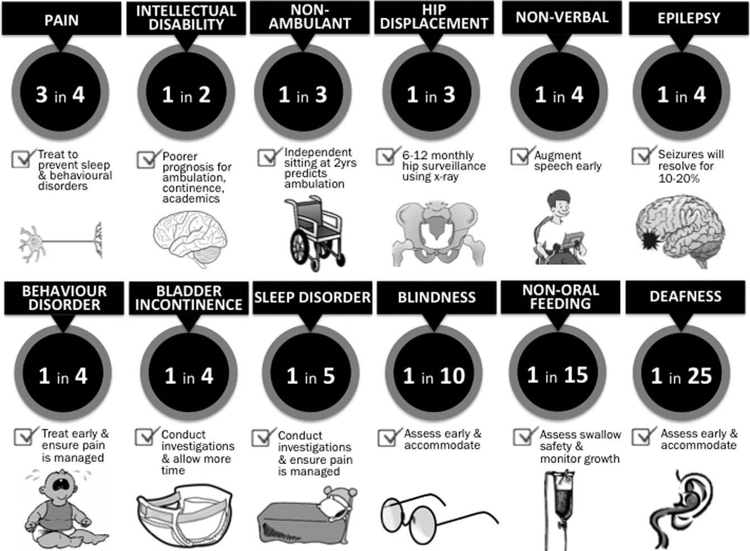
Figure 3. The comorbidities of cerebral palsy and evidence-based management.³⁶
Every child with cerebral palsy is different and every intervention plan and each child’s outcome will be unique. Long-term outcomes are influenced by the severity of the child’s physical disability, the type and topography of motor impairment, the presence of comorbidities, the well-being of the family and home environment, the intensity of therapy, and age of onset
of therapy.6,27,28,36,44
Key contemporary evidence-based principles that must be considered when counseling parents and guiding shared decision making about appropriate intervention options and expected outcomes include the following.
Consideration of motor potential. Ninety percent of the gross motor maximal capacity of a child with cerebral palsy is reached by 5 years of age, and even earlier at 3.5 years for children with the most severe cerebral palsy.⁴⁶ Parents benefit from counseling to help them understand that after 90% of their child’s gross motor potential is reached, small but not large physical gains will be possible. This difficult news helps parents gain a realistic understanding of what is possible from intervention and provides guidance about when is a good time to switch primarily to a ‘‘Compensatory and Environmental Adaptation Approach’’ rather than doubting if compensation constitutes ‘‘giving up on their child.’’ Embracing this knowledge can help the whole team not to overly focus on physical abilities at the expense of communication, social, and academic skill development, which is a common criticism of adults with cerebral palsy. This shift in rehabilitation focus can be positively reframed as one of supporting and advocating for the child’s full inclusion within society.
Use of a goal-based approach. Rehabilitation services framed by the child and family’s goals are considered best practice and reflect the substantial psychological evidence base about goal-based motivational learning. Above all, because intensive practice of tasks that are meaningful and considered necessary by the child and family are more enjoyable and more effective from a neuroplasticity perspective.⁴⁴
Intervention’s capacity. Having a clear knowledge of the intervention’s purpose as understood through the lens of the

Recommended Cerebral Palsy Interventions Descriptions, Based on Best Available Evidence.^{1,33}

Intervention Options

Behavior
Prognosis: 1 in 4 children with cerebral palsy has a behavior disorder and mental health problems also are more prevalent and can go unrecognized.
Behavior therapy:
Positive behavior support, behavioral interventions, and positive parenting are compensatory and environmental approaches that involve carers’ changing their interaction style with the child to promote positive adaptive behaviors in the child.
Cognitive behavior therapy:
Cognitive-behavioral therapy is a child-active approach that involves identifying unhelpful thoughts and behaviors and teaching cognitive restructuring and self-management of constructive thinking and actions. Bone Density
Prognosis: Previous fracture is the biggest predictor of fracture.
Assistive technology—standing frames:
Specialist equipment to passively hold the child in an upright standing position as a compensatory and environmental approach for children unable to stand independently. The purpose of this intervention varies and can include promoting bone density through weight bearing, promoting hip development through weight bearing, enabling greater participation at eye level, and promoting regular bowel emptying.
Bisphosphonates:
Bisphosphonate medication is a health and secondary prevention approach to suppress bone reabsorption to treat osteoporosis.
Vitamin D [þ/– calcium or growth hormones]:
Dietary vitamin D supplement for bone density is a health and secondary prevention approach.
Communication
Prognosis: 1 in 4 children with cerebral palsy cannot talk. Communicative frustration can cause behavioral disorders.
Alternative and augmentative communication:
Alternative and augmentative communication is a compensatory and environmental approach where alternative communication methods, eg, communication symbol board or electronic speech output devices, are used to compensate for, or augment limited or lack of verbal speech.
Communication partner training:
Communication partner training is a compensatory and environmental approach, where communication partners (eg, parent) are taught how to modify their communication style to promote the child’s active communication. Specific techniques include Interaction Training, Hanen, or It Takes Two to Talk.
Contracture Management
Prognosis: 4 in 5 children with cerebral palsy have contracture. Children with muscle spasticity are most at risk.
Ankle-foot orthoses:
Ankle-foot orthoses are a health and secondary prevention approach where a removable external device is worn over the ankle and foot designed to prevent or manage ankle contractures.
Casting:
Casting is a health and secondary prevention approach, where plaster casts are applied to limbs in a stretched position to induce muscle lengthening. The amount of lengthening possible is substantially less than in a surgical approach and is best used in new contractures.
Hand splint/orthotics:
Immobilization hand splinting is a health and secondary prevention approach that uses custom-molded thermoplastic or neoprene hand orthotics designed to hold the hand in a position of stretch to prevent or manage contractures.
Hand surgery:
Hand surgery is a health and secondary prevention approach involving surgical prevention or correction of musculoskeletal deformities, eg, muscle lengthening and tendon transfer.
Orthopedic surgery:
Orthopedic surgery is a health and secondary prevention approach involving surgical prevention or correction of musculoskeletal deformities, eg, muscle lengthening, osteotomies.
Single-event multilevel surgery:
Single-event multilevel surgery is a specific orthopedic surgery for a health and secondary prevention approach where a series of simultaneous orthopedic procedures are carried out to manage contractures, optimize skeletal alignment, and prevent ambulation deterioration or postural deterioration secondary to musculoskeletal deformities. The advantage of this surgical approach is that multiple surgeries are avoided and outcomes are superior. Gait and/or Gross Motor
Prognosis: All children with cerebral palsy by definition will have gross motor function difficulties. 1 in 3 children with cerebral cannot walk.
Ankle-foot orthoses:
Ankle-foot orthoses are a health and secondary prevention approach where a removable external device is worn over the ankle and foot designed to prevent or manage ankle contractures as well as promote gait stride length in ambulant children.
Assistive technology—walking aids:
Walking aids, frames, and sticks to promote independent mobility. This type of assistive technology is a compensatory and environmental approach for children unable to independently ambulate.

(continued)
Early intervention:
Early intervention is very variable. Contemporaneous early intervention is a child-active repetitive and structured practice of gross motor, hand function, and learning tasks. On the other hand, traditional early intervention involved general early learning stimulation or child-passive interventions where the therapist passively facilitated normalized movement patterns with the aim of inducing an upstream benefit to functional activities—traditional early intervention approaches are no longer recommended based on current neuroscience evidence.
Goal-directed training/functional training:
Goal-directed training is child-active repetitive and structured practice in walking or gross motor tasks (eg, bike riding) designed to meet a goal meaningful to the child. In goal-directed training, the tasks and the environment are also changed to promote skill acquisition.
Hippotherapy:
Therapeutic horseback riding. Hippotherapy is child-active if the child is riding the horse, but is child-passive if the child is being led and it is assumed the horse’s movement simulates and automatically transfers to the pelvic tilt required during walking. For nonambulant children, sometimes the goal of hippotherapy is to promote postural control for supported sitting.
Hydrotherapy:
Therapeutic activities in heated water, where the water provides weightlessness for ease of movement but also resistance for muscle strengthening. Hydrotherapy is child-active if the child is swimming or actively doing the movements, but is child-passive if the child is being passively moved by an adult, eg, stretched.
Physical therapy after single event multilevel surgery:
Single-event multilevel surgery is a series of simultaneous orthopedic procedures to optimize skeletal alignment and prevent ambulation deterioration secondary to musculoskeletal deformities. Child-active physical therapy is recommended for the first year after surgery to enable children to initially return to their presurgical gait level and hopefully surpass their presurgical gait level.
Robotic training:
Robotic training is gait training in robotic device that delivers high-dose, high-repetition walking practice. Robotic training is child-active if the child is actively stepping and at variable speeds and resistances, but is child-passive if the child is overly supported and the robot is initiating and completing the stepping response. Nonambulant children are sometimes given the life experience of gait using a robotic training device, even though independent ambulation is not thought to be achievable.
Treadmill training:
Ambulation training and stepping training in an upright position on a treadmill. Treadmill training is child-active if the child is actively stepping and at variable speeds and resistances, but is child-passive if the child is overly supported and the device is initiating and completing the stepping response.
Virtual reality:
Virtual reality is the use of software and/or robotics to enable high-dose, repetitive, child-active structured training in gross motor function.
Fitness
Prognosis: All children with cerebral palsy are at risk of lower fitness because of their physical disability; however, sedentary children and children with more severe physical disability have the highest risk for poor fitness. Fitness training:
Fitness training is aerobic activities at sufficient intensity to improve or maintain levels of physical fitness as health and secondary prevention approach. Achieving enough movement to attain sufficient aerobic intensity for fitness is often not possible in children with more severe physical disability, and alternatives are currently being researched.⁴⁵
Functional Skills Performance / Independence in Self-Care
Prognosis: All children with cerebral palsy will have some difficulty with functional independence.
Context-focused therapy:
Context-focused therapy is a compensatory and environmental approach where the task or the environment is changed (but not the child) to promote successful task performance.
Goal-directed training / functional training:
Goal-directed training is child-active repetitive and structured training in self-care tasks, eg, dressing, designed to meet a goal meaningful to the child. In goal-directed training, the tasks and the environment are also changed to promote skill acquisition. It can be delivered via a home program.
Home programs:
Evidence-based home programs are child-active repetitive and structured home-based practice of functional tasks meaningful to the child and family.
Hand Function
Prognosis: 3 in 4 children with cerebral palsy have difficulties with hand function. Assistive technology:
Assistive technology is a compensatory and environmental approach where alternatives to handwriting and alternative computer access is achieved via switches, alternate keyboards, or key guards.
Bimanual training:
Bimanual training is child-active repetitive, structured training in using 2 hands together, for children with hemiplegia. The approach is equally effective as constraint-induced movement therapy. A dose of 30-60 h of therapy within a 6-8-wk period is needed to be effective.
Biofeedback:
Biofeedback is electronic feedback about muscle activity to teach voluntary muscle control and is therefore a child-active approach.

(continued)
Constraint-induced movement therapy:
Constraint-induced movement therapy is child-active repetitive, structure training in the use of the hemiplegic upper limb by constraining the dominant hand. The approach is equally effective as Bimanual Training. A dose of 30-60 h of therapy within a 6-8-wk period is needed to be effective.
Goal-directed training / functional training:
Goal-directed training is child-active repetitive and structured training in hand function tasks, eg, typing, designed to meet a goal meaningful to the child. In goal-directed training, the tasks and the environment are also changed to promote skill acquisition. Can be delivered via a home program.
Hand splint / orthotics:
Functional hand splinting is a compensatory and environmental approach, where custom-molded thermoplastic or neoprene hand orthotics designed to reposition the hand for better hand function.
Occupational therapy after botulinum toxin:
Occupational therapy involving child-active practice of hand function and functional tasks (chosen by the child as important) after botulinum toxin to reduce muscle spasticity augments the effect of botulinum toxin alone.
Virtual reality:
Virtual reality is the use of software and/or robotics to enable high-dose, repetitive, child-active structured training in hand function and upper limb use.
Hip Dislocation Prevention
Prognosis: 1 in 3 children with cerebral palsy has hip displacement, and children with bilateral involvement and who are nonambulant are most at risk for hip dislocation.
Hip surveillance:
Active hip surveillance and treatment for hip joint integrity to prevent hip dislocation is a health and secondary prevention approach. The treatments can include a combination of orthopedic surgery, botulinum toxin, selective dorsal rhizotomy, and physical therapy. Management and oversight of the hips by an orthopedic surgeon is recommended.
Muscle Strengthening
Prognosis: All children with cerebral palsy are at risk of muscle weakness due to tonal abnormalities.
Electrical stimulation [neuromuscular/functional electrical stimulation]:
A health and secondary prevention approach that uses electrical stimulation of a muscle through a skin electrode to induce passive muscle contractions to enable muscle strengthening or motor activation. Strength training [resistance]:
Strength training involves the use of progressively more challenging resistance to muscular contraction to build muscle strength and anaerobic endurance and is a health and secondary prevention approach.
Nutrition, Reflux Management, and Swallowing Safety
Prognosis: 1 in 15 children with cerebral palsy requires non-oral feeding. Aspiration pneumonia is the leading cause of death in cerebral palsy.
Dysphagia management:
Dysphagia management is a health and secondary prevention approach for promoting safe swallowing by changing food textures, sitting position, oral motor skills, and using oral appliances and equipment.
Fundoplication [including Nissen and laparoscopic; gastric plication]:
Fundoplication is a health and secondary prevention approach using a surgical procedure to strengthen the barrier to acid reflux, eg, by wrapping the fundus around the esophagus. Gastrostomy:
Gastrostomy is the surgical placement of a non-oral feeding tube to prevent or reverse growth failure, or prevent aspiration pneumonia, eg, percutaneous endoscopic gastrostomy (PEG), jejunostomy, and is a health and secondary prevention approach.
Seated Mobility
Prognosis: 1 in 3 children with cerebral cannot walk and will require wheeled mobility.
Assistive technology—wheelchairs:
Wheelchairs (manual and power) to promote independent mobility. This type of assistive technology is a compensatory and environmental approach for children unable to independently ambulate. Pressure care:
Pressure care is a health and secondary prevention approach to prevent pressure ulcers via good positioning, repositioning, and provision of suitable support surfaces.
Seating:
The provision of customized positioning supports in a seat to promote an upright sitting posture for wheeled mobility and participation.
Spasticity Management
Prognosis: 3 in 4 children with cerebral palsy have spasticity, which can interfere with function, cause pain and contractures.
Baclofen [oral]:
Baclofen is an oral medication used as a health and secondary prevention approach for managing global spasticity and dystonia. In the oral format, the doses need to be high to induce a clinical effect, but this has to be balanced against the side effect of drowsiness.

(continued)
Botulinum toxin:
Botulinum toxin is a health and secondary prevention approach, which is a drug injected into overactive spastic muscles to block local spasticity. The drug is also used to manage local dystonia.
Diazepam:
Diazepam is an oral medication used as a health and secondary prevention approach for managing global spasticity.
Intrathecal baclofen:
Intrathecal baclofen is a health and secondary prevention approach for managing global severe spasticity and dystonia. Baclofen is delivered directly to the spine (and central nervous system) via a pump surgically implanted within the abdomen.
Selective dorsal rhizotomy:
Selective dorsal rhizotomy is a health and secondary prevention approach where a neurosurgical procedure is used to selectively sever nerve roots in the spinal cord, to relieve spasticity. The procedure is only effective for children with pure spastic diplegia and good presurgical muscle strength and control. The approach can worsen ambulation in children not meeting these strict inclusion criteria.

International Classification of Functioning, Disability and Health (ICF)^{46,47} is essential to predicting outcomes. Many rehabilitation providers and families hope, claim and expect that physical improvements at the ‘‘body structures and functions’’ level of the International Classification of Functioning will translate to upstream benefits in task ‘‘activities’’ performance and social ‘‘participation.’’ Rehabilitation for children with cerebral palsy is not a ‘‘fix’’ but rather should focus on developing function.⁴⁸ Recent systematic review evidence indicated that effective body structures and functions interventions lead to clinically meaningful body structures and function gains but these gains unfortunately do not yet for the most part transfer upstream to improved outcomes in activities and participation performance.¹ Also, on the contrary, effective activities interventions result in clinically meaningful gains at the activities level of the International Classification of Functioning, but these gains do not yet translate downstream to better body structures and functions, nor upstream to better life participation.¹ Therefore, if a body structures and function outcome is desired, the intervention must be selected from the suite of evidence-based body structures and function interventions. Conversely, if an activitieslevel outcome is sought, child-active learning-based interventions acting at the activities-level must be applied.¹ In clinical practice, this means professionals must clearly understand what intervention gain is desired by the child and family, and it’s corresponding level of the International Classification of Functioning, and then must choose interventions operating from the same level of the International Classification of Functioning.

Conclusion
Cerebral palsy is now the subject of much research focus, and evidence-based care for this population, is continually and rapidly changing. Thus, it is important that decision making is guided by up-to-date evidence sources. This article provides an overview of the most up-to-date diagnostic practices and intervention options based on best available evidence, using knowledge translation techniques.
Effective rehabilitation interventions include childactive learning-based interventions for motor and functional skill performance gains (eg, bimanual therapy, constraint-induced movement therapy, goal-directed training, home programs, occupational therapy after botulinum toxin); pharmacologic, orthopedic, and therapy interventions for promoting health and secondary prevention (eg, bisphosphonates, botulinum toxin, casting, diazepam, fitness training, active hip surveillance); and for promoting function compensatory and environmental interventions (eg, context-focused therapy).
The future for cerebral palsy is bright, with the possibility of more breakthroughs from currently registered clinical trials: (1) neuroprotective and neuroregenerative agents including, erythropoietin, magnesium sulfate in older preterm infants, melatonin, stem cells, and xenon and (2) neurorehabilitation advances, including very early constraint-induced movement therapy, very early motor enrichment, repetitive transcranial magnetic imaging (TMS), robotics, and web-cam motor training. Parents and cerebral palsy specialists invite and welcome the expertise of neurologists to this progressive and rapidly changing field.
Key Take-Home Messages
Evidence-based care for cerebral palsy is rapidly changing, and thus decision making must be guided by up-todate evidence sources.
This article provides an overview of the most up-to-date diagnostic practices and intervention options based on best available evidence.
The future for cerebral palsy is bright, with the possibility of more breakthroughs from currently registered clinical trials, and neurology collaborators are urgently needed.

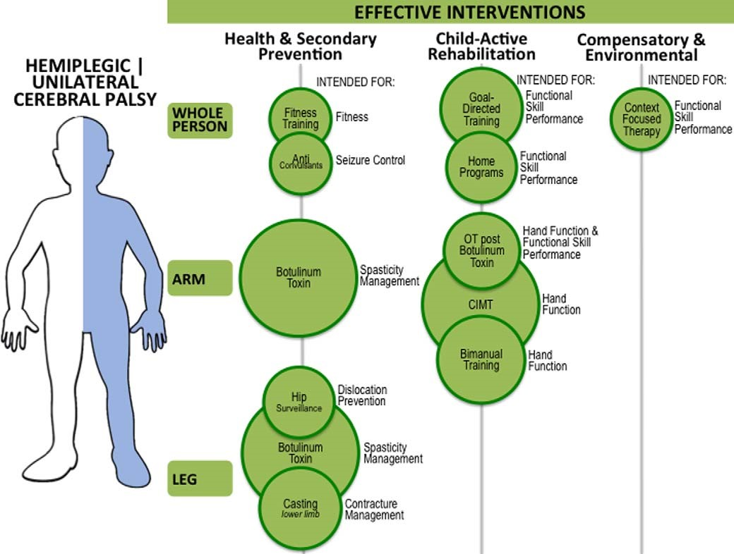
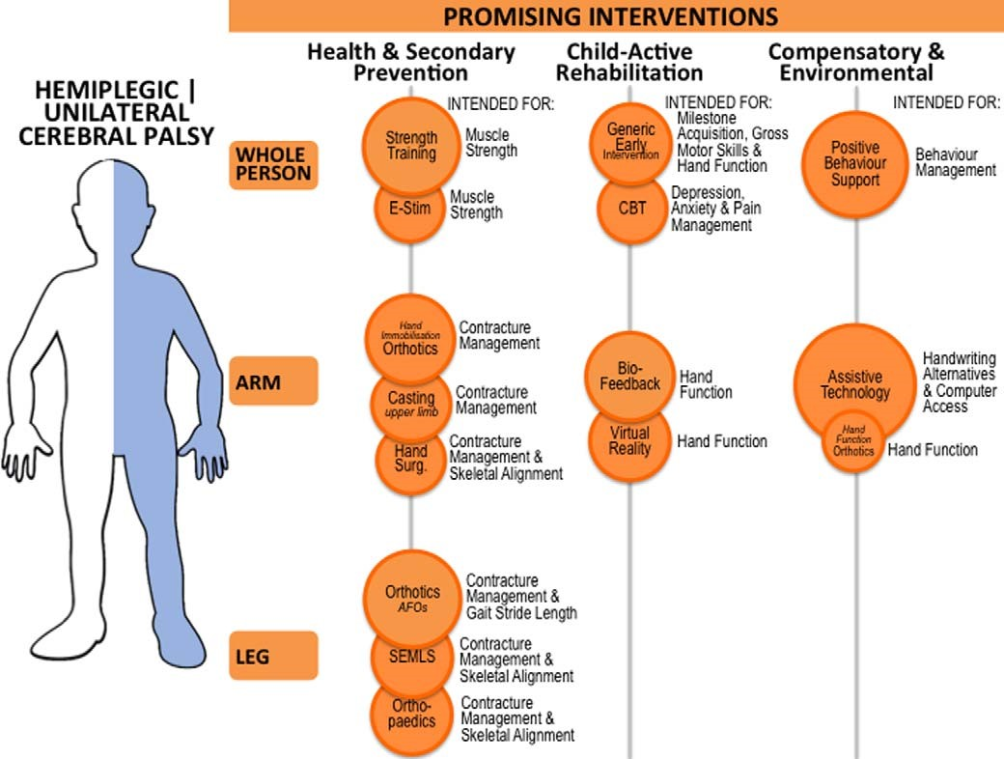
Figure 4. Evidence-based intervention for cerebral palsy by topography.
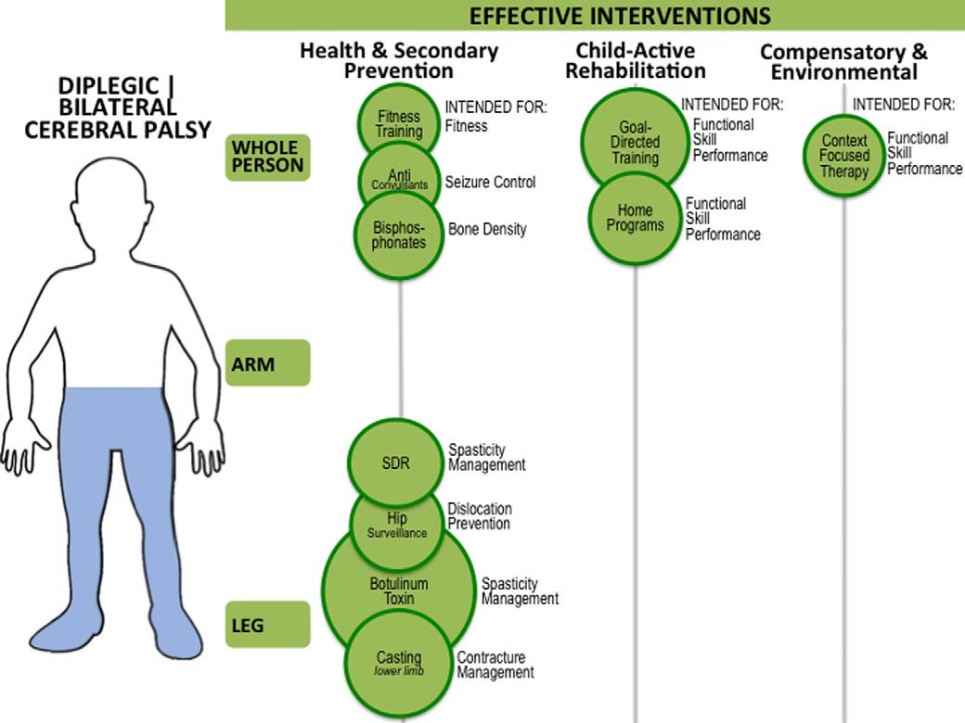
Figure 4.
Continued
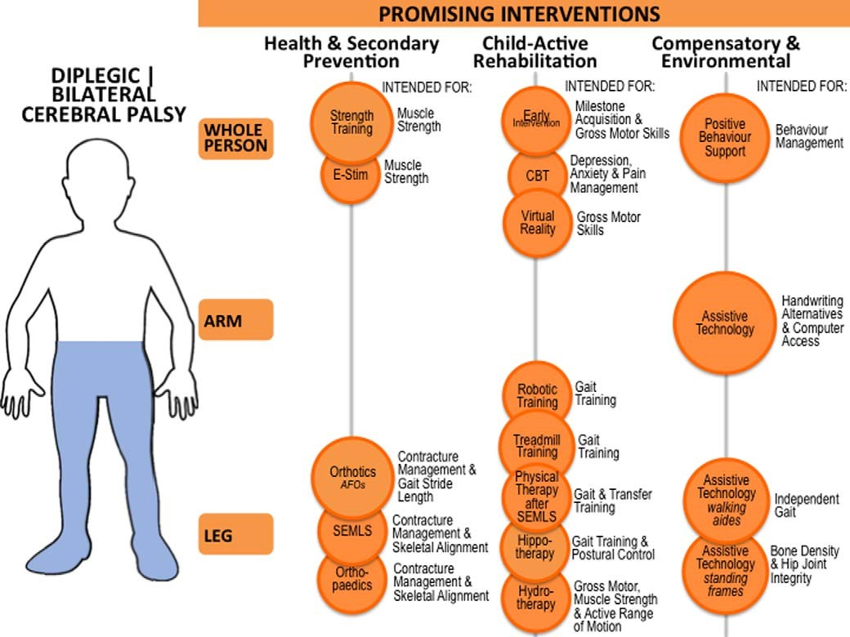
Figure 4. Continued
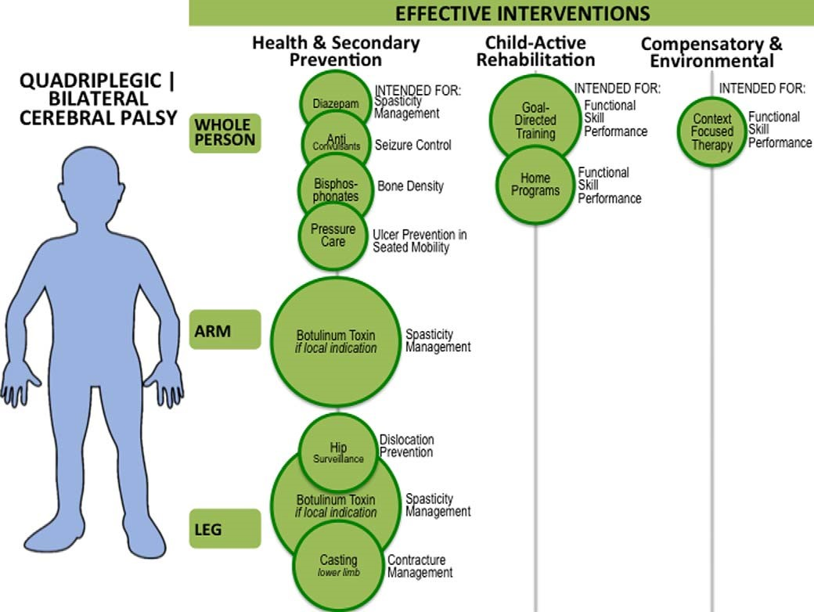
Figure 4.
Continued
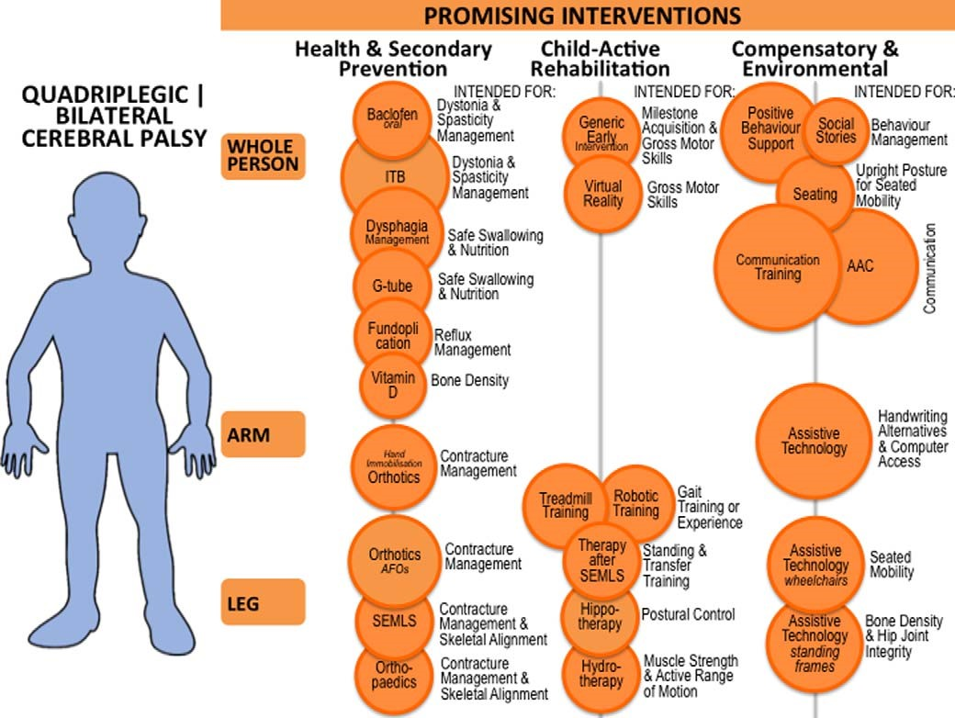
Figure 4. Continued

Acknowledgments
I would like to especially thank the parents from Reaching for the Stars and Cerebral Palsy Alliance that participated in this survey. Without your contributions, this article would not have been possible.
Declaration of Conflicting Interests
The author declared no potential conflicts of interest with respect to the research, authorship, and/or publication of this article.
Funding
The author received no financial support for the research, authorship, and/or publication of this article.
Ethical Approval
This review article did not require specific ethics approval.
References
- Novak I, McIntyre S, Morgan C, et al. State of the evidence: systematic review of interventions for children with cerebral palsy. Dev Med Child Neurol. 2013;55:885-910.
- Damiano D. Effects of motor activity on brain and muscle development in cerebral palsy. In: Shepherd RB, ed. Cerebral Palsy in Infancy: Targeted Activity to Optimize Early Growth and Development. Edinburgh: Elsevier Health Sciences; 2013:189-198.
- Rodger S, Brown GT, Brown A. Profile of paediatric occupationaltherapy practice in Australia. Aust Occup Ther J. 2005;52:311-325.
- Saleh M, Korner-Bitensky N, Snider L, et al. Actual vs. best practices for young children with cerebral palsy: a survey of paediatric occupational therapists and physical therapists in Quebec, Canada. Dev Neurorehabil. 2008;11:60-80.
- Flores-Mateo G, Argimon JM. Evidence based practice in postgraduate healthcare education: a systematic review. BMC Health Serv Res. 2007;7:119.
- Morgan C, Novak I, Badawi N. Enriched environments and motoroutcomes in cerebral palsy: systematic review and meta-analysis. Pediatrics. 2013;132:e735-e746.
- Stevenson RD. Research and practice in childhood disability:
what comes next? Dev Med Child Neurol. 2013;55:876-876.
- DavisD,DavisME,JadadA,etal.Thecaseforknowledgetranslation:
shorteningthejourneyfromevidencetoeffect.BMJ.2003;327:33-35.
- Rajic´ A, Young I, McEwen SA. Improving the utilization of research knowledge in agri-food public health: a mixed-method review of knowledge translation and transfer. Foodborne Pathog Dis. 2013;10:397-412.
- Menon A, Korner-Bitensky N, Kastner M, et al. Strategies forrehabilitation professionals to move evidence-based knowledge into practice. J Rehabil Med. 2009;41:1024-1032.
- Novak I, Russell D, Ketelaar M. Can translation of research information improve outcomes? In: Ronen GM, Rosenbaum PL, eds. Life Quality Outcomes in Young People With Neurological and Developmental Conditions. London: MacKeith Press; 2013: 265-281.
- Graham ID, Logan J, Harrison MB, et al. Lost in knowledge translation: time for a map? J Contin Educ Health Prof. 2006;26:
13-24.
- Michie S, Johnston M. Changing clinical behaviour by makingguidelines specific. BMJ. 2004;328:343.
- McIntyre S, Morgan C, Walker K, et al. Cerebral palsy—Don’tdelay. Dev Dis Res Rev. 2013;17:114-129.
- Baird G, McConachie H, Scrutton D. Parents’ perceptions of disclosure of the diagnosis of cerebral palsy. Arch Dis Child. 2000; 83:475-480.
- Shepherd R. Cerebral Palsy in Infancy: Targeted Activity to Optimize Early Growth and Development. Edinburgh: Elsevier Health Sciences; 2013.
- Ashwal S, Russman BS, Blasco PA, et al. Practice parameter: diagnostic assessment of the child with cerebral palsy. Report of the Quality Standards Subcommittee of the American Academy of Neurology and the Practice Committee of the Child Neurology Society. Neurology. 2004;62:851-863.
- Bosanquet M, Copeland L, Ware R, et al. A systematic review oftests to predict cerebral palsy in young children. Dev Med Child Neurol. 2013;55:418-426.
- Maitre NL, Slaughter JC, Aschner JL. Early prediction of cerebralpalsy after neonatal intensive care using motor development trajectories in infancy. Early Hum Dev. 2013;89:781-786.
- Pizzardi A, Romeo DMM, Cioni M, et al. Infant neurologicalexamination from 3 to 12 months: predictive value of the single items. Neuropediatrics. 2008;39:344-346.
- Romeo DMM, Cioni M, Scoto M, et al. Neuromotor developmentin infants with cerebral palsy investigated by the Hammersmith Infant Neurological Examination during the first year of age. Eur J Paediatr Neurol. 2008;12:24-31.
- Towsley K, Shevell MI, Dagenais L. Population-based study ofneuroimaging findings in children with cerebral palsy. Eur J Paediatr Neurol. 2011;15:29-35.
- Kuban KC, Leviton A. Cerebral palsy. N Engl J Med. 1994;330: 188-195.
- Spittle A, Brown N, Doyle L, et al. Quality of General Movements is related to white matter pathology in very preterm infants. Pediatrics. 2008;121:e1184-e1189.
- Ha¨gglund G, Andersson S, Du¨ppe H, et al. Prevention of dislocation of the hip in children with cerebral palsy: the first ten years of a population-based prevention programme. J Bone Joint Surg Br. 2005;87:95-101.
- Rosenbaum P, Paneth N, Leviton A, et al. A report: the definitionand classification of cerebral palsy April 2006. Dev Med Child Neurol Suppl. 2007;109:8-14.
- Palisano R, Rosenbaum P, Walter S, et al. Development and reliability of a system to classify gross motor function in children with cerebral palsy. Dev Med Child Neurol. 1997;39:214-223.
- Shevell MI, Dagenais L, Hall N. The relationship of cerebralpalsy subtype and functional motor impairment: a populationbased study. Dev Med Child Neurol. 2009;51:872-877.
- Rosenbaum P, Gorter JW, Palisano R, et al. The relationship of cerebral palsy subtype and functional motor impairment: a populationbased study. Dev Med Child Neurol. 2010;52:682-683.
- ACPR Group. Australian Cerebral Palsy Register Report 2013. Sydney: Cerebral Palsy Alliance; 2013.
- Access Economics. The economic impact of cerebral palsy in Australia in 2007. Canberra: Access Economics; 2008.
- Blair E, Watson L, Badawi N, et al. Life expectancy among people with cerebral palsy in Western Australia. Dev Med Child Neurol. 2001;43:508-515.
- Westbom L, Bergstrand L, Wagner P, et al. Survival at 19 years ofage in a total population of children and young people with cerebral palsy. Dev Med Child Neurol. 2011;53:808-814.
- Novak I, Hines M, Goldsmith S, et al. Clinical prognostic messages from a systematic review on cerebral palsy. Pediatrics. 2012;130:e1285-e1312.
- Gorter JW, Ketelaar M, Rosenbaum P, et al. Use of the GMFCS ininfants with CP: the need for reclassification at age 2 years or older. Dev Med Child Neurol. 2008;51:46-52.
- Hanna SE, Rosenbaum PL, Bartlett DJ, et al. Stability and declinein gross motor function among children and youth with cerebral palsy aged 2 to 21 years. Dev Med Child Neurol. 2009;51:
295-302.
- van Haastert IC, de Vries LS, Eijsermans MJ, et al. Gross motorfunctional abilities in preterm-born children with cerebral palsy due to periventricular leukomalacia. Dev Med Child Neurol. 2008;50:684-689.
- Himmelmann K, Uvebrant P. Function and neuroimaging in cerebral palsy: a population-based study. Dev Med Child Neurol. 2010;53:516-521.
- Lemes LC, Barbosa MAM. Telling the mother that her newbornhas a disability. Acta Paulista de Enfermagem. 2007;20:441-445.
- Kliem JA. Principles of experience-dependent neural plasticity: implications for rehabilitation after brain damage. J Speech Lang Hearing Research. 2008;51: S225-S239.
- Wittenberg GF. Neural plasticity and treatment across the lifespanfor motor deficits in cerebral palsy. Dev Med Child Neurol. 2009; 51(suppl 4):130-133.
- Guyatt G, Oxman AD, Akl EA, et al. GRADE guidelines: 1. Introduction—GRADE evidence profiles and summary of findings tables. J Clin Epidemiol. 2011;64:383-394.
- Novak I, McIntyre S. The effect of Education with workplacesupports on practitioners’ evidence-based practice knowledge and implementation behaviours. Aust Occup Ther J. 2010;57: 386-393.
- Sakzewski L, Ziviani J, Boyd R. Efficacy of upper limb therapiesfor children with unilateral cerebral palsy: systematic review and meta-analysis update. Pediatrics. In press.
- Verschuren O, Darrah J, Novak I, et al. Health enhancing physicalactivity in children with cerebral palsy: more of the same is not enough. Phys Ther. 2013;94:1-9.
- Rosenbaum PL, Walter SD, Hanna SE, et al. Prognosis for grossmotor function in cerebral palsy. JAMA. 2002;288:1357-1363.
- World Health Organisation (WHO). International Classification of Functioning, Disability and Health. Geneva: WHO; 2001.
- Rosenbaum P,GorterJW. The ‘‘F-Words’’ inChildhood Disability: I Swear This Is How We Should Think! Child. 2012;38:457-463.

Cerebral Palsy Alliance, University of Notre Dame, Australia Corresponding Author: Iona Novak, PhD, MSc (Hons), BAppSc OT, Cerebral Palsy Alliance, University of Notre Dame, PO Box 184, Brookvale, NSW 2100, Australia. Email: inovak@cerebralpalsy.org.au

