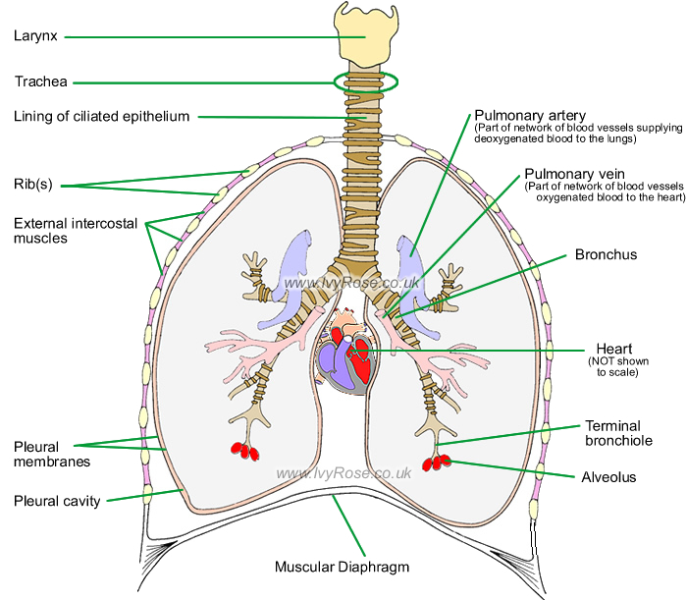
Source: https://www.google.com/search?q=internal+organs+of+the+cat+Harvard&client=firefox-b-ab&tbm=isch&tbo=u&source=univ&sa=X&ved=2ahUKEwjd1d2s1Z3eAhXRblAKHQACDPAQsAR6BAgFEAE&biw=1352&bih=654#imgdii=LIKd88xqUVAtSM:&imgrc=ewKplakasYDLDM:

