http://designresearchtechniques.com/casestudies/semi-structured-interviews/

Semi-Structured Interviews

[Design](http://designresearchtechniques.com/casestudies/category/design/), [Discover](http://designresearchtechniques.com/casestudies/category/discover/)3 min read[Dee Balkissoon](http://designresearchtechniques.com/casestudies/author/dee/)

**Authour**: Ben McCammon  
Edited by Christine Keene

**Problem**

Identification of insights into an issue from the perspective of participants or end-users.

**Solution**

Semi-structured Interviews are used to gather focused, qualitative textual data. This method offers a balance between the flexibility of an open-ended interview and the focus of a structured ethnographic survey.

**Use When**

This method is used during both the early and late stages of exploring the research domain

**Use For**

Clarifying the research domain or the specific research question. This method can uncover rich descriptive data on the personal experiences of participants. Information gathered during semi-structured interviews can move the innovation process from general topics (domains) to more specific insights (factors and variables). It can be used to develop a preliminary hypothesis, explain relationships and create a foundation for further research.

**Process**

1) **Develop questions**

Here are some guidelines for question development:

* **Style**: Use open-ended questions to get lengthy and descriptive answers rather than close-ended questions (those that can be answered with “yes” or “no”).
* **Biases**: Avoid leading questions.
* **Language**: Use terms that participants can understand, given their knowledge, language skills, cultural background, age, gender, etc. Be mindful of the social or cultural contexts of your questions.
* **Concise**: Keep the questions as short and specific as possible. Avoid asking two-in-one questions, such as, “Do you travel by car and by bike?”
* **Frame**:  Avoid questions with a strong positive or negative association. Avoid phrasing questions as negatives (e.g., “How don’t you like to get to work?”).

2) **Materials**

**Interview guide:** Determine the order of the questions. There is some disagreement over whether it is better to start with non-sensitive, less important questions or to ask the most important questions first, in case participants tire of the interview. Either way, start with some warm-up questions to help the participant feel comfortable.

When ordering questions:

* Start with earlier events and move on to more recent events;
* Begin with simpler topics and move to those that are more complex;
* Group questions on each domain/topic together;
* Within domains, start with the most concrete issues and move to the more abstract; and
* Start with the least-sensitive questions and move to most sensitive.

**Consent forms**: Prepare and have copies ready to be signed.

**Recording devices**: Determine how information will be recorded.

3) **Demographics** – Identify participants and interviewers. Determine if individual or group interviews will be conducted.

4) **Session Structure**

* Introduce yourself, explain the research and get the participant’s consent (either written or videotaped). If any recording devices are being used, point them out to the participant and make sure they’re working.
* Ask warm-up or demographic questions first; then, using the interview guide, move on to more focused questions. Allow flexibility for dialogue.

Here are some other tips to keep in mind during the interview.

* Use probing questions to gather as much information as possible.
* Try not to interrupt participants; make a note and come back to the idea later.
* If a participant gives an answer relating to a question you have not yet asked, record the answer and avoid repeating the question later.
* Keep the conversation focused on the main domains, avoiding tangents. Time is limited, so completing the entire interview guide may not be necessary. Instead, spend time on key factors, including what the participant is interested in speaking about.
* If time permits, ask the participant if there is anything else they’d like to share. Turning off the recording device before asking this question may lead to a different response.

5) **Record** – Immediately after the interview, take the time to check that the recording device was functioning properly throughout, and review your notes to fill in any gaps or add comments.

6) **Analysis** – Review interview responses and observational data for insights and patterns. A computer database, such as Ethnograph or others, may be used to analyze patterns and relationships.

7) **Report** – The research can either end at this point with a report on the data analysis, or it can be used to build out an ethnographic survey or other qualitative or quantitative research methods.

**Examples:**

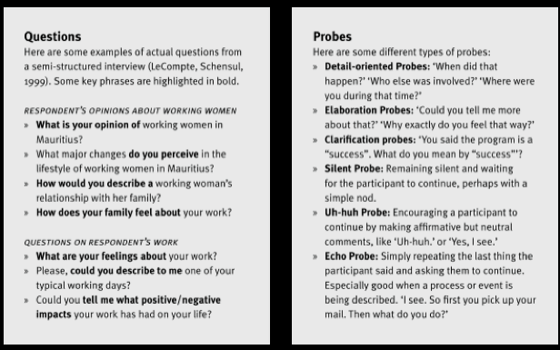

**Variations**

This is a method that can be adapted to many different contexts: academic, cultural, corporate, design, etc. The context of use will determine the domains chosen, the hypothesis tested, and the types of questions asked. Semistructured interviews can also be conducted as group interviews.

**References**

Bernard, R. (2000). Social Research Methods: Qualitative and Quantitative Approaches. Thousand Oaks, CA: Sage publications.

leCompte, M., & Schensul, J. (1999). Essential Ethnographic Methods (vol. 2): Ethnographers Toolkit. New York, NY: Altamira press.

RECOUP: Research Consortium on Educational Outcomes & Poverty. (2008). Prompts, Probes and Encouragement. Retrieved from<http://manual.recoup.educ.cam.ac.uk/wiki/index.php/Semi-structured_interviews/prompts_and_probes/handout>

Zorn, T. (2010). Designing and Conducting Semi-Structured Interviews for research. Retrieved from <http://wms-soros.mngt.waikato.ac.nz/NR/rdonlyres/em25kkojrnxofpq3j7avsnl46vkmera63kk2s6nd5ey2pypoxs32ne7dykntjde4u2qhffhpol6bzi/Interviewguidelines.pdf>

**About this site**

This compilation of concise descriptions of research methods and techniques, accompanied by references for further reading, is intended to support research teams as they incorporate various multidisciplinary research methods and techniques.

The starting points for this review were texts recommended by faculty, followed by searches for academic journals via google scholar. Content was primarily inspired by ethnography, psychology, and human-computer interaction. While there are numerous methods and techniques listed, the review is by no means exhaustive and is intended to continually evolve