University of Thessaly – School of Veterinary Science – 2018-2019 – Instructor: Dr. Anastasia-Marina G.P. Tsoutsoulopoulou
________________________________________________________________________________________________
VETERINARY SCIENCE BOOKS
Suggestions for further reading

www.amazon.uk > veterinary science books >
- https://www.amazon.co.uk/Introduction-Veterinary-Anatomy-Physiology-Textbook/dp/0702057355/ref=sr_1_cc_2?s=aps&ie=UTF8&qid=1539413796&sr=1-2-catcorr&keywords=Veterinary+Science+books#reader_0702057355
Authors: Victoria Aspinall & Melanie Cappello (3rd edition):
Introduction to Veterinary Anatomy & Physiology Textbook (2015) Elsevier Ltd. First published, 2004
ISBN: 978-0-7020-5735-9

Click on: The image of the book, and then on:
Contents (see the book/part of it).
[You can enlarge the image.]

Paperback
£25.63

43 used & new from £23.00

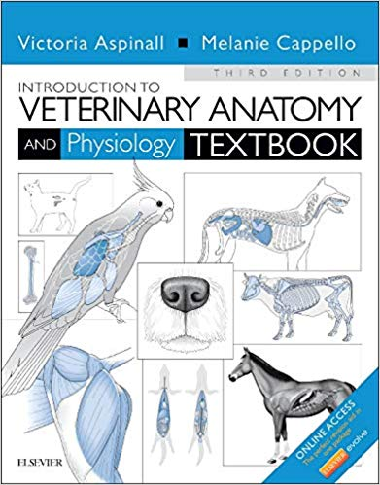

- https://www.amazon.co.uk/Introduction-Veterinary-Anatomy-Physiology-Workbook/dp/0702052329/ref=pd_sim_14_1?_encoding=UTF8&pd_rd_i=0702052329&pd_rd_r=38446937-ceb5-11e8-99e0-63ec986ade82&pd_rd_w=fYx5e&pd_rd_wg=ZG8xo&pf_rd_i=desktop-dp-sims&pf_rd_m=A3P5ROKL5A1OLE&pf_rd_p=1e3b4162-429b-4ea8-80b8-75d978d3d89e&pf_rd_r=PXCTX0H3FRHNS2AJCMZB&pf_rd_s=desktop-dp-sims&pf_rd_t=40701&psc=1&refRID=PXCTX0H3FRHNS2AJCMZB

Author: Sally J. Bowden
Introduction to Veterinary Anatomy and Physiology Workbook (Paperback) – Student Edition, [17 May 2012]
- 4.6 out of 5 stars 31 customer reviews
- Paperback
£20.46 10 Used from £20.65 30 New from £19.13
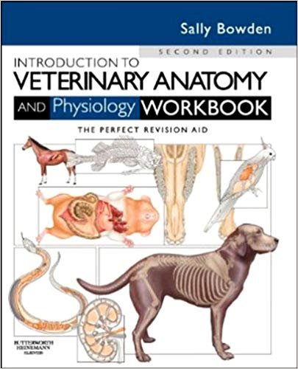
To see part of the book:
Click on: (a) the Image of the Book; (b) Contents

N.B.:
CLICK ON:
PROMOTION MESSAGE (PRIME STUDENTS GET 10% OFF THE PRICE). SEE MESSAGE!
- https://www.amazon.co.uk/s/ref=nb_sb_noss?url=search-alias%3Dstripbooks&field-keywords=cunningham%27s+textbook+of+veterinary+physiology

Author: James Cunningham
Cunningham's Textbook of Veterinary Physiology. (16 Jul 2012)
By: Bradley G. Klein PhD

Hardcover

£69.57Prime
Eligible for FREE UK Delivery
Only 12 left in stock - order soon.
More buying choices
£66.76 (42 used & new offers) Kindle Edition £62.87
See newer version

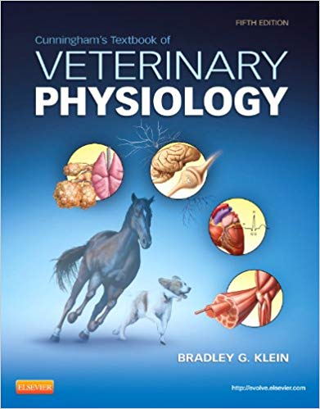
+
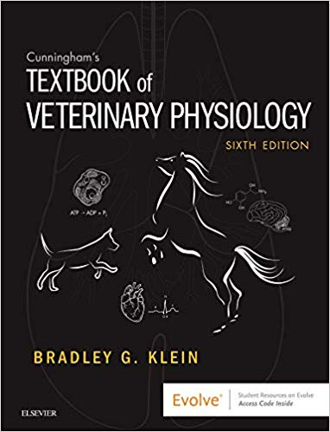

Cunningham's Textbook of Veterinary Physiology, 6e. (8 Mar 2019) Hardcover

[Newer edition to be published on 8th March 2019!!!]
by Bradley G. Klein PhD (Author)

See all formats and editions
- Hardcover
£102.00 1 New from £102.00
- This item can be delivered to Greece. Details
- Read more
Learn how to understand normal body functions before learning about the mechanisms of veterinary disease. The Textbook of Veterinary Physiology, 6th Edition approaches this vast subject in a practical, user-friendly way that helps you grasp key concepts and learn how they relate to clinical practice. From cell physiology to body system function to homeostasis and immune function, this comprehensive text provides the solid foundation needed before advancing in the veterinary curriculum.
- Expanded resources on the companion Evolve website include state-of-the-art 3D animations, practice questions, a glossary, and additional Clinical Correlations not found in the text.
- Clinical Correlations boxes present case studies that illustrate how to apply physiology principles and concepts to the diagnosis and treatment of veterinary patients.
- Practice questions at the end of each chapter test your understanding of what you have just read and provide valuable review for exams.
- Key Points at the beginning of each chapter introduce new concepts and help you prepare for exams.
- Full-color format highlights helpful information and enhances learning with a wealth of illustrations that visually depict specific functions and conditions.
- NEW! Updated animations and icons added that are relevant to content.
- NEW! New contributors lend their unique perspective and expertise to the content.

- https://www.amazon.co.uk/Pocket-British-Animal-Veterinary-Association/dp/1905319517/ref=sr_1_4?s=books&ie=UTF8&qid=1539419499&sr=1-4&keywords=Vet+Science+books
Author: Sheldon Middleton, BSAVA Pocket Book for Vets (BSAVA British Small Animal Veterinary Association) – (26 Oct 2012)
Paperback
3.0 out of 5 stars 5 customer reviews
Paperback
£23.75 12 Used from £19.61 29 New from £18.73
The BSAVA Pocketbook for Vets aims to provide the new graduate (and possibly the not so new) with a precise and quick guide to the important drugs, tests and procedures most commonly encountered in small animal practice. It pulls together information from the BSAVA Small Animal Formulary, BSAVA manuals and other sources, and is intended to be a 'quick glance' reference that can be carried in a scrub top pocket for ease of use when consulting or during ward rounds. Notes pages are provided throughout.

- https://www.amazon.co.uk/s/ref=nb_sb_noss?url=search-alias%3Dstripbooks&field-keywords=Vet+Science+books
More books to see:
- National Geographic Complete Guide to Pet Health, Behavior, and Happiness: The Veterinarian's Approach to At-Home Animal Care
2 May 2019
by Gary Weitzman and DVM
Paperback
£16.99Prime
Eligible for FREE UK Delivery
Available for pre-order

- The New Vet's Handbook: Information and Advice for Veterinary Graduates
13 Jun 2018
by Clare Tapsfield-Wright
Paperback
£20.37Prime
More buying choices
£17.77 (21 used & new offers)

- BSAVA Textbook of Veterinary Nursing (BSAVA British Small Animal Veterinary Association)
28 Oct 2011
by Barbara Cooper and Elizabeth Mullineaux
Paperback
£55.23Prime

Hardcover
£56.41 (10 used & new offers)

- http://ipokratis.gr/ipokratis/167-bsava

BSAVA Manual of Canine and Feline Ultrasonography +dvd

BSAVA Manual of Surgical Principles

BSAVA Manual of Canine and Feline Oncology, 3rd Edition

BSAVA Manual of Canine and Feline Dermatology, 3rd Edition

BSAVA Manual of Canine and Feline Neurology, (with DVD-ROM),...

BSAVA Manual of Feline Practice: A Foundation Manual

BSAVA Manual of Canine Practice: A Foundation Manual

BSAVA Manual of Canine and Feline Radiography and Radiology...

BSAVA Manual of Canine and Feline Ophthalmology 3rd Edition

BSAVA Small Animal Formulary 8th Edition

BSAVA Manual of Canine and Feline Abdominal Surgery, 2nd Edition

http://ipokratis.gr/ipokratis/147--mikra-zoa

https://www.disigma.gr/media/blfa_files/chapter_ACADEMIC_ENGLISH_FOR_BIOLOGY.pdf
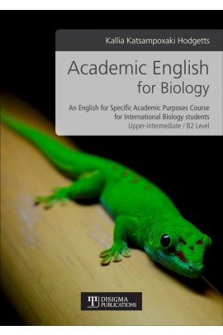

Academic English for Biology
Κατσαμποξάκη-Hodgetts Κάλλια Katsampoxaki Hodgetts Kallia
Διαθεσιμότητα: Άμεσα διαθέσιμο
Σελίδες | 272
ISBN13 | 978-618-5242-33-6
Τόπος Έκδοσης | Θεσσαλονίκη
Έτος Έκδοσης | 2018
Διαστάσεις | 21x29 cm
Εξώφυλλο | Μαλακό
Εσωτερικό βιβλίου | Έγχρωμο
Συνοδευτικό Υλικό | ΟΧΙ
Κωδικός στον Εύδοξο | 77118735

g) V.P. Studdert, C.C. Gay, D.C. Blood (editors), Saunders Comprehensive Veterinary Dictionary (4th ed.). Saunders Elsevier: Edinburgh, London, New York, et al (2012)

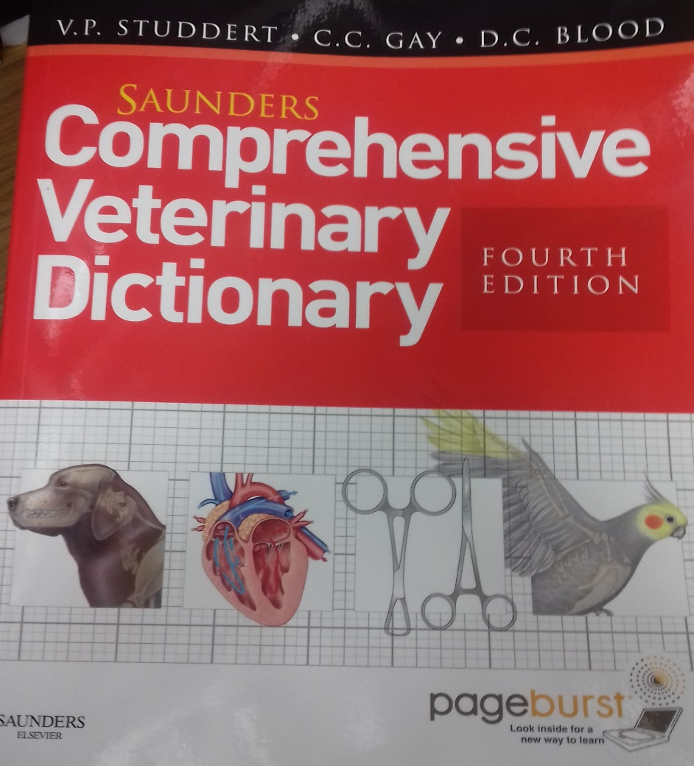
h) Peter D. Constable, Kenneth W. Hinchcliff, Stanley H. Done, Walter Gruenberg, Veterinary Medicine: A Textbook of the Diseases of Cattle, Horses, Sheep, Pigs, and Goats (11th edition). Elsevier (Vol. 1)

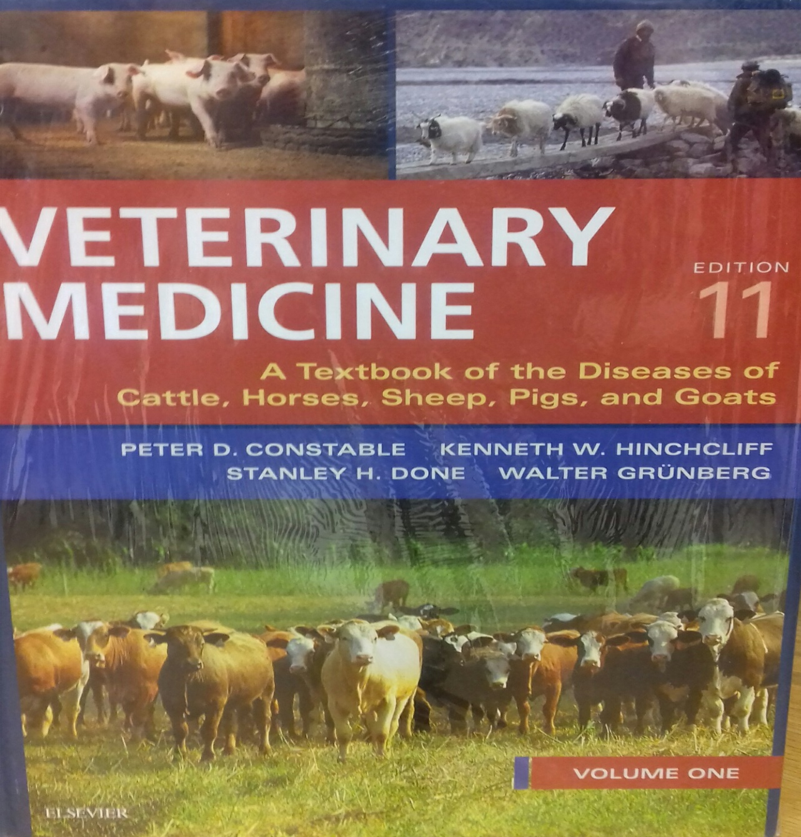

****************
******************

Source: https://www.amazon.com/Small-Animal-Internal-Medicine-5e/dp/0323086829

Small Animal Internal Medicine (Small Animal Medicine) 5th Edition
by Richard W. Nelson DVM (Author), C. Guillermo Couto DVM (Author)
4.9 out of 5 stars 28 customer reviews

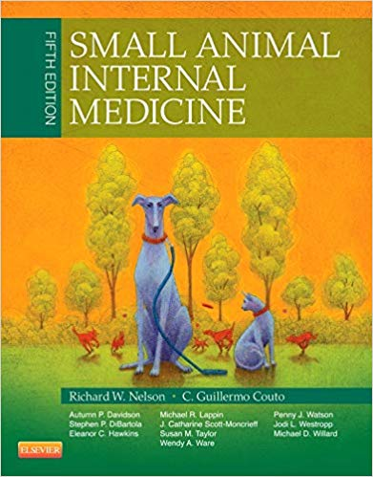

Customers who viewed Small Animal Internal Medicine... also viewed:
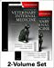
Textbook of Veterinary Internal Medicine Expert Consult, 8e (2 Volumes)
Buy new: $284.95
51Used & newfrom $181.80
4.1 out of 5 stars(15)

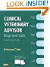
Clinical Veterinary Advisor: Dogs and Cats
Buy new: $91.64
42Used & newfrom $86.02
4.5 out of 5 stars(51)

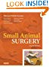
Small Animal Surgery
Buy new: $169.55
41Used & newfrom $158.00
4.6 out of 5 stars(39)

