

Insecticides: Chemistries and Characteristics

Jeffrey R. Bloomquist
Department of Entomology, Virginia Polytechnic Institute and
State University, Blacksburg, Virginia, 24061-0319
Phone: (540) 231-6129
Fax: (540) 231-9131
Internet: jbquist@vt.edu

Introduction and Scope
This portion of the course focuses on the chemistry and mode of action of insecticides. For the purposes of this discussion, the term insecticide has been interpreted broadly and encompasses both natural products and synthetic compounds. Discussion of synthetic insecticides will emphasize the major classes of commercial compounds and include some information on new compounds that are under development. Representative chemical structures for each group will be provided. No attempt is made to include all the important compounds within a group, and no endorsement of, or discrimination against, any compound is either stated or implied by its inclusion or omission in this chapter. Natural products will be discussed because many of these materials have advantageous properties for integrated pest management and also because the use of these materials in "μnorganic farming" is increasing. Discussion of insecticide mode of action will focus on their interactions with cell membrane proteins and the resulting expression of toxicity in the insect. Sufficient background information on the affected physiological processes will also be given so that the effects of insecticides on these processes can be clearly understood. This chapter will not cover chemicals that are used in pest management because of their nonlethal (e.g., pheromones, synergists, etc.) or nonspecific (e.g., oils and soaps) properties.
The length of the sections on each class of insecticide varies greatly, depending on the number of compounds involved and the amount of available information. Chemical structure and mode of action figures are highlighted in italics. Along with each chemical structure is given the available rat oral LD50 (dose that kills 50% of a group of test animals), expressed in mg active ingredient/kg body weight. This information will provide a perspective on the comparative toxicity of different compounds. At the end of the chapter are a list of the references used in assembling this information, along with some related internet databases on the chemistry and toxicology of insecticides.

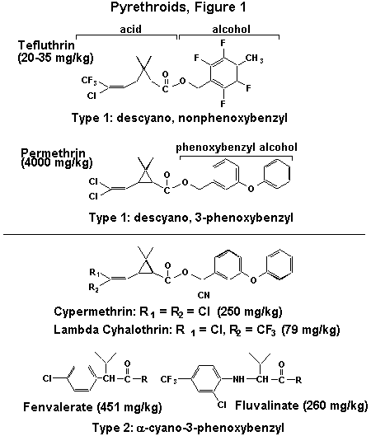
Compounds Affecting Voltage-Dependent Sodium Channels

The pyrethroid insecticides are typically esters of chrysanthemic acid having a high degree of lipophilicity (fat solubility). The original compounds in this series were the natural pyrethrins, which are isolated from the flowers of chrysanthemum. Pyrethroid chemistry and action are classified as Type 1 or Type 2, depending on the alcohol substituent. The Type 1 group is rather broadly defined and includes pyrethroids containing descyano-3-phenoxybenzyl or other alcohols. Many of the older nonphenoxybenzyl Type 1 compounds (e.g., pyrethrins, allethrin, tetramethrin) are unstable in the environment and this characteristic prevented their use in row crops. Introduction of the phenoxybenzyl (e.g., permethrin) or certain halogenated alcohols (e.g., tefluthrin) improved chemical stability and allowed the use of pyrethroids in the field. The Type 2 pyrethroids are more narrowly defined in terms of their chemical structure. They specifically contain an a-cyano-3-phenoxybenzyl alcohol, which increases insecticidal activity about 10-fold. Moreover, some commercially important Type 2 pyrethroids have altered the acid portion of the molecule to include a phenyl ring (e.g., fenvalerate and fluvalinate). The stereoisomerism of pyrethroids is important for their toxic action, but a detailed discussion of this topic is beyond the scope of this course on IPM.
The signs of intoxication by pyrethroids develop rapidly and there exist different poisoning syndromes for the two types of compounds. Typical signs of intoxication by Type 1 pyrethroids include hyperexcitability and convulsions in insects and a whole body tremor in mammals. In insects, the Type 2 pyrethroids cause predominantly ataxia and incoordination, while in mammals they produce choreoathetosis (sinuous writhing) and salivation. In insects, the effects of pyrethroids (especially Type 1) can develop within 1-2 minutes after treatment and can result in knockdown, which is a loss of normal posture and locomotion. Human dermal exposure to either type of pyrethroid can cause paresthesia, a tingling or burning sensation of the skin, but this effect is more intense for Type 2 compounds.
Pyrethroid intoxication results from their potent effects on nerve impulse generation within both the central and peripheral nervous systems. Under normal conditions, neurons possess a transmembrane voltage of about -60 mV on the inside. The nerve impulse or action potential consists of a transient depolarization (positive wave) whose upstroke is driven by an influx of Na+ ions, followed by a downstroke from the efflux of K+ ions.
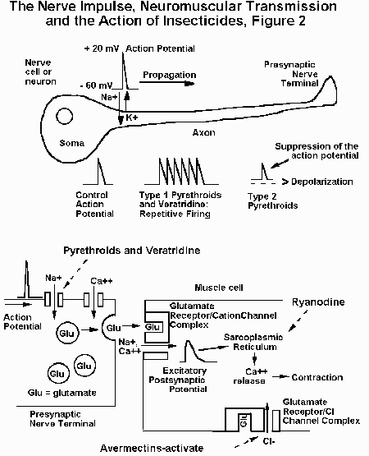
These ion fluxes occur due to the opening and closing of specific ion channel proteins embedded within the nerve membrane. The action potential is propagated down the axon until it reaches the nerve terminal, where it stimulates the release of chemical transmitters. Type 1 compounds induce multiple spike discharges in peripheral sensory and motor nerves, as well as interneurons within the central nervous system (CNS). In contrast, Type 2 pyrethroids depolarize the axon membrane potential, which reduces the amplitude of the action potential and eventually leads to a loss of electrical excitability. All these effects occur because pyrethroids prolong the current flowing through sodium channels by slowing or preventing the shutting of the channels. The somewhat different actions observed for Type 1 and Type 2 compounds are due to differences in the degree of physiological effect: the duration of modified sodium currents by Type 1 compounds lasts tens or hundreds of milliseconds, while those of Type 2 compounds last for minutes or longer. These effects on the sodium current also cause a profound increase in the release of neurotransmitters from nerve terminals. The insect neuromuscular synapse is an especially important target for the pyrethroids, as well as other insecticides

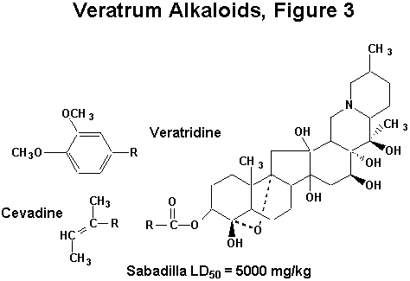
When used in organic farming or gardening, the veratrum alkaloids are usually applied as an extract (sabadilla) from the seeds of plants belonging to the genus Schoenocaulon. The insecticidal activity of sabadilla comes from the alkaloid fraction, which constitutes 3-6% of the extract. The two most important compounds are the lipophilic alkaloids veratridine and cevadine, with veratridine having greater insecticidal potency. Sabadilla breaks down rapidly in sunlight.
The major effects of sabadilla poisoning include muscle rigor in mammals and paralysis in insects. In addition, sabadilla strongly irritates mucous membranes in mammals and can cause violent sneezing. Sabadilla extract is much less toxic to mammals than most other insecticides and therefore is safe to use.
The mode of action of the veratrum alkaloids is similar to that of the pyrethroids. When applied to nerve, veratridine causes an increase in the duration of the action potential, repetitive firing, and a depolarization of the nerve membrane potential, due to effects on the sodium channel (The Nerve Impulse, Neuromuscular Transmission and the Action of Insecticides, Figure 2). Veratridine prolongs the open state of the sodium channel by delaying channel shutting and by increasing the probability of channel opening.

Insecticides Targeting Calcium Channels
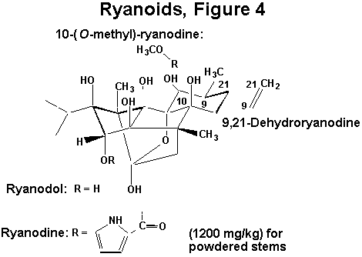
The water-soluble plant extract ryania has been used as an insecticide for about 50 years and consists of the powdered stem of the tropical shrub Ryania speciosa. The extract contains several structurally related ryanoids, including: ryanodine, 10-(O-methyl)-ryanodine, 9,21-dehydroryanodine, and ryanodol. The most toxic and abundant compounds in the extract are ryanodine and 9,21-dehydroryanodine, and thus, they account for virtually all of the insecticidal activity. The extract has a low acute toxicity to mammals.
Ryanodine induces paralysis in insects and vertebrates by causing a sustained contracture of skeletal muscle without depolarizing the muscle membrane. Under normal conditions, muscle contraction is initiated by the following sequence of events (The Nerve Impulse, Neuromuscular Transmission and the Action of Insecticides, Figure 2). First, an action potential in the motor nerve is conducted into the nerve terminal and this depolarization activates calcium channels and stimulates an influx of Ca++ ions. These ions promote the release of chemical transmitter, which in insects is the amino acid glutamate. Free glutamate diffuses across the synaptic cleft and binds to a receptor-operated ion channel that allows the influx of sodium and calcium ions. This influx induces a depolarization in the muscle membrane that propagates into the muscle fiber via the transverse tubule system to the sarcoplasmic reticulum. The sarcoplasmic reticulum is a calcium storage organelle that when depolarized, releases calcium ions onto the protein filaments and induces muscle contraction. A number of studies have confirmed that ryanodine can irreversibly activate the calcium release channel in the sarcoplasmic reticulum. The irreversible activation of this calcium channel floods the muscle fibers with calcium, inducing the sustained contraction of skeletal muscle and paralysis observed in ryanodine poisoning.

Acetylcholine Mimics

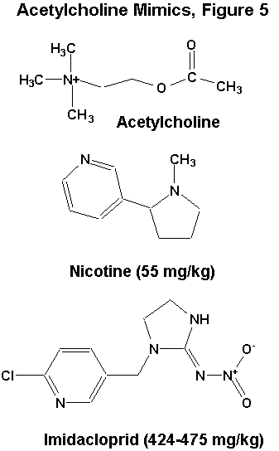
The tobacco alkaloid nicotine has been used as an insecticide since the middle of the 18th century. This compound is miscible with water and is often formulated as the sulfate salt. Nicotine has excellent contact activity, due to its ability to penetrate the integument of insects. This property increases the hazards of handling nicotine, as its contact toxicity to mammals is also significant. A newer compound in this class is the nitroguanidine, imidacloprid. This compound generally works best as a stomach poison, and has plant systemic activity as well. It is much less toxic to mammals than nicotine.
Nicotine and imidacloprid mimic the action of acetylcholine, which is a major excitatory neurotransmitter in the insect CNS. After acetylcholine is released by the presynaptic cell, it binds to the postsynaptic nicotinic acetylcholine receptor and activates an intrinsic cation channel.
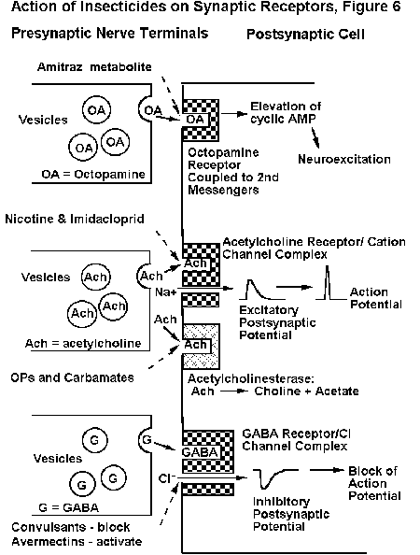
This results in a depolarization of the postsynaptic cell due an influx of sodium and calcium ions. The synaptic action of acetylcholine is terminated by the enzyme acetylcholinesterase, which rapidly hydrolyzes the ester linkage in acetylcholine. Nicotine and imidacloprid also activate the nicotinic acetylcholine receptor, but do so persistently, since they are insensitive to the action of acetylcholinesterase. This persistent activation leads to an overstimulation of cholinergic synapses, and results in hyperexcitation, convulsions, paralysis, and death of the insect.

Acetylcholinesterase Inhibitors
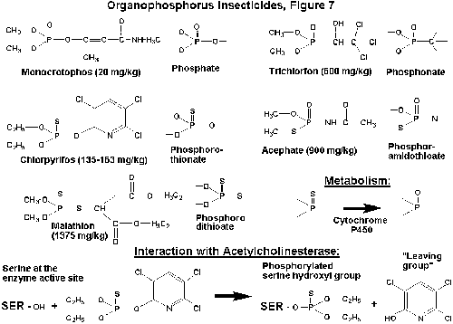

The organophosphorus insecticides (OPs) are a very important group of compounds that vary tremendously in chemical structure and chemical properties. These compounds can be miscible with water, but more typically are miscible in organic solvents. OPs can be classified into several groups depending on the atoms that are directly attached to the central phosphorus. Thus, the majority of OPs exist as phosphates, phosphonates, phosphorothionates, phosphorodithioates, phosphoramidothioates, etc (Organophosphorous Insecticides, Figure 7). An important bioactivation step occurs for OPs containing a sulfur atom attached to the phosphorus by a double bond (e.g., phosphorothionates). For these compounds, oxidative desulfuration occurs via cytochrome P450 monooxygenases, which are enzymes that oxidase a wide variety of xenobiotics (Organophosphorous Insecticides, Figure 7). However, in this case the oxidized metabolite possesses greater toxicity. The acute toxicity of the OPs varies substantially, but many of them have a high mammalian toxicity.
The primary target site for the OPs is the enzyme acetylcholinesterase. The OPs react with a serine hydroxyl group within the enzyme active site, phosphorylating this hydroxyl group and yielding a hydroxylated "leaving group" (Organophosphorous Insecticides, Figure 7). This process inactivates the enzyme and blocks the degradation of the neurotransmitter acetylcholine. The synaptic concentrations of acetylcholine then build up and hyperexcitation of the CNS occurs. The signs of intoxication include restlessness, hyperexcitability, tremors, convulsions, and paralysis. In insects, the effects of OPs are confined to the CNS, where virtually all of the cholinergic synapses are located. Because they often require bioactivation and must penetrate into the CNS, the OPs do not have a rapid action like that of the pyrethroids. The phosphorylation of acetylcholinesterase by OPs is persistent; reactivation of the enzyme can take many hours or even days.

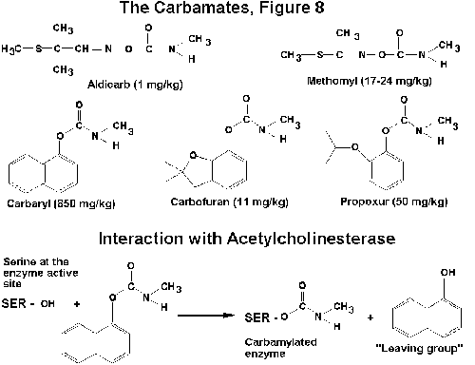
The carbamate insecticides exist as esters of carbamic acid, typically having some kind of aryl (ring) substituent as the leaving group. These compounds are most soluble in organic solvents. Other carbamates are more aliphatic in nature and may possess sufficient miscibility with water to act as effective plant systemic insecticides (e.g., aldicarb). The carbamates are often highly toxic to mammals, and must be handled carefully. Among insects, they are particularly toxic to beneficial hymenoptera such as honeybees.
The mode of action of the carbamates is similar to that of the OPs. In this case, the reaction yields a carbamylation of the serine hydroxyl group (Carbamates, Figure 8). An hydoxylated leaving group is also generated. The CNS is the site of action of carbamates and the signs of intoxication are also similar to those of the OPs. Compared to phosphorylation, the carbamylated enzyme complex is relatively less stable; it will typically hydrolyze over a time course of minutes.

Octopamine Mimics
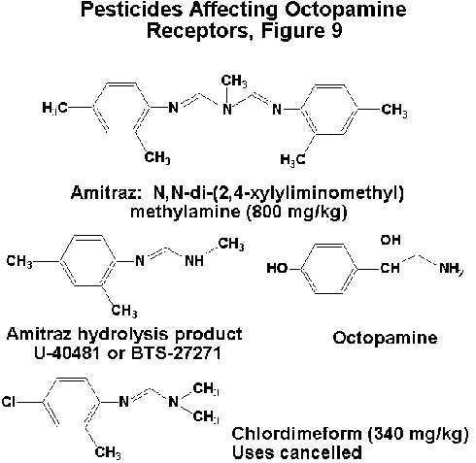
Several amidine compounds have been used for their insecticidal and miticidal properties. Chlordimeform was the primary compound in this series, but potential problems with carcinogenicity have limited its use. The major insecticidal compound still used today is amitraz, which undergoes a metabolic conversion to an active metabolite designated U-40481 or BTS-27271 (Compounds Affecting Octopamine Receptors, Figure 9). Amitraz is only sparingly soluble in water, but is soluble in organic solvents. Its acute toxicity to mammals is moderate.
These compounds mimic the action of the neurotransmitter octopamine, which regulates behavioral arousal within the CNS and also has actions on peripheral tissues as well. Octopamine binds to a receptor that elevates levels of the second messenger, cyclic adenosine monophosphate (AMP). Cyclic AMP then initiates processes that give rise to neuronal excitation. Amidines cause an overstimulation of octopaminergic synapses in insects, resulting in tremors, convulsions, and continuous flight behavior in adult insects. Moreover, these compounds have the ability to cause a true anorexia in insects and also suppress reproduction.

Compounds Affecting Chloride Channels

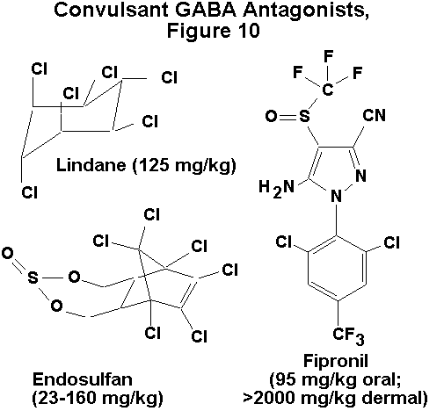
The channel blocking convulsants represent one of the oldest groups of commercial insecticides. These compounds were originally environmentally stable, lipophilic polychlorocycloalkanes, such as dieldrin and endrin. Only the more biodegradable materials, such as lindane and endosulfan, are still used in appreciable amounts. High mammalian toxicity, and especially a high dermal toxicity were hallmarks of the polychlorocycloalkanes. Recent chemical synthesis efforts resulted in the announcement of fipronil, an new arylheterocycle with a similar mode of action, but improved selective toxicity towards insects.
In both insects and mammals, chloride channel-blocking insecticides cause hyperexcitability and convulsions. These effects occur via poisoning of the CNS through antagonism of the inhibitory neurotransmitter g-aminobutyric acid (GABA). Normally, when GABA is released from the presynaptic nerve terminal, it binds to a postsynaptic receptor protein containing an intrinsic chloride ion channel (Action of Insecticides on Synaptic Receptors, Figure 6). When GABA binds to the receptor, the channel is opened, and Cl- ions flow into the postsynaptic neuron. This chloride permeability can significantly hyperpolarize (make more negative) the membrane potential and has a dampening effect on nerve impulse firing. A number of studies have demonstrated that these insecticides bind to the chloride channel and block its activation by GABA, and this absence of synaptic inhibition leads to hyperexcitation of the CNS.
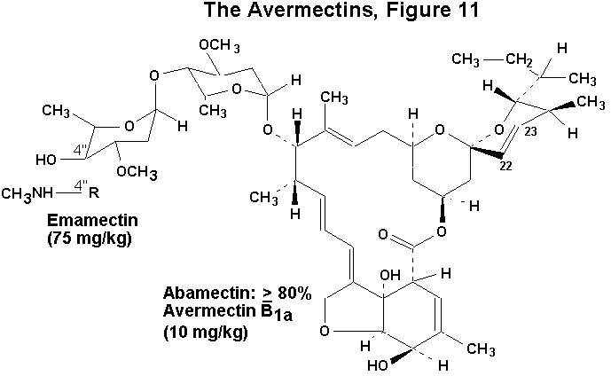
The avermectins are a group of closely related macrocyclic lactones isolated from the fungus Streptomyces avermitilis. The basic structural motif of the avermectins (they are macrocyclic lactones) is evident in the natural product avermectin B1a, which is the principal constituent of the insecticide abamectin. Chemical modification of avermectin B1a has yielded a number of semi-synthetic materials. One of the most important is the compound emamectin (4"-epimethylamino-4"-deoxyavermectin B1a), which has high insecticidal activity against caterpillars. The avermectins are insoluble in water. Both abamectin and emamectin have fairly high mammalian toxicity, but their translaminar movement into treated leaves, oral activity against insect pests, and rapid breakdown in sunlight are all favorable properties from an IPM standpoint.
Avermectin intoxication in mammals begins with hyperexcitability, tremors, and incoordination, and later develops into ataxia and coma-like sedation. In insects and nematodes poisoned by avermectins, ataxia and paralysis are the major signs of intoxication, with little or no hyperexcitation.
The avermectins block electrical activity in vertebrate and invertebrate nerve and muscle by increasing the membrane conductance to chloride ions. The effect is similar to that of GABA, but is essentially irreversible (Action of Insecticides on Synaaptic Receptors, Figure 6). In tissues containing GABA receptors, the avermectin-dependent conductance increase is often accompanied by a loss of sensitivity to exogenously applied GABA and this GABA blocking action may be responsible for the transient tremor observed in mammals. The avermectins are fairly indiscriminate in their action, and can affect a variety of other ligand- and voltage-gated chloride channels. Especially important are the glutamate-gated chloride channels of insect and nematode skeletal muscle, which may mediate avermectin-induced muscle paralysis in these organisms (The Nerve Impulse, Neuromuscular Transmission and Action of Insecticides, Figure 2).

Disruption of Energy Metabolism
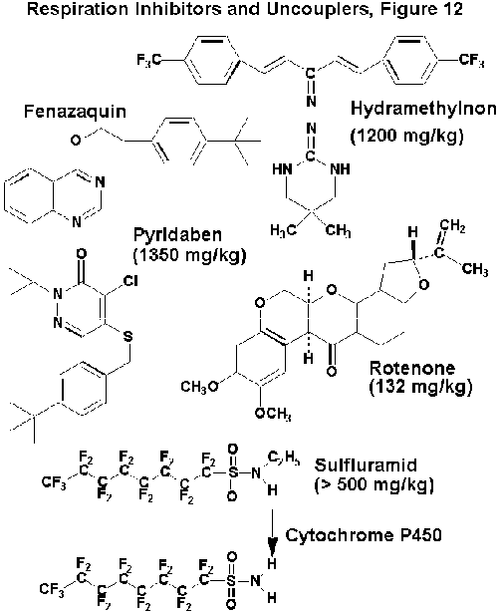
Compounds that disrupt energy metabolism have been identified from both natural and synthetic sources. An important natural product is rotenone, which is derived from Cube or Derris root. The synthetic compounds in this group include a number of nitrogen-containing heterocycles, such as fenazaquin and pyridaben. Other compounds include the amidinohydrazone, hydramethylnon and the perfluorooctanesulfonamide, sulfluramid. All of these materials have low solubility in water, and they are of low to moderate toxicity to mammals. It is interesting to note that the highest acute toxicity is observed for the natural product rotenone. This compound is also highly toxic to fish.
Disruption of energy metabolism occurs in the mitochondria and usually takes the form of either an inhibition of the electron transport system or an uncoupling of the transport system from ATP production. Inhibition of the electron transport system blocks the production of ATP and causes a decrease in oxygen consumption by the mitochondria. Rotenone, fenazaquin, and pyridaben are inhibitors at site I in the electron transport chain (Coenzyme Q oxidoreductase), while hydramethylnon is an inhibitor at site II (cytochrome b-c1 complex). For an uncoupling action, the transport system functions normally, but the production of ATP is μuncoupledξ from the electron transport process due to a dissipation of the proton gradient across the inner mitochondrial membrane. In the presence of uncouplers, oxygen consumption increases, but no ATP is produced. The de-ethylated metabolite of sulfluramid is produced by cytochrome P450 metabolism and is an potent uncoupler of mitochondrial respiration. Disruption of energy metabolism and the subsequent loss of ATP results in a slowly developing toxicity, and the effects of all these compounds include inactivity, paralysis, and death.

Insect Growth Regulators
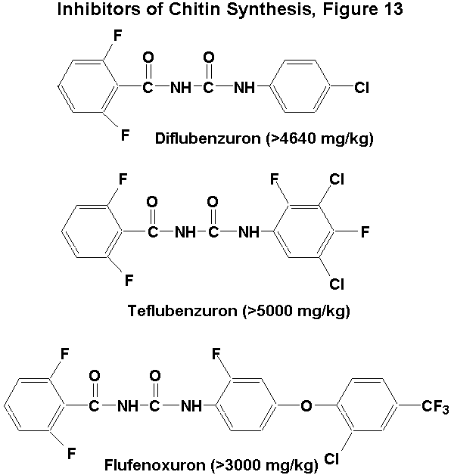
These compounds are classified as benzoylphenylureas and possess a number of halogen substituents. Diflubenzuron is the prototypical compound in this series, although second generation compounds also exist. The water solubility of these compounds is typically extremely low (< 1ppm), as is their mammalian toxicity.
Insects exposed to these compounds are unable to form normal cuticle because the ability to synthesize chitin is lost. About 50% of the cuticle is comprised of chitin, which is a polysaccharide of N-acetylglucosamine. This polymerization is blocked by the benzoylphenylureas and may occur through inhibition of a membrane transport step involving UDP-N-acetylglucosamine. In the absence of chitin, the cuticle becomes thin and brittle, and is unable to support the insect or to withstand the rigors of molting. Accordingly, the benzoylphenylureas are especially effective when applied just before a molt.
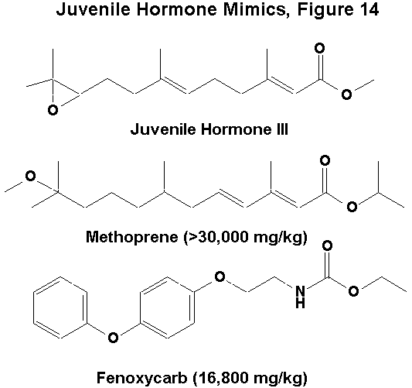

The juvenile hormone mimics are compounds bearing a structural resemblance to the juvenile hormones of insects. Juvenile hormones are lipophilic sesquiterpenoids containing an epoxide and methyl ester groups. Two insecticidal mimics of juvenile hormone are methoprene, which bears a close structural resemblance to juvenile hormones, and fenoxycarb, which possesses a phenoxybenzyl group instead of a carbon chain with an epoxide. Both compounds are soluble in organic solvents and have extremely low toxicity to mammals.
Methoprene and fenoxycarb mimic the action of the juvenile hormones on a number of physiological processes, such as molting and reproduction. Exposure to these compounds at molting results in the production of insects containing mixed larval/pupal or larval/adult morphologies. The efficacy of these compounds is greatest when normal juvenile hormone titers are low; namely, in the last larval or early pupal stages. Thus, timing of application is important for successful control. Another useful property of these compounds is that, in adults, they disrupt normal reproductive physiology and act as a method of birth control

Alimentary Toxins from Bacillus thuringiensis
Bacillus thuringiensis (Bt) forms a crystalline inclusion body during sporulation that contains a number of insecticidal protein toxins. When consumed by the insect, the inclusion is dissolved in the midgut and releases d-endotoxins. Mixtures of different d-endotoxins are usually present in the inclusion and individual toxin proteins are designated with the prefix cry. The toxin proteins contain a few hundred to over 1000 amino acids. After they are ingested, the d-endotoxins are cleaved to an active form by proteases within the midgut. The active toxins bind specifically to the membranes of the midgut epithelia and alter their ion permeability properties by forming a cation channel or pore. Ion movements through this pore disrupt potassium and pH gradients and lead to lysis of the epithelium, gut paralysis, and death

Acknowledgments
I would like to thank Drs. Radcliffe and Hutchison of the Department of Entomology, University of Minnesota, for their kind invitation to contribute this chapter. I would also like to thank Dr. Dean Bushey of Rhone-Poulenc Ag Co. for providing information on the toxicity of fipronil.

References
Anonymous, Pest Management Guide for Field Crops, Virginia Cooperative Extension, Publication 456-016, 320 pp. (1995).
Bloomquist, J. R. Toxicology, mode of action, and target site-mediated resistance to insecticides acting on chloride channels. Mini Review, Comp. Biochem. Physiol 106C: 301-314 (1993).
Bloomquist, J. R. Neuroreceptor mechanisms in pyrethroid mode of action and resistance. Rev. Pestic. Tox. 2: 185-226 (1993).
Bloomquist, J. R. Ion channels as targets for insecticides. Ann. Rev. Entomol. 41: 163-90 (1996).
Clark, J. M., Scott, J. G., Campos, F., and Bloomquist, J. R. Resistance to avermectins: extent, mechanisms, and management implications. Ann. Rev. Entomol. 40: 1-30 (1995).
Coats, J. R. Ed., Insecticide Mode of Action. Academic Press, New York (1982).
Gill, S. S., Cowles, E. A., and Pietrantonio, P. V. The mode of action of Bacillus thuringiensis endotoxins. Ann. Rev. Entomol. 37: 615-36 (1992).
Hollingshaus, J. Inhibition of mitochondrial electron transport by hydramethylnon: a new amidinohyrazone insecticide. Pestic. Biochem. Physiol. 27: 61-70 (1987).
Hollingworth, R. Ahmmadsahib, K. Gedelhak, G., and McLaughlin, J. New inhibitors of complex I of the mitochondrial electron transport chain with activity as pesticides. Biochem. Soc. Trans. (London) 22: 230-3 (1994).
Matsumura, F. Toxicology of Insecticides, Second Edition. Plenum, New York (1985).
Meister, R. T. Farm Chemicals Handbook. Meister Publishing Co., Willoughby, Ohio (1993).
Mullins, J. W. Imidacloprid: A New Nitroguanidine Insecticide. ACS Symposium Ser 524: Newer Pest Control Agents and Technology with Reduced Environmental Impact (1993).
Nijhout, F. H. Insect Hormones. Princeton University Press. Princeton, New Jersey (1994).
Schnellmann R. and Manning R. Perfluorooctane sulfonamide: a structurally novel uncoupler of oxidative phosphorylation. Biochim. Biophys. Acta 1016: 344-48 (1990).
Ware, G. W. Complete Guide to Pest Control, 2nd Ed. Thompson Publications, Fresno, California (1988).
Windholtz, M. Editor, The Merck Index, Tenth Ed. Merck & Co., Rahway, New Jersey (1983).

Internet Resources:
United States Environmental Protection Agency
United States Department of Agriculture
United States of America House of Representatives
Oregon State Extension Service, EXTOXNET (EXtension TOXicology NETwork)

Return to Radcliffe's IPM World Textbook Home Page.

The University of Minnesota is an equal opportunity educator and employer. Privacy Policy
Last modified: Tuesday, 9 January, 1996 (reformatted 23 February 1999)
© Regents of the University of Minnesota, 1999

