

http://www.ncbi.nlm.nih.gov/books/bv.fcgi?rid=hmg.chapter.551

Applications of PCR
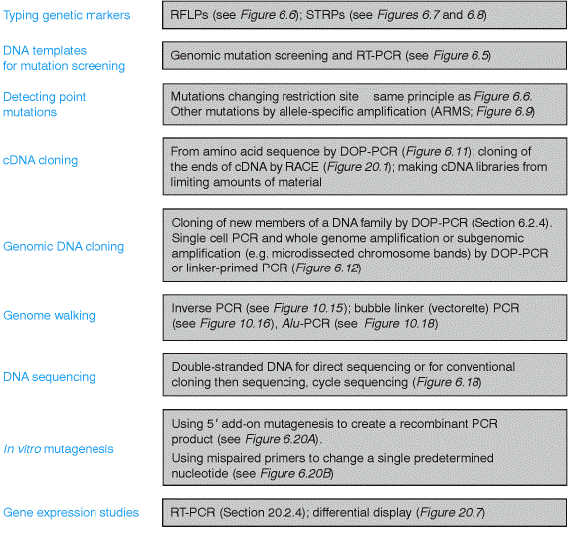
Although PCR was first developed only a decade and a half ago, the simplicity and the versatility of the technique have ensured that it is among the most ubiquitous of molecular genetic methodologies, with a wide range of general applications
(Figure 6.4).

1. PCR enables rapid amplification of template DNA for screening of uncharacterized mutations
Because of its rapidity and simplicity, PCR is ideally suited to providing numerous DNA templates for mutation screening. Partial DNA sequences, at the genomic or the cDNA level, from a gene associated with disease, or some other interesting phenotype, immediately enable gene-specific PCR reactions to be designed. Amplification of the appropriate gene segment then enables rapid testing for the presence of associated mutations in large numbers of individuals. By contrast, cell-based DNA cloning of the gene from numerous different individuals is far too slow and labour-intensive to be considered as a serious alternative.
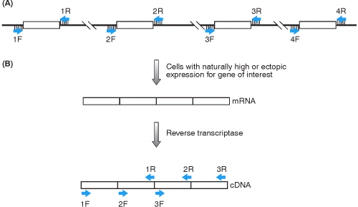
Typically, the identification of exon-intron boundaries and sequencing of the ends of introns of a gene of interest offers the possibility of genomic mutation screening. Individual exon-specific amplification reactions are developed by designing primers which recognize intronic sequences located close to the exon-intron boundary (Figure 6.5A). The resulting PCR products are then analyzed by rapid mutation-screening methods, in which the optimal size for mutation screening is usually about 200 bp (see Section 15.5.1). Conveniently, the average size of a human exon is about 180 bp but, in the case of very large exons, it is usual to design a series of primers to generate overlapping exonic products. PCR can also quickly provide amplified cDNA sequences for mutation screening. Such cDNA mutation screening may be the only way in which mutations can be screened if the exon-intron organization of a gene has not been established. To do this, mRNA is isolated from a convenient source of tissue, such as blood cells, converted into cDNA using reverse transcriptase and the cDNA is used as a template for a PCR reaction. This version of the standard genomic PCR reaction is consequently often referred to as RT-PCR (reverse transcriptase-PCR; Figure 6.5B). Clearly, the method is ideally suited to genes expressed at high levels in easily accessible cells, such as blood cells. However, as a result of low level ectopic transcription of genes in all tissues, it has also been applied to transcript analysis of genes which are not significantly expressed in blood cells, such as the dystrophin (DMD) gene (Chelly et al., 1989).
Figure 6.5. PCR products for gene mutation screening are obtained from genomic DNA using intron-specific primers flanking exons or by RT-PCR. (A) Genomic DNA. Exons 1–4 can be amplified separately from genomic DNA using pairs of intron-specific primers 1F + 1R, 2F + 2R, etc. (B) RT-PCR. This relies on at least some mRNA being present in easily accessible cells such as blood cells, permitting conversion to cDNA. The cDNA can then be used as a template for pairs of exon-specific primers (1F+1R, 2F+2R, etc.) to generate overlapping DNA fragments.
2. PCR permits rapid genotyping for polymorphic markers
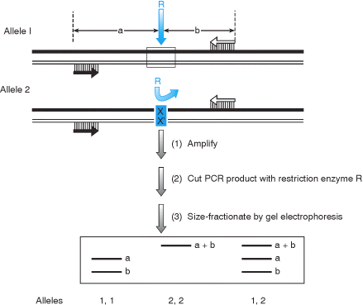
Restriction site polymorphisms (RSPs) result in alleles possessing or lacking a specific restriction site. Such polymorphisms can be typed using Southern blot hybridization. A DNA probe representing the locus is hybridized against genomic DNA samples that have been digested with the appropriate restriction enzyme and size-fractionated by agarose gel electrophoresis. The resulting RFLPs have two alleles corresponding to the presence or absence of the restriction site (Section 5.3.3). As a convenient alternative to RFLPs, PCR can type RSPs by simply designing primers using sequences which flank the polymorphic restriction site, amplifying from genomic DNA, then cutting the PCR product with the appropriate restriction enzyme and separating the fragments by agarose gel electrophoresis (Figure 6.6).
Figure 6.6. Restriction site polymorphisms can easily be typed by PCR as an alternative to laborious RFLP assays. Alleles 1 and 2 are distinguished by a polymorphism which alters the nucleotide sequence of a specific restriction site for restriction nuclease R: allele 1 possesses the site, but allele 2 has an altered nucleotide(s) X, X' and so lacks it. PCR primers can be designed simply from sequences flanking the restriction site to produce a short product. Digestion of the PCR product with enzyme R and size-fractionation can result in simple typing for the two alleles.
Short tandem repeat polymorphisms (STRPs), also called microsatellite markers, consist of a short sequence, typically from one to four nucleotides long, that is tandemly repeated several times, and often characterized by many alleles. For example, (CA)_{n}/(TG)_{n} repeats are often polymorphic when n exceeds 12, and have been widely used as polymorphic markers in the human genome (see below). Increasingly, however, trinucleotide and tetranucleotide marker polymorphisms are being typed. In each case the STRPs can be typed conveniently by PCR. Primers are designed from sequences known to flank a specific STRP locus, permitting PCR amplification of alleles whose sizes differ by integral repeat units (Figure 6.7). The PCR products can then be size-fractionated by polyacrylamide gel electrophoresis. The PCR normally includes a radioactive or fluorescent nucleotide precursor which becomes incorporated into the small PCR products and facilitates their detection. To ensure adequate size fractionation of alleles, the PCR products are denatured prior to electrophoresis. An example of the use of a CA repeat marker is shown in Figure 6.8.
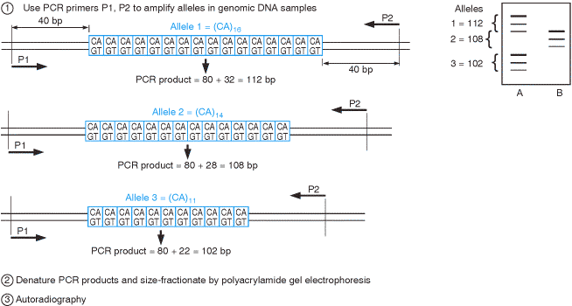

Figure 6.7. PCR can be used to type short tandem repeat polymorphisms (STRPs). The example illustrates typing of a (CA)/(TG) dinucleotide repeat polymorphism which has three alleles as a result of variation in the number of the (CA) repeats. On the autoradiograph each allele is represented by a major upper band and two minor ‘shadow bands' (see Figure 6.8). Individuals A and B have genotypes (in brackets) as follows: A (1,3); B (2,2).
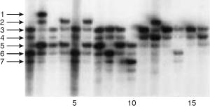
Figure 6.8. Example of typing for a CA repeat. The example illustrated shows typing of members of a large family with the (CA)/(TG) marker D17S800. Arrows to the left mark the top (main) band seen in different alleles 1–7. Note that individual alleles show a strong upper band followed by two lower ‘shadow bands', one of intermediate intensity immediately underneath the strong upper band, and one that is very faint and is located immediately below the first shadow band. For the indicated individuals, the genotypes (in brackets) are as follows: 1 (3,6); 2 (1,5); 3 (3,5); 4 (2,5); 5 (3,6); 6 (2,5); 7 (3,5); 8 (3,6); 9 (3,5); 10 (5,7); 11 (3,3); 12 (2,4); 13 (3,3); 14 (3,6); 15 (3,3); 16 (3,4). Note that in the latter case, the middle band is particularly intense because it contains both the main band for allele 4 plus the major shadow band for allele 3. Slipped strand mispairing (see Section 9.3.1) is thought to be the major mechanism responsible for producing shadow bands at tandem dinucleotide repeats ( Hauge and Litt, 1993).

3. A wide variety of PCR-based methods can be used to assay for known mutations
PCR is a very rapid and valuable tool for detecting pathogenic mutations and other mutations of interest. The examples below illustrate some popular methods.

Allelic discrimination by size or susceptibility to restriction enzyme
Small insertions or deletions (such as the three nucleotide deletion in the common cystic fibrosis (CFTR) allele, F508del) can be simply detected by designing primers from regions closely flanking the mutation site and distinguishing the normal and mutant alleles by size on polyacrylamide or agarose gels. If the mutation changes a restriction site, mutant and normal alleles can be distinguished by amplifying across the mutant site and digesting the PCR product with relevant restriction endonuclease, exactly as in Figure 6.6.

Allelic discrimination by susceptibility to an artificially introduced restriction site
Even if the mutation does not result in a restriction site difference, it may be possible to exploit the difference between normal and mutant alleles by amplification-created restriction site PCR. This is a form of mismatched primer mutagenesis (see Section 6.4.2) in which a primer is deliberately designed from sequence immediately adjacent to, but not encompassing, the restriction site. The primer is deliberately designed to have a mismatched nucleotide which together with the sequence of the mutant site creates a restriction site not present in normal alleles (see Figure 17.2 for a specific example).

Allele-specific PCR (ARMS test)
Oligonucleotide primers can be designed so as to discriminate between target DNA sequences that differ by a single nucleotide in the region of interest. This is a form of allele-specific PCR, the PCR equivalent of the allele-specific hybridization which is possible with ASO probes (Section 5.3.1). In the case of allele-specific hybridization, alternative ASO probes are designed to have differences in a central segment of the sequence (to maximize thermodynamic instability of mismatched duplexes). However, in the case of allele-specific PCR, ASO primers are designed to differ at the nucleotide that occurs at the extreme 3′ terminus. This is so because the DNA synthesis step in a PCR reaction is crucially dependent on correct base-pairing at the 3′ end (Figure 6.9). This method can be used to type specific alleles at a polymorphic locus, but has found particular use as a method for detecting a specific pathogenic mutation, the so-called amplification refractory mutation system (ARMS; Newton et al., 1989).

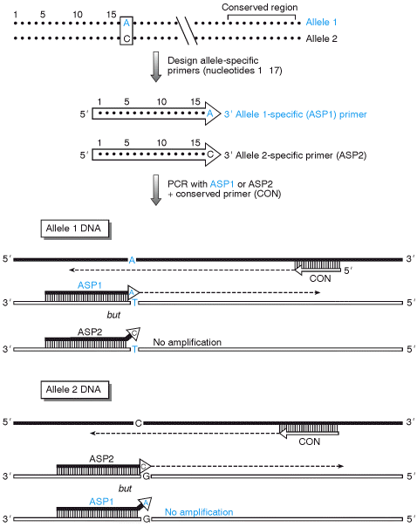

Figure 6.9. Correct base-pairing at the 3’ end of PCR primers is the basis of allele-specific PCR. The allele-specific oligonucleotide primers ASP1 and ASP2 are designed to be identical to the sequence of the two alleles over a region preceding the position of the variant nucleotide, up to and terminating in the variant nucleotide itself. ASP1 will bind perfectly to the complementary strand of the allele 1 sequence, permitting amplification with the conserved primer. However, the 3’-terminal C of the ASP2 primer mismatches with the T of the allele 1 sequence, making amplification impossible. Similarly ASP2 can bind perfectly to allele 2 and initiate amplification, unlike ASP1.

Mutation detection using the 5′ → 3′ exonuclease activity of Taq DNA polymerase (TaqMan™ assay)
Taq polymerase does not possess a proofreading 3′ → 5′ exonuclease activity but does possess a 5′ → 3′ exonuclease activity. This property can be exploited to facilitate detection of specific alleles (Holland et al., 1991; Lee et al., 1993). Such an assay involves hybridization of three primers, the third primer being intended to bind just downstream of one of the conventional primers which should be allele-specific. The additional primer carries a blocking group at the 3′ terminal nucleotide so that it cannot prime new DNA synthesis and at its 5′ end carries a labeled group. In modern versions of the assay, the label is a fluorogenic group and the third primer also carries a quencher group (see Figure 6.10). If the upstream primer which is bound to the same strand is able to prime successfully, Taq DNA polymerase will extend a new DNA strand until it encounters the third primer in which case its 5′ → 3′ exonuclease will degrade the primer causing release of separate nucleotides containing the dye and the quencher, and an observable increase in fluorescence.

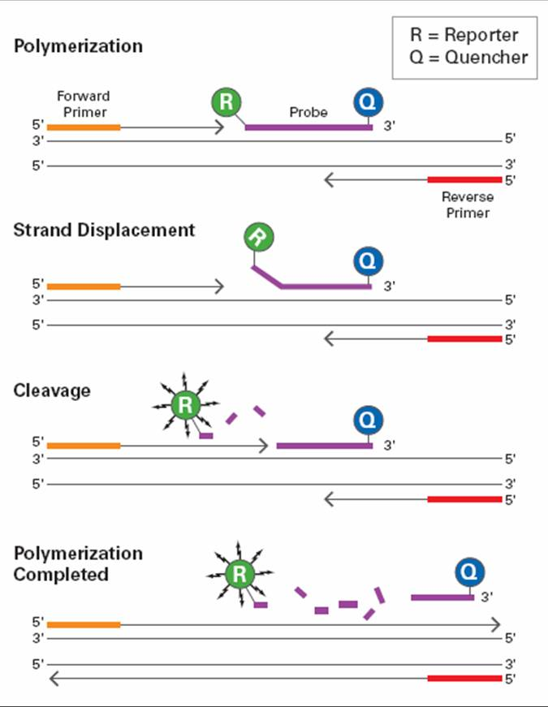

The TaqMan™ 5’ exonuclease assay. In addition to two conventional PCR primers, P1 and P2, which are specific for the target sequence, a third primer, P3, is designed to bind specifically to a site on the target sequence downstream of the P1 binding site. P3 is labeled with two fluorophores, a reporter dye (R) is attached at the 5’ end, and a quencher dye (D), which has a different emission wavelength to the reporter dye, is attached at its 3’ end. Because its 3’ end is blocked, primer P3 cannot by itself prime any new DNA synthesis. During the PCR reaction, Taq DNA polymerase synthesizes a new DNA strand primed by P1 and as the enzyme approaches P3, its 5’ → 3’ exonuclease activity processively degrades the P3 primer from its 5’ end. The end result is that the nascent DNA strand extends beyond the P3 binding site and the reporter and quencher dyes are no longer bound to the same molecule. As the reporter dye is no longer in close proximity to the quencher, the resulting increase in reporter emission intensity is easily detected.

4. Degenerate oligonucleotide primers and primers specific for ligated linker sequences permit co-amplification of sequence families, or even indiscriminate amplification
DOP-PCR (degenerate oligonucleotide-primed PCR) is a form of PCR which is deliberately designed to permit possible amplification of several products. The two primers may be partially degenerate oligonucleotides, composed of panels of oligonucleotide sequences that have the same base at certain nucleotide positions, but are different at others. As a result, there may be comparatively many primer binding sites in the source DNA. This provides a means of searching for a new or uncharacterized DNA sequence that belongs to a family of related sequences either within or between species. Note: the use of such primers also provides a way of cloning a gene when only a limited portion of amino acid sequence is known for the product (Figure 6.11).
DOP-PCR can also be used to permit comparatively indiscriminate amplification of target DNA. Primer sequences with random sequences can bind to numerous locations in the template DNA and permit a form of whole-genome amplification (Zhang et al., 1992; Cheung and Nelson, 1996). This can be advantageous where the amount of starting DNA may be limiting (as in the case of extracts from ancient DNA samples, microdissected chromosome bands, single cell typing, etc.), and PCR amplification of essentially all sequences increases the amount of DNA for study.

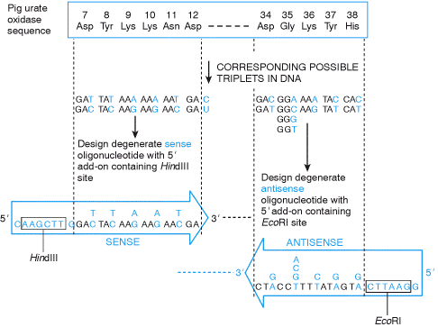

Figure 6.11. DOP-PCR can permit cDNA cloning using degenerate oligonucleotides. The figure illustrates cloning of a cDNA for porcine urate oxidase using degenerate oligonucleotides corresponding to a known amino acid sequence. The sense primer was constructed to correspond to the codons 7–11 plus the first two bases of codon 12, and the antisense primer corresponded to codons 34–38 ( Lee et al., 1988). The amino acid sequences chosen for constructing primers were selected on the basis of their high content of amino acids which were specified by only two codons (Asp, Tyr, Lys, Asn, His, see Figure 1.22). The primers have 5’ extensions containing recognition sequences for restriction nucleases, in order to facilitate subsequent cell-based cloning.

Linker-primed PCR (ligation adaptor PCR)
Another way of enabling amplification of essentially all DNA sequences in a complex DNA mixture involves first ligating a known sequence to all fragments. To do this, the target DNA population is digested with a suitable restriction endonuclease, and double-stranded oligonucleotide linkers (also called adaptors) with a suitable overhanging end are ligated to the ends of target DNA fragments. Amplification is then performed using oligonucleotide primers which are specific for the linker sequences. In this way, all fragments of the DNA source which are flanked by linker oligonucleotides can be amplified (Figure 6.12).
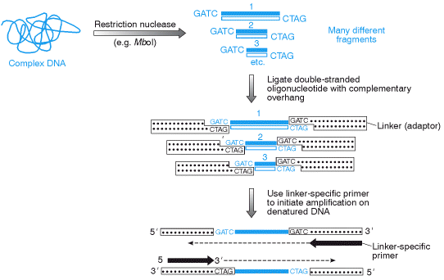

Figure 6.12. Linker-primed PCR permits indiscriminate amplification of DNA sequences in a complex target DNA. The linker (adaptor) molecule is a double-stranded oligonucleotide formed by ligating two single-stranded oligonucleotides which are complementary in sequence except that one possesses a 5’ overhang compatible with a restriction nuclease overhang (in this case, the 5’ GATC overhang produced by MboI). After ligation of the linker to the target restriction fragments, a linker-specific primer can result in amplification of all fragments by binding to two flanking linker molecules.

5. Inverse PCR and Anchored PCR amplify sequences adjacent to a known sequence
It is often desirable to be able to amplify previously uncharacterized DNA sequences that neighbor a known DNA sequence, either at the genomic or cDNA level.
Inverse polymerase chain reaction (Inverse PCR) is a variant of the polymerase chain reaction that is used to amplify DNA with only one known sequence. One limitation of conventional PCR is that it requires primers complementary to both termini of the target DNA, but this method allows PCR to be carried out even if only one sequence is available from which primers may be designed.
Inverse PCR is especially useful for the determination of insert locations. For example, various retroviruses and transposons randomly integrate into genomic DNA. To identify the sites where they have entered, the known, "internal" viral or transposon sequences can be used to design primers that will amplify a small portion of the flanking, "external" genomic DNA. The amplified product can then be sequenced and compared with DNA databases to locate the sequence which has been disrupted.
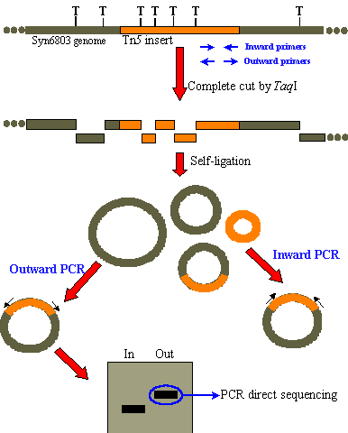
The inverse PCR method involves a series of restriction digests and ligation, resulting in a looped fragment that can be primed for PCR from a single section of known sequence. Then, like other polymerase chain reaction processes, the DNA is amplified by the temperature-sensitive DNA polymerase:
- A target region with a internal section of known sequence and unknown flanking regions is identified
- Genomic DNA is digested into fragments of a few kilobases by a usually low-moderate frequency (6-8 base) cutting restriction enzyme.
- Under low DNA concentrations, self-ligation is induced to give a circular DNA product.
- PCR is carried out as usual, with primers complementary to sections of the known internal sequence.

In an alternative method, an anchored PCR can also be used (see Figure 6.13). In this case, one of the primers is specific for the target sequence and the second primer is specific for a common sequence that can be introduced in different ways, such as by using a linker-primer method as described in the previous section, or by using primers that are modified at the 5′ end so as to introduce a novel sequence.
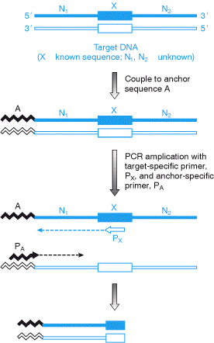

Figure 6.13. ‘Genome walking' by anchored PCR. The target may be a complex source of DNA comprised of many fragments to which an anchor sequence is attached, for example a double-stranded oligonucleotide linker. The idea is to use a primer specific for the anchor sequence and one specific for a known sequence X to be able to rescue fragments containing sequence X and so gain access to previously unidentified sequences adjacent to X. In this example the anchored sequence is shown only on the left hand side for clarity and permits amplification of the previously characterized N1 sequence adjacent to known sequence X. A variety of derivative methods have been devised, such as bubble-linker PCR (Figure 10.16).

6. Nucleic Acid Sequence Based Amplification (NASBA)
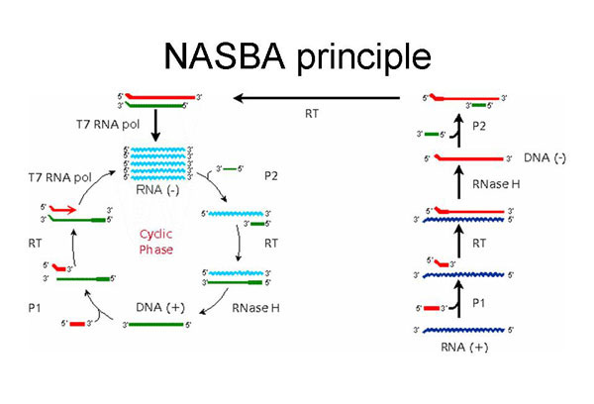
Nucleic Acid Sequence Based Amplification (NASBA) is an isothermic gene amplification method that has many features that make it well-suited for use in conjunction with liposomal-based biosensors, with and without the integrated IDA Microchip technology. NASBA amplification can be applied to both RNA and DNA targets. The reaction process for RNA analytes is shown in the following presentation (requires Power Point). The process is initiated by the annealing of an oligonucleotide primer (designated P1) to the RNA target present in the nucleic acid extract obtained from the test sample. The 3’ end of the P1 primer is complementary to the target analyte; the 5’ end encodes the T7 RNA polymerase promoter. After annealing, the reverse transcriptase activity of AMV-RT is engaged and a cDNA copy of the RNA target is produced. The RNA portion of the resulting hybrid molecule is hydrolyzed through the action of RNase H. This permits the second primer (P2; sense), which is complementary to an upstream portion of the RNA target, to anneal to the cDNA strand. This permits the DNA-dependent DNA polymerase activity of AMV-RT to be engaged again, producing a double stranded cDNA copy of the original RNA analyte with a fully functional T7 RNA polymerase promoter at one end. This promoter is then recognized by the T7 RNA polymerase, which produces a large amount (10 - 1000) of anti-sense, single stranded RNA transcripts corresponding to the original RNA target. These anti-sense RNA transcripts can then serve as templates for the amplification process, however the primers anneal in the reverse order. The entire NASBA process is conducted at 41oC, and the typical level of amplification is at least a factor of 109. For DNA, the process is the same except that an initial heat denaturing step is required before the addition of the enzymes to the reaction mix (100oC, 5 minutes).
7. Ligase Chain Reaction (LCR)
o Separation of a double stranded DNA by heat at 95 degrees.
o Annealing: 4 Synthetic oligonucleotide probes 2 for every side of the DNA are allowed to attach to their matcing base sequences on the separated DNA helicals and upon finding the perfect matching sequence on the target DNA fragment each 2 adjacent synthetic probes will by unite by ligase enzyme.
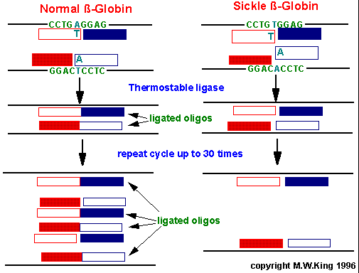
o The cycle is repeated as before.

The difference between PCR and LCR would be in that:
Ligase chain reaction overcomes the problem of inability to synthesize long nucleotide sequences, so instead small oligonucleotide probes (short sequence) are synthesized and then attached together by Ligase reaction.
Unlike PCR where mutation in the target DNA fragment is amplified as the probe extendes to cover the DNA fragment, in LCR if there is mutation in the target DNA fragment the 2 probes will not unite..no reaction.

Further reading
Ehrlich HA (1989) PCR Technology . Principles and Applications for DNA Amplification . Stockton Press, New York.
H.A. Ehrlich, D. Gelfand, and J.J. Sninsky. (1991). Recent advances in the polymerase chain reaction Science 252: 1643-1651. (PubMed)
Innis MA, Gelfand DH, Sninsky JJ, White TJ (1990) PCR Protocols. A Guide to Methods and Applications . Academic Press, San Diego, CA.
M.M. Ling and B.H. Robinson. (1997). Approaches to DNA mutagenesis: an overview Analyt. Biochem. 254: 157-178. (PubMed)
McPherson MJ, Taylor GR, Quirke P (1991) PCR: a Practical Approach . IRL Press, Oxford.
Newton CR, Graham A (1997) PCR , 2nd edn. BIOS Scientific Publishers, Oxford.

References
D.M. Bedwell, S.A. Strobel, K. Yun, G.D. Jongeward, and S.D. Emr. (1989). Sequence and structural requirements of a mitochondrial protein import signal defined by saturation cassette mutagenesis Mol. Cell Biol. 9: 1014-1025. (PubMed) (Full Text in PMC)
J. Chelly, J.P. Concordet, J.C. Kaplan, and A. Kahn. (1989). Illegitimate transcription: transcription of any gene in any cell type Proc. Natl Acad. Sci. USA 86: 2617-2621. (PubMed)
S. Cheng, C. Fockler, W.M. Barnes, and R. Higuchi. (1994). Effective amplification of long targets from cloned inserts and human genomic DNA Proc. Natl Acad. Sci. USA 91: 5695-5699. (PubMed) (Full Text in PMC)
V.G. Cheung and S.F. Nelson. (1996). Whole genome amplification using a degenerate oligonucleotide primer allows hundreds of genotypes to be performed on less than one nanogram of genomic DNA Proc. Natl Acad. Sci. USA 93: 14676-14679. (PubMed) (Full Text in PMC)
J. Cline, J.C. Braman, and H.H. Hogrefe. (1996). PCR fidelity of Pfu DNA polymerase and other thermostable DNA polymerases Nucleic Acids Res. 24: 3546-3551. (PubMed) (Full Text in PMC)
J.G. Hacia. (1999). Resequencing and mutational analysis using oligonucleotide microarrays Nat. Genet. 21 (1 Suppl.): 42-47. (PubMed)
Y. Hauge and M. Litt. (1993). A study of the origin of ‘shadow bands' seen when typing dinucleotide repeat polymorphisms by the PCR Hum. Mol. Genet. 2: 411-415. (PubMed)
Higuchi R (1990) Recombinant PCR. In: PCR Protocols. A Guide to Methods and Applications (MA Innis, DH Gelfand, JJ Sninsky, TJ White, eds), pp. 177–183. Academic Press, San Diego, CA.
P.M. Holland, R.D. Abramson, R. Watson, and D.H. Gelfand. (1991). Detection of specific polymerase chain reaction product by utilizing the 5′ → 3′ exonuclease activity of Thermus aquaticus Proc. Natl Acad. Sci. USA 88: 7276-7280. (PubMed) (Full Text in PMC)
C.C. Lee, X. Wu, R.A. Gibbs, R.G. Cook, D.M. Muzny, and C.T. Caskey. (1988). Generation of cDNA probes directed by amino acid sequence: cloning of urate oxidase Science 239: 1288-1291. (PubMed)
L.G. Lee, C.R. Connell, and W. Bloch. (1993). Allelic discrimination by nick-translation PCR with fluorogenic probes Nucleic Acids Res. 21: 3761-3766. (PubMed) (Full Text in PMC)
H. Li, U.B. Gyllenstein, X. Cui, R.K. Saiki, H. Ehrlich, and N. Arnheim. (1988). Amplification and analysis of DNA sequences in single human sperm and diploid cells Nature 335: 414-417. (PubMed)
D.A. Mead, N.K. Pey, C. Herrnstadt, R.A. Marcil, and L.M. Smith. (1991). A universal method for the direct cloning of PCR amplified nucleic acid Biotechnology 9: 657-663. (PubMed)
Newton CR, Graham A (1997) PCR , 2nd edn, pp. 75–84. BIOS Scientific Publishers, Oxford.
C.R. Newton, A. Graham, L.E. Heptinstall, S.J. Powell, C. Summers, N. Kalsheker, J.C. Smith, and A.F. Markham. (1989). Analysis of any point mutation in DNA. The amplification refractory mutation system (ARMS). Nucleic Acids Res. 17: 2503-2516. (PubMed) (Full Text in PMC)
E.M. Southern. (1996). DNA chips: analysing sequence by hybridization to oligonucleotides on a large scale Trends Genet. 12: 110-115. (PubMed)
R.K. Wilson, C. Chen, N. Avdalovic, J. Burns, and L. Hood. (1990). Development of an automated procedure for fluorescent DNA sequencing Genomics 6: 626-634. (PubMed)
L. Zhang, X. Cui, K. Schmitt, R. Hubert, W. Navidi, and N. Arnheim. (1992). Whole genome amplification from a single cell: implications for genetic analysis Proc. Natl Acad. Sci. USA 89: 5847-5851. (PubMed) (Full Text in PMC)

