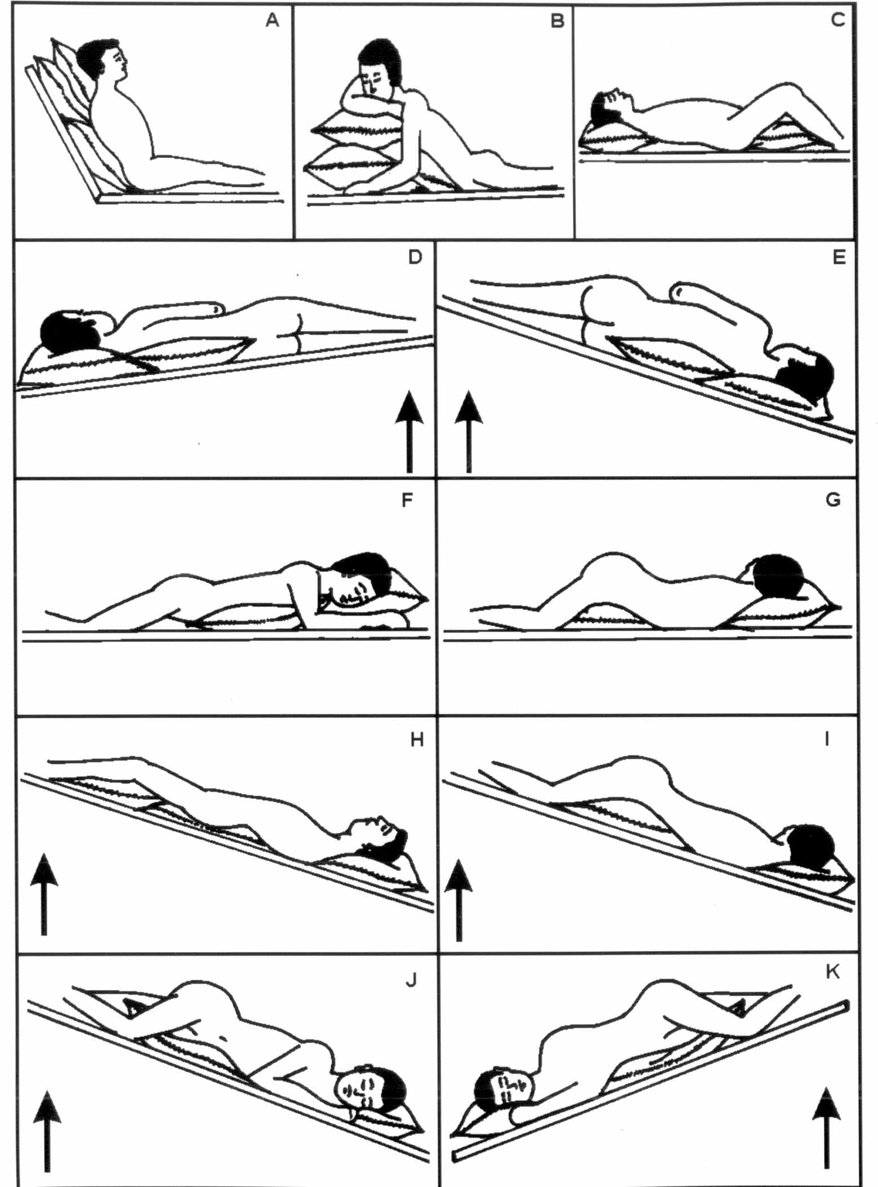
Upper Lobe:
Apical bronchus * - Sitting upright with slight variation according to the position of the lesion, i.e. slightly leaning backwards, forwards or sideways. (a)
Anterior bronchus * - Lying supine with the knees slightly flexed. (c)
Posterior bronchus:
Right - Lying on the left side and turn his face 45º resting against a pillow, with another pillow supporting the head. (f)
Left - Lying on the right side turning his/her face 45º with 3 pillows arranged to lift the shoulders by 12 inches. (b)
Middle Lobe (Right):
Lateral and medial bronchus -Lying supine with the body a quarter turned to the left maintained by a pillow under the right side from shoulder to hip and foot end raised by 14 inches (35 cms). (d)
Lingula (Left):
Superior and inferior bronchus -Lying supine with the body a quarter turned the right maintained by a pillow under the left side from shoulder to hip and foot end raised by 14 inches (35 cm). (e)
Lower Lobe
Apical basal bronchus* - Lying prone with a pillow under the hips. (g)
Anterior basal bronchus* - Lying supine with the buttocks resting on a pillow and the knees flexed. Foot of the bed raised by 18 inches (45 cm). (h)
Posterior basal bronchus* -Lying prone with a pillow under the hips. Foot of the bed raised by 18 inches (45 cm). (i)
Lateral basal bronchus* - Lying on the opposite side with a pillow under the hips. Foot of the bed raised by 18 inches (45 cm). (j)
Medial basal (Cardiac) bronchus -Lying on the right side with a pillow under the hips. Foot of the bed raised by 18 inches (45cm). (k)
Note: *means both sides.
Adopted from Ref.(4)

