PRESENTATION OF ALEVISM

WHO ARE ALEVIS?

Alevis are a sub-ethnic and cultural community from Anatolia (modern day Turkey), numbering in the millions. Alevis descended mainly from Anatolia.

Alevi belief is a way of life that also appears in other parts of the Middle East, Central Asia and the Balkans.

The Alevi path as a belief system is an ancient way of testifying that has been passed on through oral traditions in all of the languages with which Alevis have became acquainted. Oral tradition is directly relevant to the ethnic identity of Alevis. An important source of Alevi beliefs and thought are the mystical poems and musical ballads (deyisler, nefesler) that have been passed down from generation to generation, many of which have not been recorded in writing. Among the greatest Alevi-Bektashi poet-musicians (asiklar, ozanlar) are Yunus Emre (13-14th century), Kaygusuz Abdal (15th century), and Pir Sultan Abdal (16th century).

Humanistic attitude or what is often called Humanism is Alevis lens on and way of perceiving the world. In the Alevi path, divine presence is universal and resides in the heart of all humans.

This belief is based on love and respect for all people, attitudes, knowledge, sharing and science. Alevis believe that one must respect and have knowledge of nature. Alevi principles promote and encourage individuals to behave modestly, to feed, refine and mature. The principles of love, tolerance and humanism are significant to Alevi philosophy.

Alevis believe goodness in humans, and this is expressed by the Alevis saying: 'Insan Hakta Hak Insanda'. The Alevis do not believe in a god in an individualized form or as a universal force. Rather, god is within every human being as well as everything in the universe.

WHAT IS ALEVISM?

An Alevi is any Muslim who loves the family of the Prophet Muhammed.”
“An Alevi is simply any democratic, tolerant, human rights-promoting, modern-thinking person, whatever his religious background.”
“Alevism is the original, true essence of Islam.” “Alevism is a heterodox sect within Islam.”
“Alevism is the most authentic expression of Turkish Anatolian Islam.”
“Alevism is a philosophy, a ‘way of life.’”
“Alevism is pure sufism.”
“Alevism is pure Shiism.”
“Alevism is simply Sunni Islam with an extra emphasis on Ali.”
“Alevism is so syncretistic that it can't be counted as Islam at all.”
“Alevism is an alternative to orthodox Islam.”
“Alevism is an example of the classic Marxist struggle by an oppressed minority.”
“Alevism is a mixture of the best elements of Islam, Christianity, Judaism, Manichaeism, Zoroastrianism, Shamanism, and 20th century humanism.”

HISTORY

The Alevi belief and way of life have been around for thousands of years, and can be traced all the way back in history to the Sumerians.

The confusion over the Alevis is linked to a troubled past. Historically, Alevis have avoided bringing attention to themselves to avoid confrontation with authorities.

Authorities for centuries have oppressed, discriminated and massacred Alevis, forcing them into denial of their identity and assimilation into the dominant way of life. Alevis looked in hope for the establishment of the Republic of Turkey as liberation from the Ottoman oppression and religious discrimination. However, Alevis were once again not recognized as a distinct group and were oppressed, discriminated and politically assimilated. There were forced deportations by authorities, as well as masses of Alevis fleeing to other parts of Turkey and Europe because of fear for their lives. This resulted in much of the traditional Alevi culture and practices to be forgotten.

In 1925 the Turkish State adopted a policy of one race one religion, forcing Alevis to cloak themselves with Islamic veil to avoid persecution. In Alevi stories you will find some Islamic elements - this has been a deliberate way of hiding from those in power. Unfortunately policies allowing discrimination continues until today. One of the main obstacles for Alevis is the Turkish Governments perceptions of Turkey's identity - as being 99% Muslim.

The Alevi path, due to its unique identity, culture, communal structures and laws resisted against the dominant rulers. In the Alevi belief, there is a built in respect for other people's views and an emphasis on the mystical inner self. There is no support for power struggle in the Alevi philosophy. Alevi belief is dominated by deep humanism, love and tolerance.

The origins of Alevi philosophy is not the Middle East, nor Central Asia. Its birth place is Anatolia and Mesopotamia. For centuries ethnic and religious cultures living side by side have influenced one another. Therefore, in the Alevi practices we can see aspects of Zoroastrian , Shamanism, Judaism, and Christian rituals. Some claim Alevi path as an Islamic sect and denomination, but the only purpose of this has been to assimilate and dispose of the Alevi identity.

POLİTİCAL HİSTORY

Seljukies and later Ottoman State based their social law and philosophy on highly tolerant ALEVI belief system and this highly tolerant belief allowed them to convince different ethnic/belief groups to easily accept their governance. While Ottoman’s were rapidly expanding to west during 13th / 14th centuries, on their east other Turcoman tribes also established their own states with almost the same socially / religiously tolerant parameters. By 15th century Ottoman State found itself in conflict with three other Turcoman origined states, sharing the same belief system and traditions. Namely AKKOYUNLU, DULKADIROGULLARI and SAFAVİ states. Late 15th century saw increases of these conflicts and as result first major clash with these states OTLUKBELI war, was fought in 1483 with Akkoyunlus, this was followed by CALDIRAN war in 1514 with Safavis.
Ottoman emperor YAVUZ SELIM after winning a series of wars in Eastern Anatolia / Iran and Egypt decided to acquire KHALIF SHIP from Arabic reigns of EMEWIS and became the religious authority of Muslim World with the aim of using religious power for higher political stability and reduced resistance of ALEVI – Turkish population in especially Anatolia and other Eastern provinces that he was ruling.
As result of this political decision and after establishing stronger links with SUNNI Muslim theologists and authorities, OTTOMAN EMPIRE gradually converted itself to a SUNNI MUSLIM country, in spite of the fact that there was a continuous resistance from local population and various political / social unrests all over the country. SUNNI MUSLIM religious practices and superiorities given to ARABIC or Arab educated legal / religious staff, kept disturbing ALEVI Turcoman community in Anatolia and BEKTASHI community in BALKAN provinces, after 17th century Ottoman lived series of especially local unrests, Anatolian population kept resisting to SUNNI MUSLIM applications.
ALEVI BELIEFS AND WAY OF LIFE

Alevis do not wear any distinctive dress and cannot be distinguished from other people. Men and women have equal rights and responsibilities in life. In the Alevi philosophy humanity is the centre of universe and there is the unity of existence - people, nature, minerals and the universe are one. Alevis also hold dear the following values:
individual autonomy (the essence of human rights); personal responsibility (humans cannot pass this to 'higher forces'); no dogmas (no religious do's and don'ts: purity lays in someone's acts and thoughts), and Self-realization.
Men and women are given the same opportunities and take part equally in all aspects of life. In Alevi discourse, women are sublime (worthy of the highest moral and spiritual value) and you will find this philosophy condemning gender discrimination. As the following quote illustrates, in Alevi philosophy, it is not gender but peoples voluntary love, kindness, respect and contribution that is seen as superior.
My pilgrimage is towards mankind There is NO supreme religion, supreme race, supreme language, supreme culture, supreme gender in our belief.
Alevis interpret the Quran in an esoteric, allegoric, and symbolic (rather than literal) manner and repudiate the external forms of Islam and its five pillars. Alevi villages lack mosques, save those that were forcibly built in Ottoman times or built by Alevis themselves in recent decades in order to gain access to government funds. In addition to the Quran, Alevis have their own holy books called "buyruk " that contain doctrine and ritual and are claimed to have been written by important leaders. Alevis also have many liturgical hymns called nefes attributed to Shah Ismail and Pir Sultan Abdal.
Following a Sufi doctrine of the “Perfect Man,” Alevis believe that salvation exists in emulating such perfect models as Ali, Haci Bektaş and other Saints. But as Kehl-Bodrogi stresses, the absolute center of Alevi faith is the edeb moral code: the ideal Alevi is "master of his hand, his tongue, his loins," an ethic that forbids theft, lies, and adultery. Every man must seek "purity of heart" and self-knowledge, and piety is measured by lifestyle and not by ritual. Love and forgiveness are seen as important elements in interpersonal relationships.

No flower is better than another,
every flower has it's distinguished colour,
distinguished smell.
All Flowers are beautiful.
All mankind are beautiful!
All mankind are equal...
(Haci Bektas Veli, 1210-1300AD)
In Alevi cosmology all human beings are considered as "Can" or Life - living in all areas of social space.
The core Alevi belief is to purify oneself of their sub identities, such as race, religion, gender, language, status, and authority and return to their true core identity as a human being.

It is significant Alevi belief that is the absolute centre of Alevi behaviour is that 'control Real freedom is freedom from all forms of bondage. It can be achieved only through development and purification of one's own mind - purging and cleansing oneself from all taints of greed, hatred and delusion.

Another comes within' - the Alevis express this self-control by using the following moral code: "Eline, diline, beline sahip olmak".

ELINE: control of hand, formids killing, stealing or committing violence against another human.
DILINE: control of the tongue, formids gossip, lies or speaking maliciously.
BELINE: control of loins, formids adultery and non-consensual sex.

ALEVI RITUALS

An important part of the Alevi culture is Alevi Rituals. These rituals do not include the practice of prayer five times a day, attending mosque, fasting during Ramadan, undertaking pilgrimage to mecca or reciting from the Koran. Alevi's have their own prayer house called Cemevi and their own cultural and spiritual practices unique to their faith.
All Alevis are connected to or claim descent to a specific "Ocak" (Hearth/Caste) and all Ocak's are connected to a "Dergah" (lodges). The Alevi Institution comprises of the following:

Pir (Enlightened pure person; spiritual leader of a community)
Mursid (spiritual teacher)
Dede, Baba or Ana (an elder)
Rehber (a guide to the faithful)
Zakir (poet and musician)
Traditionally Dede/Ana's did not merely lead rituals, but led their communities. They also acted as judges or arbiters, presiding over community courts called "Hakkikat Meydani".
Dede/Ana performs the Cem rituals, leads funerals, teaches new generations, initiates the young, mediates conflicts and aids "Talips" (the disciples).

Cem's

One of the important Alevi rituals is the Cem. The Cem is a gathering of Alevi believers who come together to worship and establish "erkan" (a community court) to resolve community problems. It is conducted by an elder referred to as "Dede" or "Ana", accompanied by a "zakir" (musician and poet).

The most original and refined of Alevi – Bektashi rituals of belief is undoubtedly the "cem", which have several categories. The two main categories are (Görgü Cemi) and (Muhabbet Cemi). The cem ceremonies are conducted under several different names, depending on their aims, geographic regions, different traditions, etc. These differences are a reflection of the cultural wealth of these regions and the synthesis of several cultural traditions. Because of their cultural and sociological significance, cem ceremonies are considered a treasure in Anatolian ethnology.

The Alevi world view has set out several moral principles (not harming any living being without reason, principles of self-control, non-discrimination, etc.) which are transmitted to individuals during cem ceremonies and other rituals. Those who do not observe these rules are chastised with specific punishments, which can go from a simple excuse to full repentance, and may include financial and corporal punishment (such as making husbands who have beaten their wives to stand up with a big weight on their shoulders), and in extreme cases might result in the exclusion from the spiritual path or society altogether.

There are several important elements in a Cem gathering, some of which include:

Dede / Ana - an elder that conducts the Cem ritual
Rehber - guide and communicator between the "Dede/Ana" and the disciples
Zakir - a musician ,who plays the "saz" and recites spiritual songs and poems
Erkan - a community court comprising of equal numbers of men and women, who are mature and respected community members
Cerag - lighting of a flame, which symbolizes the lighting of the path
Kurbanci - person responsible for the offering
During this gathering, spiritual dancing of semah and music played by the saz is performed. This is followed by the sharing of a meal called lokma which is provided by the community.
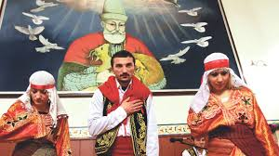
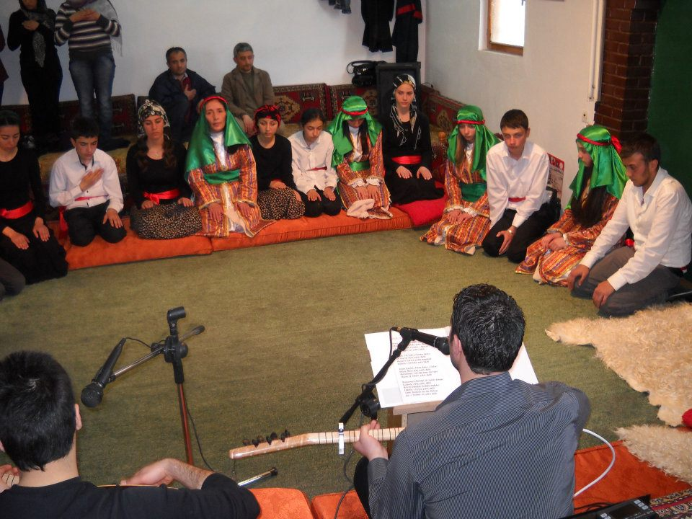

SEMAH

The Semah, which is a spiritual dance, is an important part of the Cem and is characterized by turning and swirling. This dance of worship has many varieties. The semah is performed by men and women to the accompaniment of the Saz or the lute. The semah is an inseparable part of any Cem. Semah can be described as a set of mystical and aesthetic body movements in rhythmic harmony. They constitute one of the twelve main services found in Cem rituals, religious practices performed by adherents of Alevi-Bektaşi, a belief system based on admiration for Ali, the fourth caliph after the prophet Muhammed. Semahs are performed by semahçıs (Semah dancers), accompanied by devout musicians playing the saz long-necked lute. Various forms of Semah exist in Alevi-Bektaşi communities across Turkey, each with distinct musical characteristics and rhythmic structures. One consistent characteristic is the performance of the ritual by both men and women, side by side. Semah rituals are founded upon the concept of unity with God as part of a natural cycle: people come from God and return to God. There are two forms of Semah: İçeri Semah are performed in Cems only among adherents as part of the twelve services; Dışarı Semah are performed independent of services to promote Semah culture to younger generations. Semahs are the most crucial means for the transmission of the Alevi-Bektaşi tradition. All practices, traditional motifs and teachings are passed on orally, and distinct genres of art and literature associated with the tradition continue to thrive. In this way, Semahs play a crucial role in fostering and enriching the traditional music culture of Turkey.
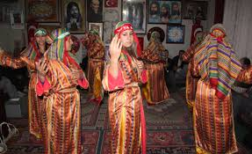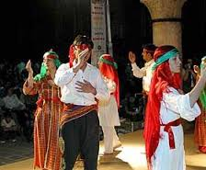

Musahiplik (Fraternity)

Musahiplik is a form of ritual kinship or brotherhood which links two men together, obliging them to unending support of one another in a variety of forms, including economic and moral support. This support is unending in that, once the tie between two men has been recognized by a dede, it is assumed to survive even into the next world, where the two men will recommend one another to God on the Day of Judgement. However, this form of commitment and support is not open to all Alevis, but only to those especially initiated for it by the dede, who must first recognize the couples’ preparedness in terms of their spiritual growth. As such,musahiplik should not be considered a necessary element for all Alevis, but it certainly must be acknowledged as an integral aspect of Alevi religious culture, as it is present in all known rural Alevi communities which are organized around an ocak or ‘Holy Family.’ One can be Alevi without it, but to achieve it is to attain a higher stage in the striving for spiritual perfection and thus to be honored by the community for this achievement.

Muharrem Orucu (Muharrem Fast) and Aşure

In the Alevi belief, another ritual called Muharren Orucu is a major Alevi fast which is generally held in the first 12 days of the month of Muharrem. In addition to abstaining from food, many Alevis who fast during these 12 days, also abstain from drinking water both day and night. They will intake liquids other than water. During this fast, Alevis will also avoid any sort of comfort or enjoyment. The main purpose of this fast is to mourn the death of Ali's son, Huseyin, during the battle of Kerbela.

At the conclusion of the fast of Muharrem, a special food dish called ashure (asure) is prepared from a variety (often 12 in number) of grains, fruits and nuts. Many events are associated with this celebration, including the salvation of Hüseyin’s son, Zeynel Abidin, from the massacre at Kerbela, thus allowing the bloodline of the family of the prophet to continue. This is shared amongst community members.

Abdal Musa Feast

Another significant event in the Alevi faith is the Abdal Musa Feast. The Abdal Musa Feast is a celebration where the traditions of unity and togetherness are preserved. The Abdal Musa Feast has been celebrated by the Anatolian Alevis since the 14th Century.

Abdal Musa was one of the most significant saints in the Alevi tradition. His philosophy is to love one another, share the wonders of the world, and help those less fortunate than themselves.

The Abdal Musa feast is a celebration of peace, love and togetherness, where a meal of bulgur rice and meat of offering is cooked in communal pots. After a blessing by the Dede or Ana, an Alevi elder and spiritual leader, the meal is shared by all.

Abdul Musa celebrations include music and the mystical dance called Semah, accompanied by the sacred ritual instrument known as the Saz.

Nevroz

Nevroz falls on 21 March and marks the first day of spring and the beginning of the year. It is celebrated my many ethnic groups, including Alevis and represents a day of newness, reconciliation and the start of spring. Alevis celebrate Nevroz with "Cems" and other special programs. In 2010, the UN's General Assembly recognized the International Day of Nevroz, describing it a spring festival of Persian origin which has been celebrated for over 3000 years.

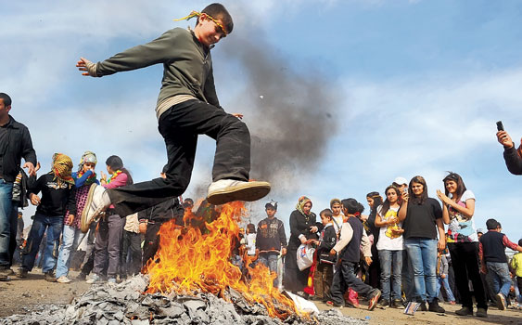

Hızır Orucu (Hizir Fast)

Another Alevi fast is the three-day Hizir fast (Hizir Orucu), generally observed 13-15 February. Many Alevis fast during this time to honor Hizir, a holy figure who they believe saves those who are in distress. Alevi's call on him for help and rescue. Hizir is the patron saint of travelers, protecting them from the dangers and difficulties of the road. Alevis have dedicated a specific day to him in February called "Hizir Day". This is a day of prayer, contemplation, mysticism, healing, wish-fulfillment, music, poetry and festivities. After fasting for three days, Alevis gather and call on Hizir to be with them at all times. This special celebration includes special foods, the performance of sacred Semah, and singing sacred songs.

HIDIRELLEZ

"Hidir Ellez" is the day on which prophets Hızır and Ilyas met with each other on earth. Some hold that Hıdır comes to the rescue of those in distress on land, while Ilyas helps those at sea; and that they meet at a rose tree in the evening of every 6 May. The words Hızır and Ilyas have since fused together and is pronounced as
Hıdırellez. Hıdırellez falls on May 5-6. There are various theories about the origin Hıdırellez. Hızır is the symbol of spring, and the new life which emerges with it.

Hıdırellez, which is still celebrated in Anatolia, has been celebrated since ancient times. Although it is celebrated under different names and in different times, it is possible to see the motifs of Hıdırellez in many places. The arrival of spring and awakening of nature have been perceived by mankind as a phenomenon to be celebrated. In fact, Hıdırellez, as a spring festival, has a universal character.

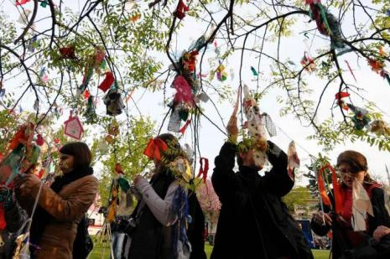

KARBALA AND MOURNING

Karbala and Mourning : The month of Muharram (the first month of the Islamic calendar) is a month of mourning due to the events that took place in Karbala. On the twentieth day following Eid-ul Adha, the Muharram fasting begins, lasting twelve days. Very little is eaten and one drinks as little water as possible. The fasting ends on the 12th day (10th among the Bektashi) with the distribution of asure (a desert with a wheat and chickpea basis and several ingredients). In Alevi-Bektashi belief, the tenth day of Muharram is not only the anniversary of Hussein's martyrdom in Karbala, but of many other events, such as Heaven's acceptance of Adam's repentance, the deliverance of Moses' people, the rescue of Abraham from fire, the reunification of Jacob with Josef, the return of the dove to Noah with an olive branch in its beak, the escape of Jonah from the fish's belly and the ascension of Jesus. This day is commemorated with a cem ceremony. The amount of daily water intake is slightly increased at this stage, but water-fasting continues until the 12th day of Muharram when Hussein was buried.

During this period, some Alevi tribes (such as yörüks) do not kill animals or cut trees, do not use sharp instruments, shed blood, or eat meat or eggs. They avoid holding knifes – in some villages, even onion is cut and prepared before Muharram. Verbal disputes and swearing are completely forbidden.

RELATIONSHIP TO SUNNI ORTHODOXY AND FUNDAMENTALISM

The relationship between Alevis and Sunnis is one of mutual suspicion and prejudice, dating back to the Ottoman period. Sunnis have accused Alevis of heresy, heterodoxy, rebellion, betrayal and immorality. Alevis, on the other hand, have argued that the original Quran does not demand five prayers, nor mosque attendance, nor pilgrimage and that the Sunnis distorted early Islam by omitting, misinterpreting, or changing important passages of the original Quran, especially those dealing with Ali and ritual practice. Alevis see Sunni narrowmindedness as originating in Arabia and as contrary to the Turkish national character. Sunna and
Hadith were Arab elite innovations, created to ensure Arab dominance of Islam and to enslave the masses through manipulation. All evil developments in Islam are seen as the fault of Arab society and character. Sunnism, according to the Alevis, is not true Islam but an aberration that by its strict legalism opposes free and independent thought and is seen as reactionary, bigoted, fanatic, and antidemocratic. Alevis believe Sunni nationalism is intolerant, domineering, and unwilling to recognize Alevi uniqueness.
The ideals of equality, justice, and respect for all are prominent in Alevi society and give Alevi women a more respected status than that of Sunni women. Alevi women do not need to be veiled and are not as segregated, nor must they fear polygamy or one-sided divorce as Alevis practice monogamy.Women also partake equally in the religious life of the community. In today’s political arena Alevis see themselves as a counterforce to Sunni fundamentalism, ensuring the continued secularism of Turkey. Alevis, who have a great interest in blocking the rising fundamentalist influence, are the main allies of the secularist forces, and are also searching for alliances with moderate Sunnis against the extremists. They are demanding that the state recognize Alevism as an official Islamic community equal to, but different from Sunnism.

ALEVI VIEWS OF ALEVISM

Alevis situationally prioritize various aspects of their identity presenting Alevism as a separate religion, a belief-system, the true Islam, an Islamic Caferi madhab, a Sufi tariqa, an ethnic group, a philosophy, a worldview, a way of life, a political position, a social opposition, a culture, and a civilisation. They believe their religion isone of reason and wisdom which stresses education, is progressive, stands for secularism, democracy and science, promotes personal and public honesty, and is compatible with modernity. In the nationalist discourse of modern times Alevis see themselves as the "real Turks", maintainers of true Turkish culture, religion and folklore in face of the Arabizing Ottoman Sunnis. This view has been strengthened by the Kemalist stress on Anatolian culture as the authentic source of Turkish national identity.Since the beginning of the republic, the Alevis claimed Turkishness as a main marker of their community. Alevism, according to them, is a Turkish-Anatolian religion combining Islam with elements of Turkish culture including Shamanism. Their faith is much more suitable for Turks than Arabic Islam as it includes Turkish traits supposedly suppressed by Sunnism, such as tolerance, humanitarianism, egalitarianism, and a stress on the inner religion of the heart. Alevis view themselves as the true preservers of authentic Turkish culture, religion, and language amidst Ottoman pressures to Arabize or Persianize. In sum, the Turks are the real guardians of Islam, and the Alevis are the real Turks.

ALEVİ VİEWS OF HZ. ALİ

The name Alevi can be simply translated into English as “of Ali” or “follower of Ali.” It fits a pattern in Turkish for common names of two other major religious groups: Musevi, (follower of Moses (Musa), or Jewish); and Isevi, (follower of Jesus (Isa), or Christian).
There is much debate as to actually when the broad Anatolian population which today call themselves Alevis actually took on that name. For our purposes here, it is enough to simply know that today they do prefer to call themselves Alevi.
It is visibly obvious that Ali is extremely important to modern Alevis. His picture is
prominent in every Alevi worship place and association, and it often appears on the cover of Alevi publications. Many families place pictures of him in their homes. And some, particularly young people, wear small gold replicas of Ali’s sword, zülfikar, attached to chains around their necks.

Essential Views

While there is a wide variety of opinions among Alevis about exactly who Ali was or is, almost all Alevis agree on the following:

1. Ali was Muhammed’s cousin (amca oglu) and son-in-law (damat), marrying the prophet’s daughter, Fatima.
2. Ali was the first to believe in Muhammed's prophethood; therefore he became the first Muslim.
3. Ali was the closest human being to Muhammed.
4. Ali was Muhammed’s intended successor, and therefore the first caliph, but competitors stole this right from him. Muhammed intended for leadership of Muslims to perpetually stem from his family line (Ehli Beyt) beginning with Ali, Fatima, and their two sons, Hasan and Hüseyin. Ali, Hasan, and Hüseyin are considered the first three imams, and the other nine of the 12 imams (oniki imam) come from Hüseyin’s blood line.

PROPHETS FOR ALEVİS

Alevis in general express belief in the prophets mentioned in the Kuran. These were men chosen by God for specific purposes for specific times. Moses, David, Jesus and Muhammed received major books from heaven. Others, like Abraham and Noah, also received small amounts of written revelation from God. Most Alevis say that all the prophets were sinless.
Some say that all the prophets were human representations of God.

Jesus

To the majority of Alevis, Jesus is no more or less great than any of the other prophets. He is known specifically as the prophet of the Christians, and the prophet to whom the Gospel (Incil) “descended upon.” Some Alevis believe the Kuran literally where it says that Jesus was born of a virgin. Alevis who do not believe in the supernatural do not believe the Biblical stories of Jesus's virgin birth, his working miracles, and his resurrection from the dead.
However, almost all Alevis who have read the New Testament (also Incil in Turkish) strongly identify with how Jesus acted toward the religious fanatics and hypocrites of his day. Alevis are also surprised at how Jesus summarized all of the teaching of the Torah, the Psalms, and the prophets in two simple commands: “Love God with all of your heart, soul, mind, and strength; Love your neighbor as yourself.” This essential teaching of Jesus reminds Alevis of their basic values of “love of God and love of man” (Tanri sevgisi, insan sevgisi).
Some Alevis are aware of the teaching of Jesus’ second coming to earth. Among these Alevis, some say that Jesus is the same person as Mehdi, the 12th imam, who they are return to earth.

CURRENT SOCİAL ISSUES

Women

Alevis are proud to point out that they are monogomous, Alevi women worship together with men, Alevi women are free to dress in modern clothing, Alevi women are encouraged to get the best education they can, and Alevi women are free to go into any occupation they choose.

Democracy

In a debate between democracy and Islamic law, or sharia (seriat), it would be almost
impossible to find an Alevi who would argue against democracy and for rule by religious law.
Nearly all Alevis are for equal rights for minorities and women, the rule of constitutional law,
tolerance and equal rights for all religions, and freedom of speech.

Mustafa Kemal Atatürk

Almost all Alevis speak of Ataturk (Mustafa Kemal Atatürk) with great respect. They believe his reforms placed Turkey on the road to become socially progressive, educationally advanced, and technologically modern. Many hang pictures of Ataturk in prominent places in their homes, offices, associations, and worship centers right next to their pictures of Ali and Haji Bektash. Long marginalized and discriminated against under the Ottomans, rural Alevis were great supporters of Kemal Ataturk’s Young Turk ideology, which stressed European-type nationalism as the basis of state unity and secularism as the guarantee of modernization and progress. The new construct of an authentic Turkish nationalism favored the Alevis as the true bearers of the ancient Turkish Anatolian language and culture, while secularism promised them equality with the Suni majority. For his part, Ataturk saw the Alevis as natural allies in his struggle against the traditional Ottoman elite and he selectively included Alevi cultural markers in his construct of the new Turkish national identity.

Secularity

Alevis are almost universally in favor of separation of religion and state, or secularity
(laiklik). Alevis often discuss these main issues connected with secularity in Turkey today:
1. the required religion courses in schools;
2. whether Alevis should be officially recognized as a distinct religious group;
3. the existence, activities, and funding of the government's Department of Religious Affairs (Diyanet İşleri Başkanlığı).

Pir Sultan Abdal

Pir Sultan Abdal dominates the Turkish Alevi-Bektaşi oral lyric tradition in his influence through text and persona and is counted as one of the seven great bards, the yedi ulu ozan, of Alevi-Bektaşi ritual tradition.The legendary story of Pir Sultan Abdal is understood from songs that are part of the Pir Sultan Abdal tradition as well as from folk legends, the latter collected particularly from the Sivas region.
Pir Sultan Abdal presents a complex persona encompassing the mystical expression of sixteenth-century antinomianism together with a personal story of integrity and betrayal. This faceted persona has provided, in the texts attributed to him and identified as such by the self-naming device (mahlas), the substance for the production of interpretative works and discourse, especially in recent decades.
The significance of the figure of Pir Sultan Abdal can be understood from the number of deyiş attributed to him and, perhaps more importantly, from the influence that both his lyrical works and his persona maintain over Alevi-Bektaşi ritual and, especially, social and political culture from his home and heartland in Anatolia to the Balkans and beyond to the modern Alevi disapora in Europe and elsewhere.
Pir Sultan Abdal emerged from the esoteric and guarded community of Alevi ritual and culture into a wider public scrutiny shortly after the establishment of the Turkish Republic in 1923.

HACIBEKTASH AND BEKTASHISM

Somewhat distinct from but quite similar to Anatolian Alevism is a religious order or sect (tarikat) called the Bektashis, named after Haji Bektash (Hünkâr Haci Bektas Veli), who lived in the 13th century. There have historically been two groups of Bektashis. One, called the Çelebis, claimed that they were direct physical descendants of Haji Bektash (bel evladi). A larger group of Bektashis, called the Dedes or Dedebabas,claimed that Haji Bektash had no natural sons but only had spiritual disciples (yol evladi). Bektashis are found throughout Anatolia and the Balkans, particularly in Albania.
It has been commonly explained that a person only becomes an Alevi by being born into an Alevi family, but a person can become a Bektashi by joining the sect. In a very broad historical generalization, it has been said that Bektashis were traditionally urbanized and educated while Alevis lived in villages in the Anatolian countryside.
To show that modern Alevi and Bektashi groups have much more in common than they have differences, Alevis will often talk about “Alevi-Bektashi culture” (kültür) “Alevi-Bektashi faith” (inanç), or “Alevi-Bektashi philosophy” (felsefe). Many describe the differences between the groups with these statements: “There is no difference in path, just in practices” (Yol farki yok, sürek farki var) and “
The way is one, the form a thousand and one” (Yol bir, sürek bin bir).
Alevis today place great importance on Haji Bektash. They proudly display his picture in their associations and worship centers. They name associations after him. They often quote sayings attributed to him. Hundreds of thousands of Alevis visit his tomb in Kirsehir every August.
There is very little actual historical detail available about Haji Bektash. It is almost
universally accepted that he was a Turkmen born in Horasan in Iran, trained as a mystic, moved to Anatolia, settled in what is now the town of Haji Bektash, and died around A.D. 1271. Beyond these few facts there are many stories about Haji Bektash whose truth is debated. Most of these stories show Haji Bektash as a man with supernatural wisdom and powers.
Today, Alevis love to quote sayings attributed to Haji Bektash. Here is a sample:

“Seek and find.”
Ara bul.
“Don’t forget that your enemy is also a human being.”
Düsmaninizin dahi insan oldugunu unutmayiniz.
“Teach the women.”
Kadinlari okutun.
“Don’t do to anyone what you don’t want done to you.”
Nefsine agir geleni kimseye tatbik etme.
“Do not criticize any man or people.”
Hiç bir milleti ve insani ayiplamayiniz.
“Even if you are offended, do not offend in return.”
Incinsen de incitme.
“Take responsibility for your words, actions, and morals.”
Eline diline beline sahip ol.
“Take responsibility for your own spouse, job, and nourishment.”
Esine, isine, asina sahip ol.

SOURCES:

David Zeidan, THE ALEVI OF ANATOLIA, Volume 3, No. 4 - December 1999, Middle East Review of International Affairs
John Shindeldecker, Turkish Alevis Today, http://www.alevibektasi.org/xalevis1.htm
Alevilik'te Hizir, http://www.aleviakademisi.org/component/content/article/47-alevilikte-kutsal-gunler/162-alevilikte-hzr.html
Nevroz, http://en.wikipedia.org/wiki/Nevroz
What is "Hidrellez"?,http://www.hidrellez.org/english.asp
A Turkish university professor’s socio-historical analysis of scholarly and popular views of Alevi-Bektashism.
Uyur Idik Uyardilar.
Melikoff, Iréne (Cem Yayinevi, 1993)

