Local Administration, Urban Planning, and Public Participation in Greece: Developments, Conflicts, Perspectives

Κ. Lalenis

Law
  - Rules of conduct of any organized society, however simple or small, that are enforced by threat of punishment if they are violated. (Columbia Encyclopedia, Sixth Edition, 2001).
  - a. A rule of conduct or procedure established by custom, agreement, or authority. B. The body of rules and principles governing the affairs of a community and enforced by a political authority. (The American Heritage® Dictionary of the English Language: Fourth Edition. 2000).

Policy
- A plan or course of action, as of a government, political party, or business, intended to influence and determine decisions, actions, and other matters. (The American Heritage® Dictionary of the English Language: Fourth Edition. 2000).
- An official or prescribed plan or course of action. (Roget’s II: The New Thesaurus, Third Edition. 1995).

Four distinct periods can be identified in the evolution of systems of Local Administration in Greece (Beriatos, 1994):
- The period of Kapodistrias (the first Governor of the new Greek State) and the succeeding administration of the Bavarian Court of the first king Othon (1828 – 1887).
- The period of great reforms of Prime Ministers Trikoupis and Venizelos (1887 – 1927).
- The period of relative stagnation before and after the second World War (1927 – 1974).
- The period of recent reforms and efforts towards modernization of administration.

Period of I. Kapodistrias and the Bavarians (1828 – 1887).

Local Administration:

During the Ottoman Empire, local administration was decentralized.
Ioannis Kapodistrias and his efforts for an effective central administration.
Organization of local administration by the Bavarian Court:
10 Prefectures (Nomarchia), 47 Counties (Eparhia), 750 Municipalities (Demos) (later 442).
Elected: Municipal representatives. Still strong municipalities.

Urban Planning:
First urban plans: Patras (1828), Pylos (1829), Athens (1830), Nafplion (1834).
Royal Decree of 3-4-1835 “Concerning the “healthy” structuring of cities and towns”. Focus on construction.
Royal Decree 5-6-1842, approving Urban Plans of Athens and Ermoupolis.
Planning Law of 1867. Housing squares, building regulations etc.
No regional planning.
1843: Tanzimat. Tobacco warehouses in Kavala. Drama, Xanthi. 1865: Orient Express.

Participation:
No public involvement. Police responsible for implementation of urban planning.

Period of Great Reforms by E. Venizelos and H. Trikoupis (1887 – 1927).

Local Administration

1864: elected municipal authorities. Mayors gaining power.
Trikoupis (1887): abolished counties, reorganized prefectures.
Venizelos (1912): created 6000 small communities, organized prefectures. French influence.
Two levels of local administration: prefectures and municipalities/communities.
Elected: municipal/community representatives.

Urban Planning
1892-98 the making of Alexandroupolis.
1917: Big fire in Thessaloniki. Wave of Jewish migration. L. 823/1917 (Papanastasiou), Hebrard Ernest-new plan, 29/6/1918.
1923: 1.300.000 refugees in Greece.
Policy to resettle the refugees: three organizations responsible, private, public, and public/private. Land allocation, new settlements, financial aid etc.
Legislative Decree 17-7-1923 “Concerning the plans of cities, townships and communes of the State”.
City Plans.

Participation
Obligation of local municipalities to express opinion. Public: appeals only in case of “legitimate interest”.

Period of Relative Stagnation before and after World War II (1927 – 1974).

Period of political instability. WW2, civil war, repression, military dictatorship. No worth mentioning reforms or changes.

Local Administration
Two levels of local administration: prefectures and municipalities/communities.
Elected: municipal/community representatives.
Local government of EAM governed settlements.

European influence
Reforms in Europe in local administration, fewer and stronger municipalities.

Urban Planning
Land allocation used as a political tool.
Legislative Decree 1003/1971 “Concerning active urban planning”.
Zones designated for development of improvement (ZEP).
Legislative Decree 1262/1972 “Concerning master plans for urban areas”.
Regional plan, master plan, urban plan, land use.
Legislative Decree 8/73 “General Building Code”.
French and German influences.
Duplication of planning responsibilities of the ministries.

Participation
Advisory role of municipalities, public lodging objections.

THE PERIOD after the reestablishment of democracy and until the Turn of the Century.

Political stability, participation in E.U. Key words: Modernization, harmonization. But also, outdated legislation, deterioration of urban and physical environment, illegal construction.

Developments in Local Administration.

Ministry of Planning: 1983: “urban compounds”: 54 “urbanized areas”/cities, 494 “open cities”.

Ministry of Internal Affairs: Law 1416/1984, “development conjunctions” in “geographic entities”. Voluntary. French influence (SIVOM). Ignores “open cities”. Poor implementation.
Two levels of local administration: prefectures and municipalities/communities.
Elected: municipal/community representatives.

Ministry of Internal Afffairs: Law 1622/86, “enlarged municipalities” in “geographic regions”. “Central” characteristics (as opposed to “federal” ones of “open cities”. Poor implementation.
Three levels of local/regional administration: regions (13), prefectures and municipalities/communities.
Elected: municipal/community representatives.

Ministry of Internal Affairs: Law 2218/94, “district councils”. Obligatory.
Three levels of local/regional administration: regions (13), prefectures and municipalities/communities.
Elected: municipal/community and prefectural representatives.

Stormy succession of invalidating previous laws. Poor policies.

Ministry of Internal Affairs: Law 2539/98 (program I. Kapodistrias). Fewer and stronger municipalities: from 5755 to 1033. European funding. Diversion from French model (the traditional donor of institutional transplants in local administration).

Developments in Urban Planning.

Ministry of Planning: Law 947/1979.Influence from French and German laws. General study, urban study. Urban study: zone of active urban planning, urban land consolidation, normative building regulations.
Contributions in land and money.

Also, L. 360/76 “concerning regional planning and the environment” (KEPA), L. 651/77 and L. 720/77 “concerning illegal construction”, Presidential Decree 6/17-10-78 “concerning construction out of city plans”, L. 880/79 “concerning transfer of building ratios”, L. 998/79 “concerning construction of garages”, L. 1032/80 “concerning the establishment of the ministry of planning”.
From the above, only one (947/79) with a global and innovative approach in planning, and two (360/76, 1032/80) backed related policies.
Poor planning outcomes, very centralized system.

Ministry of Planning: Law 1337/1983. General development plan, urban study/ revision – extension plan, implementation act. Illegal housing. Contributions in land and money (new way of estimation). Neighbourhood planning committees. “Transitional” which became permanent.

Urban reconstruction operation. Cities and “open cities”.
Regional planning proposal for each prefecture. First regional planning policies.
Attempts for decentralization, participation (populist means), but also poor implementation level. Decline of EPA at end of 80’s. Replacement of minister. Lack of cooperation between ministries.

Ministry of Planning: Law 2508/1997. A. Master plans (rythmistiko), program for the protection of the environment, general development plan, plan of organization of space and housing of “open cities”. B. Revision/extension plans, implementation acts, special urban studies (regenerations etc.).
Lack of supporting policies.

Law 2742/99 about regional planning and sustainable development.

Other pieces of legislation for local administration, never implemented. The 21st century.

A new law : L. 2946/2001 towards further enlargement of administrative units of the first level (“Sympolitia”).

Two proposals for new laws under discussion (remained as such):
“Democratic Decentralization” : Complementary to Law 2946/2001. Describes organizational structure (General Assemblies). Local councils in small communities meant to be abolished.

“Greek Atlas of Local Administration” : Extensive piece of legislation.
Two, rather unspecified, levels in local administration. Autonomy of the third level of local administration, still vague.

Judicial intervention in planning.
Transfer of building ratios, approval of urban plans, legitimacy of urban plans according to the way of being published in the Official Journal of the Government etc. Debate about the role of judiciary.

Recent and present reform: program Kallikratis

Οι δήµοι και οι περιφέρειες συγκροτούν τον πρώτο και δεύτερο βαθµό τοπικής αυτοδιοίκησης και ως έκφραση της λαϊκής κυριαρχίας αποτελούν θεµελιώδη θεσµό του δηµόσιου βίου των Ελλήνων, όπως αυτός κατοχυρώνεται από τις διατάξεις του άρθρου 102 του Συντάγµατος και του Ευρωπαϊκού Χάρτη Τοπικής Αυτονοµίας που κυρώθηκε µε το ν. 1850/1989 (ΦΕΚ 144 Α΄).

Οι Αποκεντρωµένες Διοικήσεις συγκροτούνται ως ενιαίες µονάδες για τις αποκεντρωµένες υπηρεσίες του κράτους και ασκούν γενική αποφασιστική αρµοδιότητα στις κρατικές υποθέσεις της περιφέρειάς τους, σύµφωνα µε το άρθρο 101 του Συντάγματος.

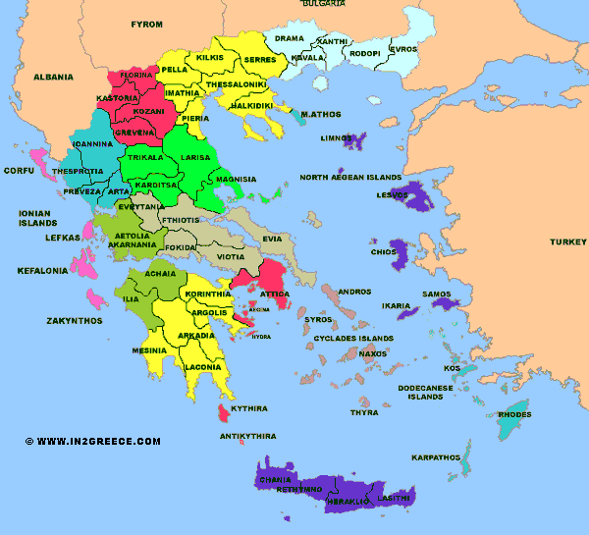

Χάρτης της Ελλάδας

Οι 13 Περιφέρειες και οι νομοί της χώρας

Ο νέος αυτοδιοικητικός χάρτης της χώρας

Από την 1-1-2011:

η χώρα χωρίζεται σε 13 περιφέρειες που εδαφικά συμπίπτουν με τις υπάρχουσες σήμερα.

Σε επτά αποκεντρωμένες διοικήσεις:

1 Αττικής με έδρα την Αθήνα

2 Θεσσαλίας-Στερεάς Ελλάδας με έδρα τη Λάρισα

3 Ηπείρου-Δυτικής Μακεδονίας με έδρα τα Ιωάννινα

4 Πελοποννήσου-Δυτικής Ελλάδας και Ιονίου με έδρα την Πάτρα

5 Αιγαίου με έδρα τον Πειραιά

6 Κρήτης με έδρα το Ηράκλειο

7 Μακεδονίας-Θράκης με έδρα τη Θεσσαλονίκη

Και 325 δήμους

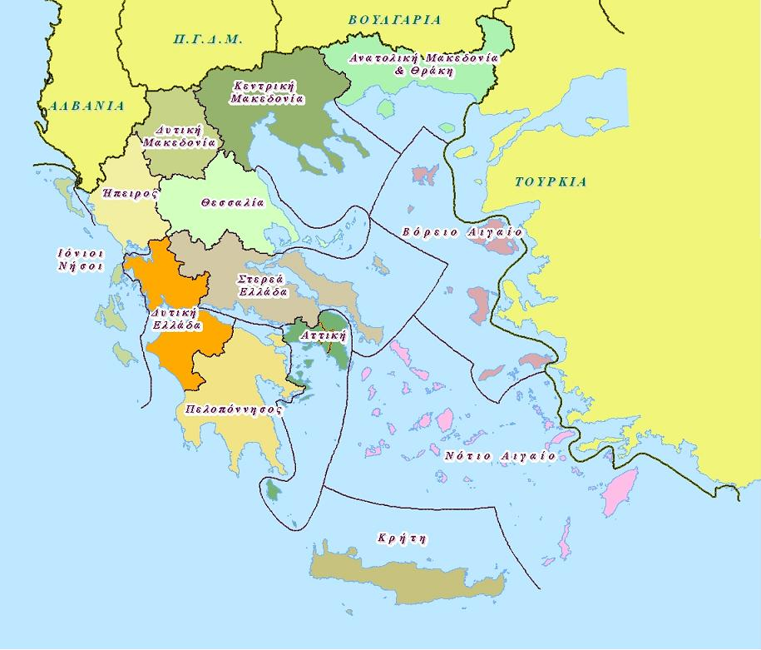

Τι προβλέπει το Σύνταγμα

Στο 102 άρθρο του Συντάγματος κατοχυρώνονται οι δύο βαθμοί της Τοπικής Αυτοδιοίκησης στη χώρα.

Με τον Καλλικράτη έχουμε τους Δήμους να αποτελούν τον πρώτο βαθμό και τις Περιφέρειες το δεύτερο.

Οι Αποκεντρωμένες Διοικήσεις είναι λειτουργία του Κεντρικού Κράτους.

Η Ελλάδα έχει ψηφίσει- και αποτελεί νόμο του κράτους- τον Ευρωπαϊκό Χάρτη της Τοπικής Αυτονομίας (Ν.1850/1989, ΦΕΚ 114/τ.Α), που υπο- γράφτηκε στο Στρασβούργο στις 15-10-1985.

Responsibilities of Local Authorities in Urban Planning.

L.D. 17-7-1923: obligation for expressing oppinion.
Law 947/1979: advisory role, written appeals/objections.
Law 1337/1983: propose studies, express opinion, approve urban study (criteria). Public participation, neighborhood planning committees.
Law 2508/1997: Master plan approved by ministers, g.d.p. approved by general secretary of region, revision /extension plans approved by prefect or by mayor (criteria).
Recent changes……

