Πολυπλεκτης
library ieee;
use ieee.std_logic_1164.all;

entity Mux_4_To_1 is
port (
i_Select : in std_logic_vector(1 downto 0);
i_Data1 : in std_logic;
i_Data2 : in std_logic;
i_Data3 : in std_logic;
i_Data4 : in std_logic;
o_Data : out std_logic
);
end entity Mux_4_To_1;

architecture RTL of Mux_4_To_1 is
begin
o_Data <= i_Data1 when i_Select = "00" else
i_Data2 when i_Select = "01" else
i_Data3 when i_Select = "10" else
i_Data4;

-- Alternatively:
with i_Select select
o_Data <=
i_Data1 when "00",
i_Data2 when "01",
i_Data3 when "10",
i_Data4 when others;

-- Alternatively:
p_Mux: process (i_Select, i_Data1, i_Data2, i_Data3, i_Data4) is
begin
case i_Select is
when "00" =>
o_Data <= i_Data1;
when "01" =>
o_Data <= i_Data2;
when "10" =>
o_Data <= i_Data3;
when others =>
o_Data <= i_Data4;
end case;
end process p_Mux;

end architecture RTL;

Πολυπλεκτης

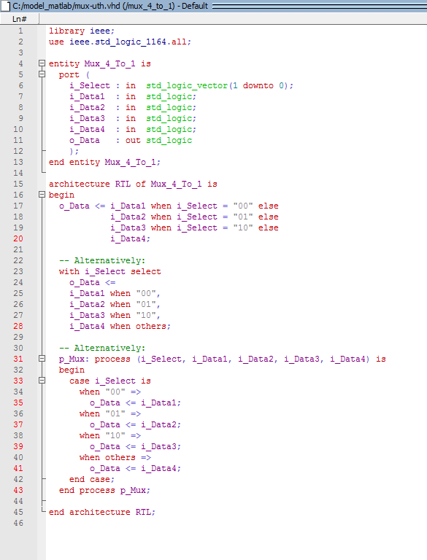

Πολυπλεκτης

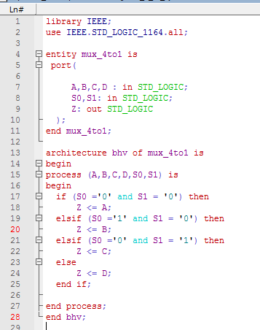

Αποπολυπλεκτης

library IEEE;
use IEEE.STD_LOGIC_1164.all;

entity demux_1to4 is
port(

F : in STD_LOGIC;
S0,S1: in STD_LOGIC;
A,B,C,D: out STD_LOGIC
);
end demux_1to4;

architecture bhv of demux_1to4 is
begin
process (F,S0,S1) is
begin
if (S0 ='0' and S1 = '0') then
A <= F;
elsif (S0 ='1' and S1 = '0') then
B <= F;
elsif (S0 ='0' and S1 = '1') then
C <= F;
else
D <= F;
end if;

end process;
end bhv;

l

_7segment

library IEEE;
use IEEE.STD_LOGIC_1164.ALL;

entity bcd_7segment is
Port ( BCDin : in STD_LOGIC_VECTOR (3 downto 0);
Seven_Segment : out STD_LOGIC_VECTOR (6 downto 0));
end bcd_7segment;

architecture Behavioral of bcd_7segment is

begin

process(BCDin)
begin

case BCDin is
when "0000" =>
Seven_Segment <= "0000001"; ---0
when "0001" =>
Seven_Segment <= "1001111"; ---1
when "0010" =>
Seven_Segment <= "0010010"; ---2
when "0011" =>
Seven_Segment <= "0000110"; ---3
when "0100" =>
Seven_Segment <= "1001100"; ---4
when "0101" =>
Seven_Segment <= "0100100"; ---5
when "0110" =>
Seven_Segment <= "0100000"; ---6
when "0111" =>
Seven_Segment <= "0001111"; ---7
when "1000" =>
Seven_Segment <= "0000000"; ---8
when "1001" =>
Seven_Segment <= "0000100"; ---9
when others =>
Seven_Segment <= "1111111"; ---null
end case;

end process;

end Behavioral;

_7segment

