DNA Turning Human Story Into a Tell-All

By ALANNA MITCHELL

Published: January 30, 2012
The tip of a girl’s 40,000-year-old pinky finger found in a cold Siberian cave, paired with faster and cheaper genetic sequencing technology, is helping scientists draw a surprisingly complex new picture of human origins.
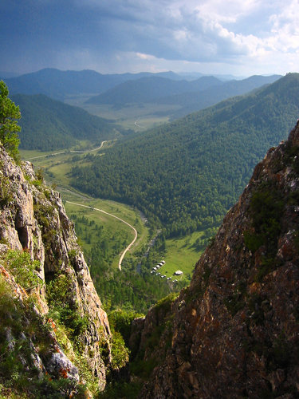
The new view is fast supplanting the traditional idea that modern humans triumphantly marched out of Africa about 50,000 years ago, replacing all other types that had gone before.
Instead, the genetic analysis shows, modern humans encountered and bred with at least two groups of ancient humans in relatively recent times: the Neanderthals, who lived in Europe and Asia, dying out roughly 30,000 years ago, and a mysterious group known as the Denisovans, who lived in Asia and most likely vanished around the same time.
Their DNA lives on in us even though they are extinct. “In a sense, we are a hybrid species,” Chris Stringer, a paleoanthropologist who is the research leader in human origins at the Natural History Museum in London, said in an interview.
The Denisovans (pronounced dun-EE-suh-vinz) were first described a year ago in a groundbreaking paper in the journal Nature made possible by genetic sequencing of the girl’s pinky bone and of an oddly shaped molar from a young adult.
Those findings have unleashed a spate of new analyses.
EARLY LAIR A view above the Denisova cave, where clues to prehistoric interbreeding were found. Faster technology is aiding research.
Scientists are trying to envision the ancient couplings and their consequences: when and where they took place, how they happened, how many produced offspring and what effect the archaic genes have on humans today.
Other scientists are trying to learn more about the Denisovans: who they were, where they lived and how they became extinct.
A revolutionary increase in the speed and a decline in the cost of gene-sequencing technology have enabled scientists at the Max Planck Institute for Evolutionary Anthropology in Leipzig, Germany, to map the genomes of both the Neanderthals and the Denisovans.
Comparing genomes, scientists concluded that today’s humans outside Africa carry an average of 2.5 percent Neanderthal DNA, and that people from parts of Oceania also carry about 5 percent Denisovan DNA. A study published in November found that Southeast Asians carry about 1 percent Denisovan DNA in addition to their Neanderthal genes. It is unclear whether Denisovans and Neanderthals also interbred.
A third group of extinct humans, Homo floresiensis, nicknamed “the hobbits” because they were so small, also walked the earth until about 17,000 years ago. It is not known whether modern humans bred with them because the hot, humid climate of the Indonesian island of Flores, where their remains were found, impairs the preservation of DNA.
This means that our modern era, since H. floresiensis died out, is the only time in the four-million-year human history that just one type of human has been alive, said David Reich, a geneticist at Harvard Medical School who was the lead author of the Nature paper on the Denisovans.
For many scientists, the epicenter of the emerging story on human origins is the Denisova cave in the Altai Mountains of Siberia, where the girl’s finger bone was discovered. It is the only known place on the planet where three types of humans — Denisovan, Neanderthal and modern — lived, probably not all at once.
John Hawks, a paleoanthropologist at the University of Wisconsin-Madison, whose lab is examining the archaic genomes, visited the cave in July. It has a high arched roof like a Gothic cathedral and a chimney to the sky, he said, adding that being there was like walking in the footsteps of our ancestors.
The cave has been open to the elements for a quarter of a million years and is rich with layers of sediments that may contain other surprises. Some of its chambers are unexplored, and excavators are still finding human remains that are not yet identified. The average temperature for a year, 32 degrees Fahrenheit, bodes well for the preservation of archaic DNA.
Could this cave have been one of the spots where the ancient mating took place? Dr. Hawks said it was possible.
But Dr. Reich and his team have determined through the patterns of archaic DNA replications that a small number of half-Neanderthal, half-modern human hybrids walked the earth between 46,000 and 67,000 years ago, he said in an interview. The half-Denisovan, half-modern humans that contributed to our DNA were more recent.
And Peter Parham, an immunologist at the Stanford University School of Medicine, has used an analysis of modern and ancient immune-system genetic components — alleles — to figure out that one of the Denisovan-modern couplings most likely took place in what is now southeastern China. He has also found some evidence that a Neanderthal-modern pair mated in west Asia.
He stressed, however, that his study was just the first step in trying to reconstruct where the mating took place.
Dr. Parham’s analysis, which shows that some archaic immune alleles are widespread among modern humans, concludes that as few as six couplings all those tens of thousands of years ago might have led to the current level of ancient immune alleles.
Another paper, by Mathias Currat and Laurent Excoffier, two Swiss geneticists, suggests that breeding between Neanderthals and modern humans was rare. Otherwise, they say, modern humans would have far more Neanderthal DNA.
Were they romantic couplings? More likely they were aggressive acts between competing human groups, Dr. Stringer said. For a model, he pointed to modern hunter-gatherer groups that display aggressive behavior among tribes.
The value of the interbreeding shows up in the immune system, Dr. Parham’s analysis suggests. The Neanderthals and Denisovans had lived in Europe and Asia for many thousands of years before modern humans showed up and had developed ways to fight the diseases there, he said in an interview.
When modern humans mated with them, they got an injection of helpful genetic immune material, so useful that it remains in the genome today. This suggests that modern humans needed the archaic DNA to survive.
The downside of archaic immune material is that it may be responsible for autoimmune diseases like diabetes, arthritis and multiple sclerosis, Dr. Parham said, stressing that these are preliminary results.
Although little is known about the Denisovans — the only remains so far are the pinky bone and the tooth, and there are no artifacts like tools. Dr. Reich and others suggest that they were once scattered widely across Asia, from the cold northern cave to the tropical south. The evidence is that modern populations in Oceania, including aboriginal Australians, carry Denisovan genes.
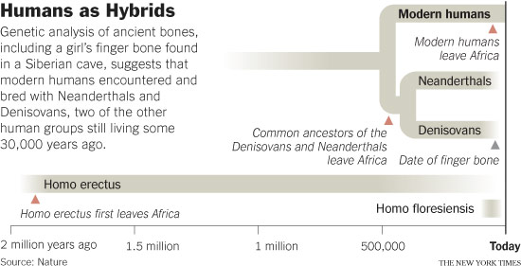
Dr. Reich and others suggest that the interbreeding that led to this phenomenon probably occurred in the south, rather than in Siberia. If so, the Denisovans were more widely dispersed than Neanderthals, and possibly more successful.
But the questions of how many Denisovans there were and how they became extinct have yet to be answered. Right now, as Dr. Reich put it, they are “a genome in search of an archaeology.”

