Μemoryscapes: experiments in deepening our sense of place
Toby Butler
Περίληψη
Μνημοτοπία: πειράματα στην εμβάθυνση της αίσθησης του τόπου
Το κείμενο ασχολείται με την αναστοχαστική πρακτική της δημιουργίας νέων μιντιακών διαδρομών μνήμης που συνδέονται με συγκεκριμένες τοποθεσίες, με σκοπό τη «χωροθέτηση» της προφορικής ιστορίας. Ο Toby Butler δημιούργησε μια σειρά από διαδρομές ‘μνημοτοπίων’ που ερμηνεύουν τους δημόσιους χώρους με τη βοήθεια καταγραφών ήχων και προφορικών μαρτυριών. Παρουσιάζονται οι πειραματισμοί του στο να δώσει φωνή στους σημερινούς – και παλιούς – κατοίκους του Λονδίνου στην ερμηνεία των ραγδαίων αλλαγών που σημειώνονται στις γειτονιές της πόλης.

The story of how I found myself in a rowing boat, intensely following a piece of rubbish floating in the river Thames for fifteen miles, is going to take some telling. It begins at the Museum of London, where I worked as an advisor on a sound art installation, called “Linked”, by the artist Graeme Miller. This was a trail which ran alongside the M11 link road in Hackney, the site of the biggest anti-road protest Britain had ever seen. The trail was made up of oral testimony from people who had lost their homes in the process of the motorway construction, broadcast from lamp posts in the streets alongside the new road. At certain points on the walk you listen to tracks at specific locations using audio equipment borrowed from local libraries, a little like the museum audio guides that most people are familiar with, but used in the outside landscape.
This was my first experience of a sound walk – a trail that you follow using some kind of audio equipment, usually a CD walkman, an MP3 player or a receiver of some sort. I later dubbed walks that involve oral history recordings ‘memoryscapes’ – landscape interpreted and imagined using the memories of others.
I arrived at the museum when this programme was in full swing and I was set to work advising on the interview-gathering process from residents and protestors and later evaluating Miller’s work (Butler 2005). I then decided to develop the idea of the audio walk conceptually, as an active and immersive way to understand and map the cultural landscape, and more practically as a potential medium for oral historians to use for presenting work to the public. I set out to construct two oral history trails or memoryscapes of my own near my home – which at the time was a houseboat moored off a small island in the River Thames in West London.
One of the first hurdles to constructing a trail is to decide on a method of choosing a route – through the landscape as well as the subject matter. After working on Graeme Miller’s “Linked” project I was heavily influenced by his approach of using a route way – in his case a motorway – as a way of linking a series of ostensibly unrelated places; an idea that has also been adopted in literature. Authors have made many creative attempts to treat transport routes as destinations in themselves, worthy of comment and study. Thus the kaleidoscopic, even chaotic accumulation of impressions in Platt’s Leadville: A Biography of the A40 gives us many takes on reality; cumulatively we feel that we somehow ‘know’ the road by the time we reach the end of the book (Platt 2001). Iain Sinclair’s London Orbital: A Walk Around the M25 (Sinclair 2003) and Patrick Wright’s The River; the Thames in our Time (Wright 1999) both use a route to organise reflections. Using the conceit of a journey is a quickly understandable way of organising narrative; it has an aesthetic of its own that can embrace the unusual and the unexpected in a creative way.
Having lived on the Thames in a houseboat for ten years, I was acutely aware that the river in London was an entity in itself with a culture of its own, yet many Londoners seemed to spatially comprehend the river more as a border, an administrative and cultural dividing line between north and south. Maps of conservation areas and local government boundaries often ended up in the middle of the river. I happened to live there, this led to absurdities – for example I voted and paid my local taxes to a local authority on the north side of the river, yet all my services, such as rubbish collection were provided by another authority on the south side of the river. A report by the London Rivers Association summed up this fractured approach to London’s river:
The opposites that structure the mindsets of the planning and built environment sectors, local/strategic, natural/urban, brownfield/greenfield – and even water/land – seriously handicap our ability to think about urban water spaces and their relationship with the city and beyond. The zones, hierarchies (of policy, plans and strategies), sectoral boxes and checklists that result from, and reinforce this approach effectively undermines the spatial configurations and naturalness of rivers which refuse to conform to the socially constructed lines on plans and in strategies (as many of the annually flooded towns and cities now contend).’ (Munt & Jaijee 2002:75)
With this in mind, I wanted to find a way of acknowledging the spatial and natural dimensions of the river by developing a more artistic and intuitive approach to structuring my field work. I developed a method of using the current of the river to find my ‘sample’ of river interviewees and physically link their lives up. A float was made out of driftwood and other river-carried material, using a design borrowed from hydrologists that use floats to track currents in rivers and oceans (fig. 1). I followed the float for many days, tracking its route through London, and noting where it collided with the bank (or any other interesting thing). In this way I wanted to experience London from the river, feeling its flow and using a natural phenomenon as a memory path through the modern city.
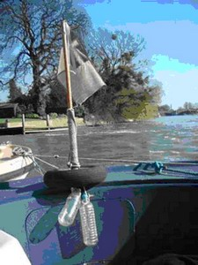
Fig. 1. The drifting float used to find interviewees in West London
Many of these collision points became sound points on the walk, as more often than not a potential interviewee would become apparent – the float would hit a boat or a property that was owned by someone, or a place where an individual was working or resting, and people were generally willing to be recorded. Usually this meant an in-depth interview at their home or place of work at a convenient time. The method presented some severe challenges. Moving at the pace of the river, often in a rowing boat, took a great deal of patience (in some stretches it moved at less than 1/10th of mile an hour, or even flowed backwards with the tide). Some places the float hit seemed so barren that it became a real challenge to find a connection with human culture, but I found that if I waited long enough and looked hard enough a connection could often be made. An old outfall pipe of a disused waterworks led to an interview with a retired water engineer, for example. The flow of the river suggested quiet and noisy points. Turns in the river usually presented me with more collisions, different vistas and encounters with whole families of other floating objects, each with its own unknowable source, story and trajectory.
The landscape of the banks of the Thames in London also contains some of the most imposing architecture in Britain, as successive political and economic powerhouses were built along the prestigious waterfront (palaces, bridges, parliaments and corporate headquarters). Many of these buildings have such strong historical and visual centres of gravity on the riverscape that they are all but impossible to ignore. Yet the float managed to do so. On long, straight stretches the float would move fast, disregarding royal palaces, whole industries, entire localities. The flow gave me a strange, unfamiliar structure to my beachcombing of river-related memories. It forced me to consider talking to people that I would not have thought of ordinarily and it gave me a fresh set of memory places.
This was the latest in a long line of practices that in some way challenge dominant cultural practices associated with national places of memory by providing an alternative. You may well be familiar with or involved in many such practices: neighbourhood tours, parish mappings, public art, gardening projects (Till 2003:294-296).
The result was a carefully constructed three mile walk with 12 different sound points along the route, containing a total of an hour of memories from 14 different people (fig. 2). The sound tracks were also layered with binaural recordings of the river bank – recordings made with a stereo two-part microphone that is placed in each ear of the recorder, which picks up sound in the exactly the same way as the human head. When the binaural recording is listened to with headphones, the result is a startling ‘surround sound’ – if footsteps are recorded behind you, it will sound as if someone is behind you when you listen. This gives the walk an added temporal dimension, as the listener is hearing the past of the sound recording along the route (complete with rowers, ducks, swans and pushchairs) along with the past of the memories that they are hearing. The idea was to sensitise people to every day sounds and remind the listener that their drift along the river would necessarily be different for each person that does it. Walking speed and pace play a very important part in the walk too. The number and crucially the location of the drifting sound points corresponded to the flow pattern of the river, so it is a very unusual trajectory. The whole design of the walk was meant to slow people down, to take more notice of what surrounds us and therefore make place more meaningful. I decided against continuous audio to allow people to reflect, process and have their own adventure between sound points. Of course, the medium also allows the walker to skip or listen at their own pace, and some people enjoyed the walk in a very different way, for example by walking and listening non-stop. The overall effect has been described by one reviewer as being a little like a Zen koan; ‘a fluid pattern of multiple agendas, effecting and being effected by the Thames and its social, political historical and economic sectors. Each location and narrator is accompanied by the river’s own music, its aural ebbs and flows, the creaking of wooden boat joints, the wash, a tugboat toot, bodying the world of a major urban riverway’ (Friedman 2006).
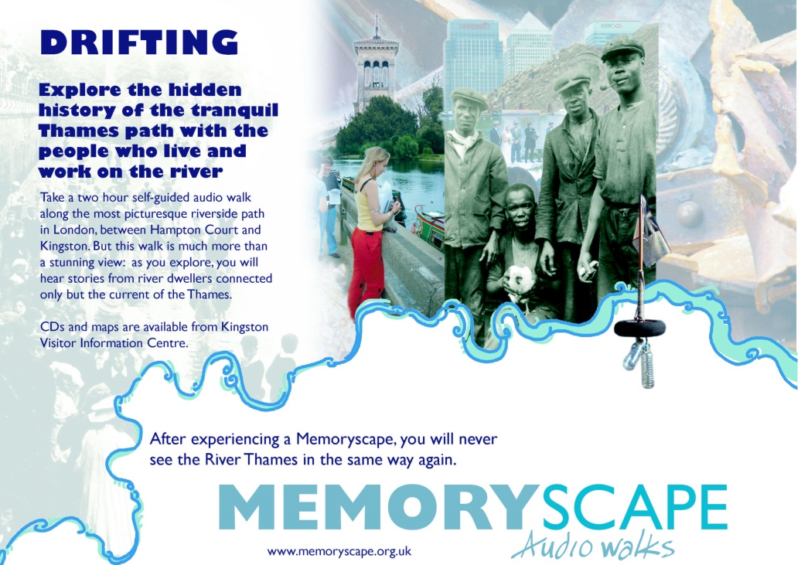
Fig. 2. Poster advertising the Drifting trail
The drifting float method used to find interviewees became unworkable in the eastern part of London. The author Patrick Wright roughly divided up river culture into two sections – ‘upriver’ people who believe that the Thames starts in a field in the Cotswolds and makes its way between tea rooms and thatched pubs down to London, and ‘downriver’ people who believe that the London Thames truly starts at the sea and works its way up the estuary. My downriver float fought bravely on from the first/last tidal lock at Teddington and got about as far as Kelmscott House, William Morris’s home in Hammersmith. From there the float became impossible to follow; the river was too wide, tidal and strong flowing for there to be enough points of impact with the bank. The float either shot along the mid-flow of the river or was propelled backwards for hours as the tide came in. To see this strange effect, walk along the Thames in East London in March and watch the Christmas trees floating up and down, trapped in a strange, slow tidal dance after being tossed in two months earlier in the vain hope that the river would take them away.
To have continued with my earlier method would have taken months. For the Dockers’ trail I used the same style of a river-culture based walk, using binaural recordings of the route, but this time I drew on a rare collection of 200 interviews with dock workers, now archived at the Museum in Docklands but recorded over 20 years ago when the London Docks were shut down.
The route runs from picture-postcard Greenwich, starting at the remains of the Cutty Sark tea clipper, and runs along the quaysides of the Greenwich peninsula to end up at the extraordinary Millennium Motel, part greasy spoon cafe, part gypsy campsite, in the shadows of the Dome. The memories used encompass dramatic events, such as when the Greenwich foot tunnel was used a shelter against the Zeppelin raids, but is mostly concerned with life in the dockside communities from childhood to working on the barges, cranes and warehouses near the river. The experience of standing in front of the ruins of an old crane, and hearing the pride in the voice of a crane driver who tells us he could pick up anything ‘from an elephant to a packet of pins’ gives a strange sensation of bringing the past present in a very direct way that no memorial or information board can touch – if you visit this website you can hear his words (www.memoryscape.org.uk/Dockers05.htm) (fig. 3).
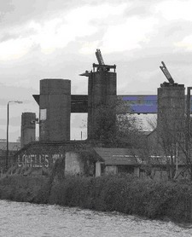
Fig. 3. Lovell’s wharf – crane base in 2007 (now destroyed and replaced by apartments)
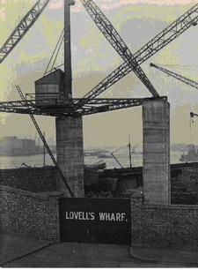
Fig. 4. Lovell’s Wharf – as the crane looked in the 1950s
Since making the trail, Lovell’s Wharf (fig. 4) and the Millennium Motel have both been demolished to make way for apartment blocks. I hope that walkers are given the chance to make meaning of a confusing post industrial landscape; understand a little of the culture that was once there, and reflect on the fact that the last remains of this industrial landscape are likely to disappear forever. The experience is not necessarily nostalgic; the present industry on the river and the existing (and changing) life along the route, both natural and human, temper the pull of the past to some extent; and a recent interview with the owner of the Millennium Motel at the end of the walk gives a positive view of the residential development of some very derelict areas. I hope the variety of voices and stories give a nuanced and complex impression of the area rather than a wholly nostalgic or developer-happy impression of nothing but views and progress.
One of the trickiest elements of designing the walks was deciding how much narration to include. The first version of the walk did not have any narration, because I wanted to get as far away as possible from the authorial/tour guide style. People just had to use the maps and work out what to do. In the pilot study it was clear that some people liked it, but a lot of people were not sure what was going on. The whole drifting experiment got lost; people wanted to know who/why people were included and they wanted to feel that they were in the ‘right’ place. Artists like Graeme Miller celebrate the idea of getting a bit lost because that is when you start to have a bit of an adventure. It is the opposite of most people’s instinct, particularly of curators in museums who take great effort to make things as accessible as possible. Basically some people will have a great time, but a lot of people just do not get it or feel very insecure without being guided. I wanted the walk to appeal as widely as possible, and the whole point was to locate the memories, so in the end we put in the narration. I think it works particularly well on the drifting work, which was a highly personal piece – it gave me the chance to get that across and lay bare some of the mechanics of the drifting experiment. In some ways the process of using archive recordings for this walk was more difficult; there were some wonderful stories that were impossible to locate, not least because many people worked in different docks; brief catalogue summaries made hunting for relevant material very time consuming and the quality of the recording became more important than usual for use with a walkman in a noisy environment. This meant that some nice recordings had to be rejected purely on sound quality grounds. Nevertheless, many voices that would have remained silent in the archives can now be heard at or near the places where the memories were born.

What did people make of it?
I made a particular effort to get my sound walks into the public domain, making sure that they were available on a website, in local bookshops, museums, libraries and tourist information centres, and publicising the walks in the local press and on local radio. In five months at least 3000 people looked at the website in a meaningful way, 600 downloaded a walk or bought the CDs and at least 350 people actually walked the two hour walks (as opposed to listening at home or online). These may not be enormous figures, but with no marketing budget and a small amount of promotional effort the circulation has grown far beyond the expected readership of many journals or local history books; and a year on at least 7000 people have encountered the memoryscapes in one way or another.
I have conducted audience evaluation using questionnaires and interviews with nearly 150 adults. Almost everyone was very positive about the experience, which bodes well for future work that is aimed at a wide public audience. The evaluation process revealed some interesting benefits to the memoryscape concept. Several people remarked that they felt empathy towards the people that they listened to despite the fact that they were from a different age, class or culture. This ‘normalisation’ effect seemed to come from a combination factors including the content of the recordings, the style of speaking, and the fact that the listener could not see the interviewee. Listeners seemed to respond particularly well to the variety of voices used: most people seemed to enjoy hearing from ‘real’ people as opposed to a mono-vocal guide, and to prefer shorter tracks that used more than one interviewee.
For me the most exciting finding was that the walks seemed to engender a feeling of identity with the landscape. Respondents reported that using a variety of senses, imagination, and references in the landscape, all helped to make the experience more meaningful and therefore memorable. Creating these connections, or links to place seem to have had led to a feeling of closeness, or rootedness for some people. One newcomer to London wrote ‘now I know a sense of a beginning attachment’. Another walker described the process beautifully as ‘deepening my attachment to the river. Like roots shooting off into the soil.’ Several people talked about the experience adding a new reality, or a new dimension of reality to the existing landscape. Furthermore, anyone who visits the landscape again can use those links to remember something of the stories that they heard. Thus:
‘Memoryscape has made me consider the part the river has played in so many people’s lives. I think about this whenever I visit the river since listening to the recording ‘drifting’.’
Perhaps this aspect of the experience could be of interest to those wishing to encourage feelings of belonging and identity in a particular community or location.
On the other hand, the intimacy of some of the recordings combined with hearing them outside someone’s house or workplace made some people feel uncomfortable, particularly if the memories involved referred to recent circumstances. For example, one track featured a number of neighbours talking about a new house in the area – the footpath was located opposite the house that had enormous plate glass windows and you could see inside. Hearing details of the house and people’s views of it seemed to become more powerful when stood outside the house itself, and there is a danger that using oral history in this way could verge on the voyeuristic. However, as the memoryscape process involved listening, understanding, consent and empathy I think it ran contrary to an act of voyeurism, which is based on the powerlessness of the subject – but I think it is worth pointing out as a potential concern with location based oral history.
Another interesting issue that came up was how conversational recording can become quite a different beast when listened to in specific locations. For example, one couple had described to me how their idyllic riverside bungalow suffered from sewerage flooding, due to the sewers being over-run by the sheer number of properties built in the area. The interviewees objected to the inclusion of the sewerage story, because they felt that it might affect the price of their property if a potential buyer tried the walk. In the end the clip was kept in with the agreement that their names and the exact location of their house would not be mentioned, but this was an interesting example of how the new context for the recording can introduce a whole new set of ethical dilemmas.

The future of the memoryscape
Location-based technology is becoming widespread. In-car satellite navigation and MP3 players are now almost ubiquitous. Now new generations of location aware tablet computers and phones with gps chips such as the i-phone are selling in their millions, and we are already seeing local, national and even worldwide grids of information. A long awaited European GPS system will eventually make navigation more accurate than ever before; new location based games and entertainments will be coming that make use of these location aware systems; mobile internet services are becoming cheaper and in some cities they will be free; and the sound walk, memoryscape or its multi-media equivalent will be rapidly evolving as different disciplines and sectors explore its potential.
Memoryscapes are already being jumped on companies interested in promoting brand awareness through new technology. Adidas have sponsored sound walks of graffiti walls in the Bronx in New York and in Glasgow Tennent’s Lager commissioned a freely downloadable MP3 walking tour of Glasgow’s music venues; more recently several local authorities and heritage organisations have commissioned similar ‘app’ based trails delivered by mobile phone. Computer manufacturers and software developers such as Hewlett Packard have long invested in research and development work for outdoor, mobile computing which includes location-based computer games that can geographically locate players in real time using gps. Content will be varied according to other real-world sensors, such as heart rate, direction and light using bio mapping techniques (Nold 2006). In Britain a BAFTA (our equivalent of the Oscars) was awarded to a BBC producer for creating a series of audio walks (linked to the Coast documentary series), and there are various web-based portals for local groups or organisations to podcast their own walks – territory already being rapidly dominated by Google Earth and Google Maps.
The medium should certainly not left solely for the market and large institutions to dominate. At best, this cultural, historical and geographical information system can be used to introduce multiple voices and conflicting readings of the landscape (and those that move and live in it). It can also be an empowering and expressive use of technology for the gazed at (or listened to). Just as simple websites can be constructed by individuals or small groups, sound walks can be made with minimal training and gain easy exposure on the internet (for examples of student work see www.raphael-samuel.org.uk). A walk has none of the practical problems associated with exhibiting landscape-related conventional art work or sculpture, because no exhibition space or planning permission is necessary. In the past this has proved to be a serious impediment to community-based initiatives that do not stem from local government or the arts establishment and the medium has the potential to be relatively inclusive.
For example, I have been working on ‘Ports of Call’, a community project near the Olympics 2012 site in East London. Unbelievably Newham, the borough with control of Stratford, does not even have a museum and the Royal Docks and its surrounding communities are almost completely devoid of any heritage interpretation in public areas. The Royal Docks, once the busiest in the world but now in a strange phase of dereliction and redevelopment, are in severe danger of being the victim of the splintered urbanism that characterised much of the development of the Isle of Dogs and Canary Wharf. Premium sites such as the Excel conference centre and London City Airport develop excellent connections and facilities, but are in danger of becoming effectively gated communities, leaving a poor, fractured communities physically or psychologically excluded from supposedly publicly accessible spaces. The trails that we have been creating with local people will hopefully encourage connections between the different parts of the docks and psychologically ‘ungate’ these premium sites by incorporating them as trail locations, and in turn encourage international visitors to venture beyond the taxi rank.
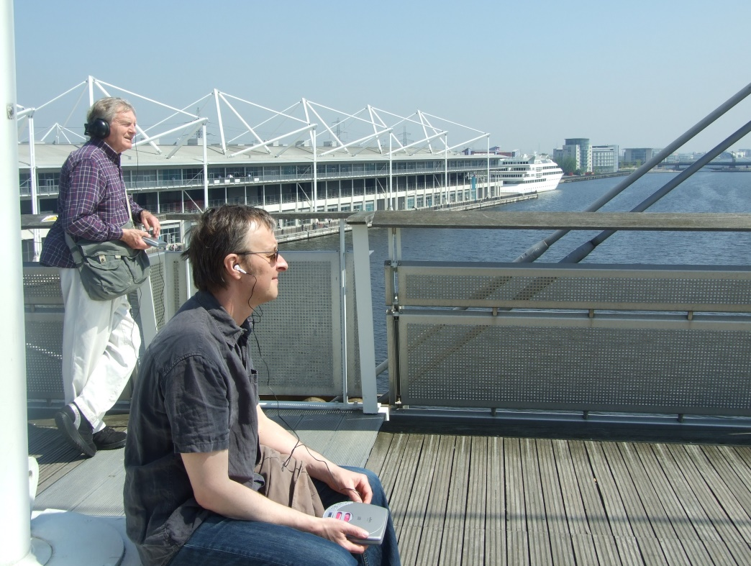
Fig. 5. Walkers experiencing a memoryscape at the Royal Docks
Hopefully the process of creating and walking the trails will also provide opportunities for people to build identity and empathy with their surroundings – that feeling of ‘rootedness’ , particularly for substantial proportions of the local population that are very new to the area (new dockside development residents; school children; newly arrived ethnic groups; students coming to the University of East London). In charting the area’s cultural, industrial, maritime and natural history before it is gone forever, we are also setting out to invent the traditions of a sustainable future which builds on rather than disregards local resources, both environmental and human. Our aim is to do this in an active, participatory way which gives local people new skills whilst at the same time giving some kind of context to the wider process of regeneration which for the first time is bringing large numbers of middle class professionals to live and work around the docks. The project really does have the potential to give past and present residents a voice in one of the most rapidly developing urban areas in the world.
We should all be keeping a close eye on the locedia phenomenon, which could have an impact as big as the invention of the printing press. Whatever technologies evolve, they will all need one thing – interesting, located (local) content. In the future I can foresee great demand for people with existing skills in local and oral history, particularly for people who have experience of recording and editing and can manage the technical and ethical challenges that creating public oral history entails. New producers will also come into the field, and they will need guiding and training in the practicalities and ethical aspects of recording local people. Archivists may also find that there is much more demand for local and oral history archive recordings. Finally, and perhaps most importantly, this medium will give communities, groups and disciplines an alternative ‘output’ that can be immersive, complex, multi-vocal, accessible and with real public appeal.
The two memoryscape walks, ‘drifting’ and ‘dockers’ can be downloaded (or experienced online) at www.memoryscape.org.uk and the latest Ports of Call trails are available from www.portsofcall.org.uk; trails created by staff and students on the MA in Heritage Studies: Place, Memory and History, that I lead, can also be found at www.raphael-samuel.org.uk

Bibliography
Butler, T. 2005. “Linked: a Landmark in Sound, a Public Walk of Art”. Cultural Geographies, 12/1:77-88.
Friedman, J. 2006. “Media Review: Drifting, from Memoryscape Audio Walks. Produced by Toby Butler.” Oral History Review, 33/1:107-109.
Miller, G. (Artist). 2003. Linked: a Landmark in Sound, an Invisible Artwork, a Walk [Sound installation].
Munt, I., & Jaijee, R. 2002. Postscript. In River Calling: the Need for Urban Water Space Strategies. London: London Rivers Association.
Nold, C. 2006. Bio Mapping. http://biomapping.net/ Retrieved 24 March, 2006
Platt, E. 2001. Leadville: A Biography of the A40. London: Picador.
Sinclair, I. 2003. London Orbital. London: Penguin.
Till, K. 2003. “Places of Memory”. In K. M. J. Agnew, G. O'Tuathail (Ed.), Companion to Political Geography, Oxford and Cambridge: Blackwell, 289-301.
Wright, P. 1999. The River: the Thames in Our Time. London: BBC Books.

Toby Butler is senior lecturer in history at the Raphael Samuel History Centre, University of East London. t.butler@uel.ac.uk.

