Source: https://getpocket.com/explore/item/stop-giving-toxic-people-your-time

Stop Giving Toxic People Your Time
Darius Foroux Visit Site

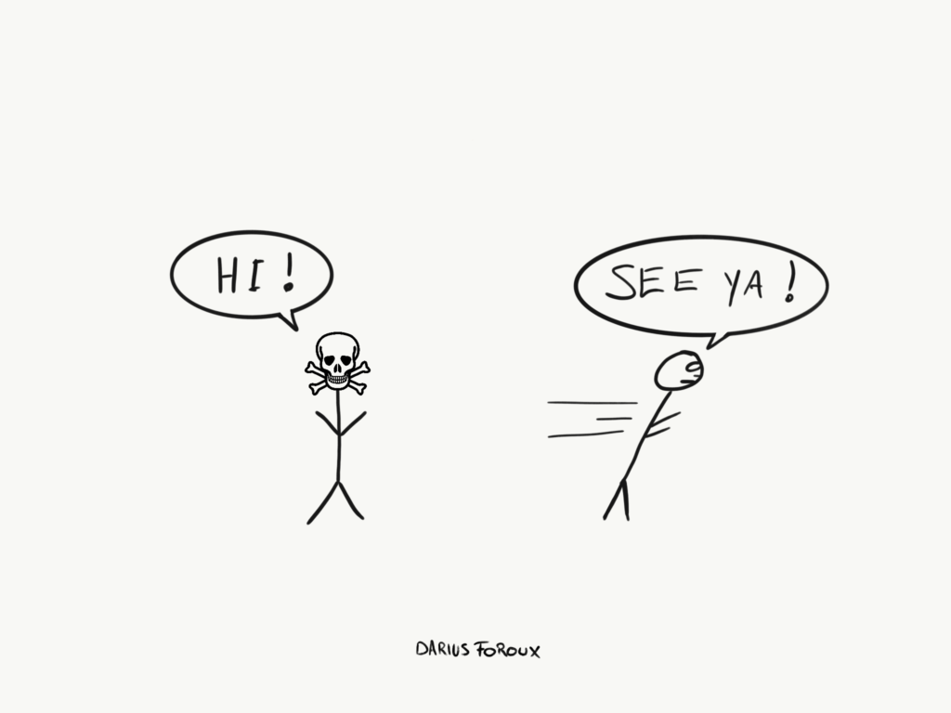

Do you ever get upset about the nasty behavior of your co-workers, friends, or even family? Well, if you let others upset you, it’s not their fault.
“It’s not me, it’s him!” is what most of us say. We’re always quick to blame others for how we feel.
We say that others make us feel that way. But that’s false. You decide how you feel about the things that happen in your life.
Events can’t harm us. Our perception of an event harms us. That’s one of the most important ideas of Stoic philosophy.
In other words, you decide what meaning you give to the things that happen in your life. If your friend tells lies about you behind your back, and you get upset, that’s because you decided to get upset.
After all, you don’t control others. That’s why who you spend your time with is a matter of life and death.
The great Stoic philosopher, Epictetus, said this in his Manual For Living:
“Avoid fraternizing with people who don’t share your values. Prolonged association with those with false ideas can only tarnish your thinking.”
It’s something I truly live by. I’ve seen others destroy people’s lives too often to take this idea carelessly.
And I bet that you’ve had your share of, for lack of a better term, “toxic” people in your life.

There Are Two Kinds Of People
- People with values
- People without values
I think that less than 1% of the population has values. Values entail nothing more than answers to questions like:
- How do you treat people?
- How do you treat yourself?
- What’s right and what’s wrong?
Here’s an easy way to detect people without values: When you see that someone becomes an entirely different person in a heartbeat — that’s when you know someone has no values.
For example, at our company, we recently hired a toxic intern. The intern turned out to be a different person from the person we thought we hired.
Of course, that’s our mistake. Even though we talked extensively about values during the interview process, we didn’t detect any warning signals.
And everything was fine during the first week. But as soon as the intern found a partner in one of our other interns, things started to change.
All of a sudden, with this new-found support, the intern started gossiping, trying to manipulate others, and causing mayhem. Fortunately, we identified it quickly and communicated that we have a zero-tolerance policy for toxic behavior.
It’s not an unusual thing in organizations. People often hide their true colors. I should say, they hide the fact that they don’t have colors.
When you lack values, you automatically gravitate towards natural human behavior. And that’s very dark. I recently read 12 Rules For Life by Dr. Jordan Peterson, a clinical psychologist, and a professor at the University of Toronto.
His fundamental proposition is that people are malevolent and that life is suffering. To prove that statement, Peterson shares compelling examples of human history with us.
He’s right. People have always lied, killed, and deceived their way through life.

But There’s An Alternative
Look, you can easily go down the rabbit hole of nasty behavior. Just spend enough time with bad people — eventually, you will become one of them.
You can also fill your days with gossiping, lying, and manipulating others. And you’ll probably also feel good when you do it. A sense of power, no matter how it’s achieved, gives people satisfaction. That’s how our minds work.
So, when you recognize someone who doesn’t have principles, shows nasty behavior, and has multiple personalities — step away.
Instead, surround yourself with people who want the best for you.
Not with people who are jealous, can’t see your success, and thrive off negativity. I think this is important to realize for anyone who wants to live a good life.
A few years ago, when I started to live a conscious life, I had to say goodbye to people who only wanted to live a life of pleasure.
And I’ve also seen other friends that started to change their life for the better, but were dragged back into the bottomless pit of darkness by others.
But as you and I both know, life is also full of warm and caring people. It’s not all bad.

Be Stingy With Your Time
“You’re the average of the five people you spend your time with.” It has become such a cliché. But I don’t think that we truly understand the impact that other people can have on us.
Like Epictetus said, others can tarnish your thinking. Is that worth it?
Look at it this way. Would you give $1000 to the people in your life if they asked for it? If the answer is no, stop giving the people who don’t share the same values as you, your time.
I’ve narrowed down the list of people I spend 90% of my time with to my direct family and my two best friends. Other than that, I spend my time working and exercising. That’s what I mostly do. And I’ve never enjoyed my life this much.
So, if you have a job you love, and a few people in your life who you love, you don’t even have more time to spend.
Nothing else gives more satisfaction than having a meaningful career and a strong family.
“But what if my family is toxic?”
Inspire them to change for the better. I don’t give up on my family. Even if it takes 10 years, I will still try to help them.

Create Your Values And Stick To Them
To live a virtuous life, you need principles. Without principles (or values), we have no character. And without character, we’re nothing.
“Who cares!”
Well, you should care. You’re the one who looks in the mirror every day. Are you happy with what you see?
That’s the only measure I have for my life. I must like the person I see in the mirror. If I don’t like that guy, I’ll change. That’s what I’ve always done. And that’s what I still do every day.

Improve Yourself
What’s the alternative? Like Peterson concludes in his 12 Rules For Life, there’s no other viable option for life.
There’s only one path to happiness: Forward motion.
You need the promise of what could be. You need a path to a better life. None of us is perfect.
It doesn’t matter if we ever reach our desired destination or not. What matters is that we keep improving.

-----------------------------------------------------------------------------------------------------
This post originally appeared on Darius Foroux. This article is republished here with permission.

